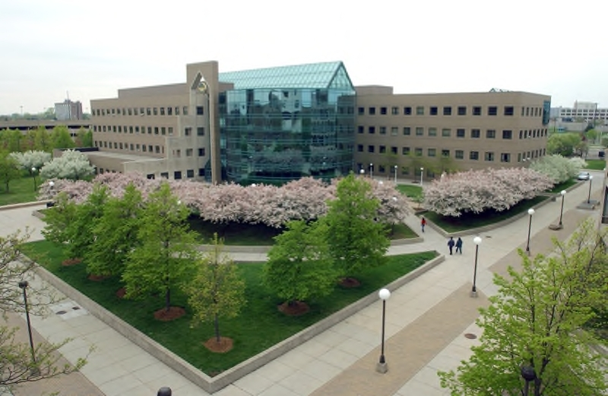
2010
Affirmative Action Status Report

Presented to the
Wayne State University Board of Governors
on December 7, 2011

Louis Lessem, Vice President and General Counsel
Christopher Jones, Director, Office of Equal Opportunity
TABLE OF CONTENTS

PREFACE,
President Allan D. Gilmour 3
INTRODUCTION 4
REPORTING REQUIREMENTS 4
I. UNIVERSITY EMPLOYMENT 5
A. FULL-TIME ACADEMIC AND NON-ACADEMIC EMPLOYMENT 6
B. FACULTY EMPLOYMENT 8
C. UNIVERSITY NON-ACADEMIC EMPLOYEES (STAFF) 12
D. TEMPORARY POSITIONS 14
E. COMPARISON WITH OTHER UNIVERSITIES……………………………… 15
II. UNIVERSITY COMPLAINTS 31
III. WAYNE STATE UNIVERSITY SUPPLIER DIVERSITY PROGRAM 35
IV. HIGHLIGHTS OF EQUAL OPPORTUNITY ACTIVITIES 39

Appendices

I. Definitions of EEO Categories

II. Responsibility for Affirmative Action

III. Definition of Terms

IV. Academic Classifications

V. Other Employee Definitions

VI. 2008 Data Tables

VII. Five Year Comparison Graphs

VIII. 2010 Comparison by Occupational Category

OFFICE OF THE PRESIDENT
4200 Faculty/Administration Building
313.577.2230 / 313.577.3200 Fax

MEMORANDUM

TO: Members of the Wayne State University Community

FROM: Allan D. Gilmour, President

SUBJECT: 2010 Affirmative Action Status Report to the Board of Governors

DATE: December 7, 2011

Wayne State University has a strong tradition of support for the principles of equal opportunity, non-discrimination and affirmative action. As a university of opportunity, we pride ourselves on providing educational opportunities for a diverse student body that varies widely in terms of age, race, ethnicity and economic status.

Diversity among our faculty, students and staff is a major source of our intellectual vitality and innovative spirit. We believe that a broad spectrum of informed perspectives enhances the educational and work experience on campus, and prepare our graduates to succeed in an increasingly interdependent and multicultural world.

Wayne State strives to be a place where people from varied walks of life can reach their full potential. Our commitment to the core values of inclusiveness and opportunity are essential to the fulfillment of our mission as a model urban research institution.

The following report summarizes Wayne’s affirmative action status for 2010, and provides examples of some of our achievements and direction for the future.

INTRODUCTION

Wayne State University is a national leader in providing equal access and employment opportunities to women and minorities. This report highlights the efforts of our schools, colleges and divisions in providing equal opportunity in employment and in enhancing diversity throughout Wayne State University. Even during difficult economic times, we have achieved many successes.

Wayne State University is the most diverse public university in the State of Michigan. The 2010 Affirmative Action Status Report (“AASR”) to the Wayne State University Board of Governors demonstrates that Wayne State University continues to lead in ensuring equality of opportunity. Our continued commitment to diversity is a significant strength in the educational experience we provide to our students. This report is intended to present a comprehensive, cross-divisional view of Wayne State University’s performance in this important area.

REPORTING REQUIREMENTS

This report is provided pursuant to Board of Governors statute (WSUCA 2.28.01.070 - 120), which provides that a report be made on an annual basis to the Board on Wayne’s affirmative action efforts. In many respects, the report is derived from data compiled pursuant to federal reporting requirements. The Office of Federal Contract Compliance Programs (“OFCCP”) in the U.S. Department of Labor, which regulates federal grant expenditures, requires that federal contractors with 50 or more employees who receive $50,000 or more in federal funds have an Affirmative Action Plan (“AAP”) and prepare an annual report to the contractor’s governing board and executives.

This report includes information from four major areas of University activity, with national and/or regional comparisons where available. These areas are (I) overall University employment, including detailed information on full-time, academic and non-academic staff and supplemental information on part time and temporary employees, including a comparison of Wayne and other universities in the state and around the country; (II) internal and external discrimination and harassment complaints; (III) the Wayne State University Supplier Diversity Program; and (IV) highlights of campus affirmative action and equal opportunity activities.

This report was compiled by the Office of Equal Opportunity (“OEO”) with input from and the collaborative efforts of many units, including the Office of the General Counsel, Office of the Provost, the Office of Budget, Planning and Analysis, and the Division of Finance and Facilities Management.

Information regarding staffing levels and discrimination complaint data contained in this report are based on personnel actions reported on a calendar year basis from January 1, 2010 to December 31, 2010. Data related to supplier diversity and external financial management is reported on a fiscal year basis beginning on October 1, 2009 and ending September 30, 2010. The report includes additional headcount data tables for the previous twelve month period (January 1, 2009 – December 31, 2009) at Appendix VI. Graphs of five-year comparisons on staffing levels have been provided in Appendix VII. Finally, the report also includes a breakdown of Minority and Women Faculty by College/School/Division in Section B, Table 5.

I. UNIVERSITY EMPLOYMENT

As the tenth largest employer in Detroit, Wayne State University is a major hiring force in southeastern Michigan. As of December 31, 2010, Wayne employed 8,135 persons, both full and part time, including temporary employees. While the report’s focus is on full time employees in permanent positions with the University, it includes a snapshot of temporary employees as well.

In 2010, Wayne employed 5,192 persons in full time positions. Wayne recruits approximately 60% of its workforce from a four-county statistical area consisting of Macomb, Oakland, Washtenaw and Wayne counties. Applicants for most non-academic positions are residents of one of these counties.

Wayne recruits its faculty from a national labor pool that is specific to individuals who hold doctoral and specialty degrees (Ph.D., M.F.A, etc.). Executive and some management-category positions also are recruited from a national labor employment pool. For the most part, other staff is recruited from a local labor pool.

Wayne also has a large number of student employees. Wayne State employs undergraduate students as student assistants through college work-study and other programs. Graduate students frequently are employed as graduate assistants and sometimes as part-time faculty. In addition, approximately 631 temporary employees are employed at any given time each year. The majority of these employees work in professional or research classifications.

Wayne State’s workforce exceeds the regional availability in the percentage of women, Black and Asian/Pacific Islanders it employs. Among total full-time employees, just over 52% of Wayne’s employees are female, compared to the regional average of just below 47%. 24.1% of Wayne’s full-time employees are Black, compared to 20.4% regional availability, and slightly more than 14% are Asian/Pacific Islanders, which is over four times the regional availability. Wayne has been less successful in recruiting Hispanic and Native American employees, and lags behind regional availability with regard to both of these minority groups.

Minority Representation Compared to Regional Availability
As of 12/31/10 (Table 1)

Race/Ethnicity/Gender | 2010 Full Time Employee Headcount | % of WSU Workforce | Regional Availability | % Difference
Black | 1,251 | 24.10% | 20.40% | 3.70%
Asian / Pacific Islander | 751 | 14.50% | 2.80% | 11.70%
Hispanic | 129 | 2.50% | 2.70% | -0.20%
White, Non-Hispanic | 3,010 | 58.00% | N/A | N/A
Native American | 12 | 0.20% | 0.30% | -0.10%
Not Identified | 32 | 0.60% | N/A | N/A
Women | 2,705 | 52.10% | 46.80% | 5.30%

The classifications utilized in this report are drawn from federally-established terminology utilized for EEOC reporting purposes. (For purposes of this report the term “minority” includes Blacks, Asian/Pacific Islanders, Hispanics, and Native Americans.) Overall, minorities comprise 41.4% of Wayne’s workforce and are represented in 90 percent of Wayne State University's 254 departments and in 99% of the departments that employ 10 or more people. Women represent just over 52% of Wayne’s full-time workforce, and are represented in 94% of all departments, and 99% of all departments that employ 10 or more people. These results reflect the diversity that Wayne State University has been able to achieve in its workforce.

A. FULL TIME ACADEMIC AND NON-ACADEMIC EMPLOYMENT

In 2010, Wayne State University employed 5,192 persons in both academic (1,816) and non-academic (3,376) full time positions. Of the 5,192 full time employees, 2,705 were women employees and 2,150 were minority employees.

2010 Full Time Women and Minority Employment
As of 12/31/10 (Table 2)

Year | Women | % of total Headcount | Minority | % of total Headcount
2010 | 2,705 | 52.1% | 2,150 | 41.41%
2009 | 2,665 | 51.70% | 2,145 | 41.61%
2008 | 2,645 | 52.25% | 2,123 | 41.94%
2007 | 2,852 | 53.27% | 2,221 | 41.49%
2006 | 2,769 | 53.10% | 2,113 | 40.52%
Most full-time employees are employed as “Faculty” (1,816 employees) or “Other Professionals” (2,129 employees).

2010 Total Full Time Academic and Non Academic Employee Headcount
As of 12/31/10 (Table 3)

Category | 2010 Total | Black | Asian / Pacific Islander | Hispanic | Native American | 2 or More Races | Total Minorities | Women
Faculty | 1,816 | 123 | 365 | 44 | 3 | 0 | 535 | 699
Faculty |  | 6.8% | 20.1% | 2.4% | 0.2% | 0.0% | 29.5% | 38.5%
Executive / Administrative / Managerial | 246 | 49 | 9 | 2 | 1 | 0 | 61 | 112
Executive / Administrative / Managerial |  | 19.9% | 3.7% | 0.8% | 0.4% | 0.0% | 24.8% | 45.5%
Other Professionals | 2,129 | 478 | 366 | 56 | 3 | 5 | 908 | 1,297
Other Professionals |  | 22.5% | 17.2% | 2.6% | 0.1% | 0.2% | 42.6% | 60.9%
Technical / Paraprofessional | 73 | 12 | 0 | 0 | 0 | 0 | 12 | 32
Technical / Paraprofessional |  | 16.4% | 0.0% | 0.0% | 0.0% | 0.0% | 16.4% | 43.8%
Clerical / Secretarial | 505 | 325 | 7 | 13 | 3 | 2 | 350 | 441
Clerical / Secretarial |  | 64.4% | 1.4% | 2.6% | 0.6% | 0.4% | 69.3% | 87.3%
Skilled Crafts | 116 | 33 | 2 | 1 | 0 | 0 | 36 | 4
Skilled Crafts |  | 28.4% | 1.7% | 0.9% | 0.0% | 0.0% | 31.0% | 3.4%
Service / Maintenance | 307 | 231 | 2 | 13 | 2 | 0 | 248 | 120
Service / Maintenance |  | 75.2% | 0.7% | 4.2% | 0.7% | 0.0% | 80.8% | 39.1%
Total | 5,192 | 1,251 | 751 | 129 | 12 | 7 | 2,150 | 2,705
Total |  | 24.1% | 14.5% | 2.5% | 0.2% | 0.1% | 41.4% | 52.1%

Female employees comprise over half of the Wayne State University workforce. Almost half of all women employed at Wayne are concentrated in the Other Professionals category, and approximately 25% are faculty. These categories are followed by the Clerical/Secretarial category and the Service/Maintenance category.

2010 Total Full-Time Women Employee Headcount
Category | Black | Asian / Pacific Islander | Hispanic | Native American | 2 or More Races | White | Unknown Race/  Ethnicity | 2010 Total
Faculty | 71 | 113 | 18 | 2 | 0 | 490 | 5 | 699
Faculty | 10.15% | 16.16% | 2.60% | 0.29% | 0.0% | 70.10% | 0.71% | 699
Executive / Administrative / Managerial | 28 | 3 | 0 | 1 | 0 | 80 | 0 | 112
Executive / Administrative / Managerial | 0.25% | 2.70% | 0.00% | 0.90% | 0.0% | 71.42% | 0.00% | 112
Other Professionals | 366 | 173 | 39 | 2 | 4 | 706 | 7 | 1,297
Other Professionals | 28.22% | 13.34% | 3.01% | 0.15% | 0.31% | 54.43% | 0.54% | 1,297
Clerical / Secretarial | 289 | 4 | 11 | 1 | 2 | 133 | 1 | 441
Clerical / Secretarial | 65.53% | 0.91% | 2.50% | 0.23% | 0.45% | 30.20% | 0.23% | 441
Technical / Paraprofessional | 4 | 0 | 0 | 0 | 0 | 28 | 0 | 32
Technical / Paraprofessional | 12.50% | 0% | 0% | 0% | 0.0% | 87.5% | 0% | 32
Skilled Crafts | 2 | 0 | 0 | 0 | 0 | 2 | 0 | 4
Skilled Crafts | 0.50% | 0% | 0% | 0% | 0.0% | 0.50% | 0.00% | 4
Service / Maintenance | 102 | 0 | 3 | 2 | 0 | 13 | 0 | 120
Service / Maintenance | 85.0% | 0% | 2.50% | 1.76% | 0.0% | 10.83% | 0.00% | 120
Total | 862 | 293 | 71 | 8 | 6 | 1,452 | 13 | 2,705
Total | 31.87% | 10.83% | 2.62% | 0.29% | 0.22% | 53.68% | 0.48% | 100%
As of 12/31/10 (Table 4)

B. FACULTY EMPLOYMENT

Wayne State University strives to provide an efficient and user-friendly faculty hiring process that contributes to a diverse pool of qualified candidates. The Online Hiring System provides applicants with global access to employment opportunities 365 days of the year, 24 hours a day. The OEO is a resource for departments conducting academic searches by providing all academic departments with hiring plans to assist in identifying staffing needs and the OEO publishes information in the “Guide for Successful Searches.” Additionally, the OEO also provides diversity resources for publicizing employment opportunities and training in the faculty hiring process.

Wayne State University continues to promote diversity within its faculty. As shown in Table 4 below, the recruitment of women and minority faculty at Wayne State University has been successful in producing diversity within the faculty, despite difficult economic pressures and a highly competitive environment.

a. Full Time Faculty – Tenured and Non-Tenured

In 2010, Wayne employed 1,816 tenured and non-tenured full time faculty. Tenured faculty made up 1,043 of the total faculty, of whom 318 or slightly more than 30% of tenured faculty are women. Minorities hold 300 tenured faculty positions.
In 2010, the non-tenured faculty totaled 773. The number of women holding non-tenure system faculty appointments comprised 381 of the total non-tenure positions. Minorities also held a significant number of non-tenure positions in 2010, standing at 235.

2010 Full Time Faculty - Tenure and Non-Tenure System
As of 12/31/10 (Table 5)

Rank | 2010 Faculty Total | Black | Asian / Pacific Islander | Hispanic | Native American | Total Minority | Women
Tenure System | 1,043 | 56 | 212 | 31 | 1 | 300 | 318
Tenure System | 1,043 | 5.4% | 20.3% | 3.0% | 0.1% | 28.8% | 30.5%
Non-Tenure System | 773 | 67 | 153 | 13 | 2 | 235 | 381
Non-Tenure System | 773 | 8.7% | 19.8% | 1.7% | 0.3% | 30.4% | 49.3%
Total | 1,816 | 123 | 365 | 44 | 3 | 535 | 699
Total | 1,816 | 6.8% | 20.1% | 2.4% | 0.2% | 29.5% | 38.5%

2010 Full Time Faculty – Minority Representation
Chart 1

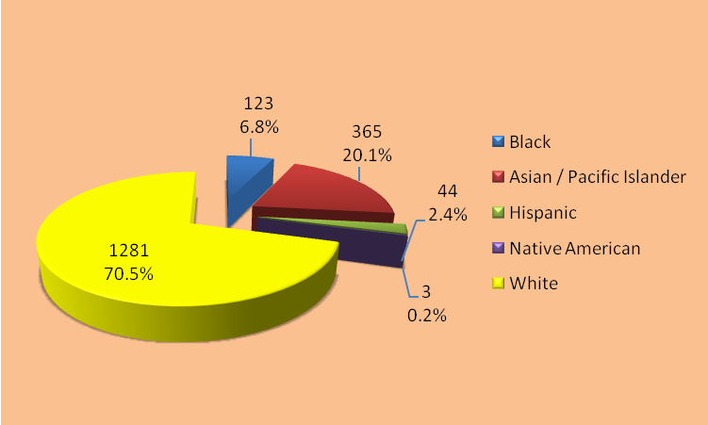

2010 Full Time Faculty – Gender Representation
Chart 2
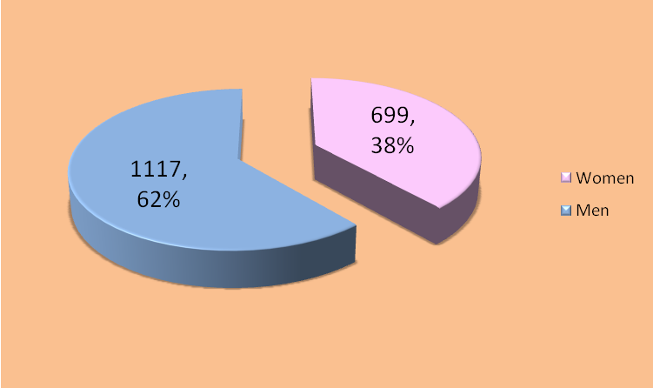
b. Tenure-System Faculty by Rank

Wayne State University promoted 29 tenured/tenured track faculty during 2010, 19 less than in 2009. The 29 promotions included a decrease in the number of women faculty who were promoted (8, a decrease of 11 from the previous year). Eleven minority faculty received promotions, a modest decrease of 5 from 2009.

Just over 43% of the 1,043 tenured faculty, hold the rank of Professor. The majority of women and minorities are concentrated in the ranks of Associate Professor and Assistant Professor. In 2010, Wayne had 450 Professors, of which 86 were women and 107 were minorities. The total number of Associate Professors was 330 in 2010, of which 121 were women and 89 were minorities. The total number of Assistant Professors was 263, of which 111 were women and 104 were minorities.

2010 Full Time Faculty Promotions - Tenure and Non-Tenure System
As of 12/31/10 (Table 6)

Rank | 2010 Total Faculty Promotion | Black | Asian / Pacific Islander | Hispanic | Native American | Total Minority | Women
Professor | 14 | 1 | 3 | 0 | 0 | 4 | 3
Professor | 14 | 7.10% | 21.40% | 0.00% | 0.00% | 28.60% | 21.40%
Associate  Professor | 15 | 2 | 4 | 1 | 0 | 7 | 5
Associate  Professor | 15 | 13.30% | 26.70% | 6.70% | 0.00% | 46.70% | 33.30%
Assistant  Professor | 0 | 0 | 0 | 0 | 0 | 0 | 0
Assistant  Professor | 0 | 0.00% | 0.00% | 0.00% | 0.00% | 0.00% | 0.00%
Total | 29 | 3 | 7 | 1 | 0 | 11 | 8
Total | 29 | 10.3% | 24.1% | 3.4% | 0.0% | 38.0% | 27.6%

2010 Tenure-System Faculty by Rank
As of 12/31/10 (Table 7)

Rank | 2010 Faculty Total | Black | Asian / Pacific Islander | Hispanic | Native American | Total Minority | Women
Professor | 450 | 13 | 86 | 8 | 0 | 107 | 86
Professor | 450 | 2.9% | 19.4% | 1.8% | 0.0% | 23.8% | 19.1%
Associate  Professor | 330 | 18 | 60 | 11 | 0 | 89 | 121
Associate  Professor | 330 | 5.5% | 18.2% | 3.3% | 0.0% | 27.0% | 36.7%
Assistant  Professor | 263 | 25 | 66 | 12 | 1 | 104 | 111
Assistant  Professor | 263 | 9.5% | 25.1% | 4.6% | 0.4% | 39.5% | 42.2%
Total | 1,043 | 56 | 212 | 31 | 1 | 300 | 318
Total | 1,043 | 5.4% | 20.3% | 3.0% | 0.1% | 28.8% | 30.5%

Full Professors – Gender and minority representation
Charts 3 and 4

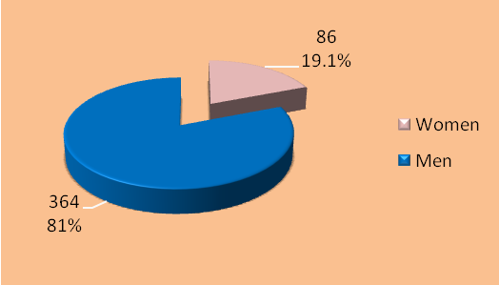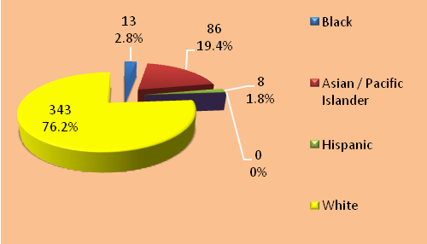

Associate Professors - Gender and minority representation
Charts 5 and 6

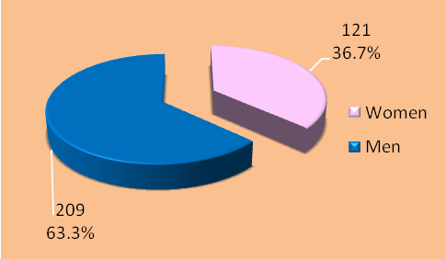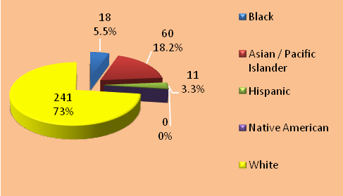

Assistant Professors - Gender and minority representation
Charts 7 and 8

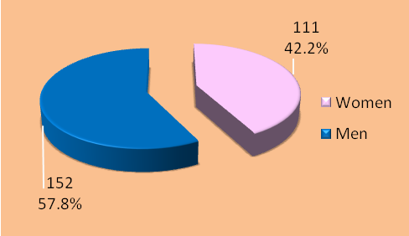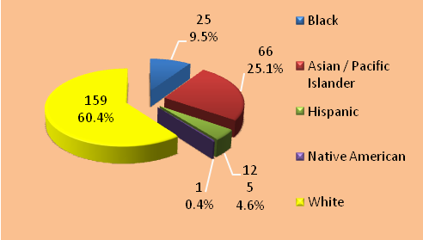

Women and minorities are represented throughout the faculty ranks of Wayne State University. As seen in Table 6, minority and female faculty are distributed throughout the schools, colleges, and divisions, with the majority being within the College of Liberal Arts and Science and the School of Medicine.

2010 Tenured Faculty by School/College/Division – Minorities and Females
As of 12/31/10 (Table 8)

School/ College/ Division | Black | Asian | Hispanic | Native American | 2 or more Races | Unknown | Total Minorities | White | Female | Total
School of Business Administration | 5 | 12 | 0 | 0 | 0 | 0 | 17 | 24 | 8 | 41
School of Business Administration | 12.2% | 29.3% | 0.0% | 0.0% | 0.0% | 0.0% | 41.5% | 58.5% | 19.5% | 41
College of Education | 8 | 8 | 3 | 1 | 0 | 0 | 20 | 41 | 33 | 61
College of Education | 13.1% | 13.1% | 4.9% | 1.6% | 0.0% | 0.0% | 32.8% | 67.2% | 54.1% | 61
College of Engineering | 5 | 44 | 1 | 0 | 0 | 0 | 50 | 33 | 8 | 83
College of Engineering | 6.0% | 53.0% | 1.2% | 0.0% | 0.0% | 0.0% | 60.2% | 39.7% | 9.6% | 83
College of Fine & Performing Arts | 5 | 2 | 3 | 0 | 0 | 0 | 10 | 64 | 29 | 74
College of Fine & Performing Arts | 6.7% | 2.7% | 4.0% | 0.0% | 0.0% | 0.0% | 13.5% | 86.5% | 39.2% | 74
Law School | 2 | 1 | 0 | 0 | 0 | 0 | 3 | 28 | 9 | 31
Law School | 6.4% | 3.2% | 0.0% | 0.0% | 0.0% | 0.0% | 9.7% | 90.3% | 29.0% | 31
College of Liberal Arts & Science | 19 | 62 | 13 | 0 | 0 | 0 | 94 | 266 | 112 | 360
College of Liberal Arts & Science | 5.3% | 17.2% | 3.6% | 0.0% | 0.0% | 0.0% | 26.1% | 73.9% | 31.1% | 360
School of Library & Information Science | 1 | 0 | 1 | 0 | 0 | 1 | 2 | 10 | 7 | 13
School of Library & Information Science | 7.7% | 0.0% | 7.7% | 0.0% | 0.0% | 7.7% | 15.4% | 76.9% | 53.8% | 13
School of Medicine | 5 | 72 | 7 | 0 | 0 | 0 | 84 | 207 | 64 | 291
School of Medicine | 1.7% | 24.7% | 2.4% | 0.0% | 0.0% | 0.0% | 28.9% | 71.1% | 22.0% | 291
College of Nursing | 2 | 2 | 1 | 0 | 0 | 0 | 5 | 21 | 24 | 26
College of Nursing | 7.7% | 7.7% | 3.8% | 0.0% | 0.0% | 0.0% | 19.2% | 80.8% | 92.3% | 26
College of Pharmacy & Health Science | 1 | 5 | 0 | 0 | 0 | 1 | 6 | 23 | 7 | 30
College of Pharmacy & Health Science | 3.3% | 16.7% | 0.0% | 0.0% | 0.0% | 3.3% | 20.0% | 76.7% | 23.3% | 30
School of Social Work | 3 | 0 | 1 | 0 | 0 | 0 | 4 | 13 | 11 | 17
School of Social Work | 17.6% | 0.0% | 5.9% | 0.0% | 0.0% | 0.0% | 23.5% | 76.5% | 64.7% | 17
Division of Research | 0 | 4 | 1 | 0 | 0 | 0 | 5 | 11 | 6 | 16
Division of Research | 0.0% | 25.0% | 6.3% | 0.0% | 0.0% | 0.0% | 31.3% | 68.7% | 37.5% | 16
Grand Totals: | 56 | 212 | 31 | 1 | 0 | 2 | 300 | 741 | 318 | 1043
Grand Totals: | 5.4% | 20.3% | 3.0% | 0.1% | 0.0% | 0.2% | 28.8% | 71.0% | 30.5% | 1043

C. UNIVERSITY NON-ACADEMIC EMPLOYEES (STAFF)

The term “staff” refers to individuals in positions ranging from maintenance personnel to executive officers. The non-academic staff at Wayne State University is diverse in its representation of women and minorities. Of the 3,376 non-academic staff at Wayne State University in 2010, women totaled 2,006 (59%) and minorities totaled 1,615 (48%). Blacks are the largest minority group with 1,128 employees (33%), followed by Asian/Pacific Islanders with 386 (11%), Hispanics with 85 (2.5%), and Native Americans with 9 (.3%).

Full-Time Non-Academic Employees by EEO Categories

The EEO categories in this report are based upon Federal Department of Labor Standard Occupational Classifications (“SOC”) according to the nature of the work performed and educational level (degree obtained) and are related to occupations of a similar nature. There are 23 major groups in the SOC and 821 detailed occupations within those groups. As shown in Table 9 below, Wayne State University’s non-academic employment population is comprised of six of these categories: Executive/Administrative/Managerial; Other Professionals; Clerical/Secretarial; Technical/Paraprofessional; Skilled Crafts; and Service/Maintenance.

2010 Total Full-Time Non-Academic Employee Headcount
As of 12/31/10 (Table 9)

Category | 2010 Total | Black | Asian / Pacific Islander | Hispanic | Native American | 2 or More Races | Total Minorities | Women
Executive / Administrative / Managerial | 246 | 49 | 9 | 2 | 1 | 0 | 61 | 112
Executive / Administrative / Managerial |  | 19.9% | 3.7% | 0.8% | 0.4% | 0.0% | 24.8% | 45.5%
Other  Professionals ³ | 2,129 | 478 | 366 | 56 | 3 | 5 | 908 | 1,297
Other  Professionals ³ |  | 22.5% | 17.2% | 2.6% | 0.1% | 0.2% | 42.6% | 60.9%
Technical / Paraprofessional | 73 | 12 | 0 | 0 | 0 | 0 | 12 | 32
Technical / Paraprofessional |  | 16.4% | 0.0% | 0.0% | 0.0% | 0.0% | 16.4% | 43.8%
Clerical / Secretarial | 505 | 325 | 7 | 13 | 3 | 2 | 350 | 441
Clerical / Secretarial |  | 64.4% | 1.4% | 2.6% | 0.6% | 0.4% | 69.3% | 87.3%
Skilled Crafts | 116 | 33 | 2 | 1 | 0 | 0 | 36 | 4
Skilled Crafts |  | 28.4% | 1.7% | 0.9% | 0.0% | 0.0% | 31.0% | 3.4%
Service / Maintenance | 307 | 231 | 2 | 13 | 2 | 0 | 248 | 120
Service / Maintenance |  | 75.2% | 0.7% | 4.2% | 0.7% | 0.0% | 80.8% | 39.1%
Total | 3,376 | 1,128 | 386 | 85 | 9 | 7 | 1,615 | 2,006
Total |  | 33.4% | 11.4% | 2.5% | 0.3% | 0.2% | 47.8% | 59.4%

With nearly 48% minority and more than 59% female representation in the non-academic employee group, Wayne State continues to retain and employ a diverse workforce.

It is significant that minorities and women are heavily represented throughout all levels of job categories at Wayne. In 2010, 246 employees were classified in the “Executive/Administrative/Managerial” category. This roughly corresponds to non-academic employees holding the rank of Director or above. Minorities represent nearly 25% of this high-level group. The number of women represented in this group was 112 in 2010, which represents over 45% of the total employee group.

Full-time employees in the “Other Professional” category include academic support personnel as well as those job assignments that require a college degree. The population of the “Other Professional” category fluctuates with enrollment and grant funding trends.

Of the 2,129 employed in this category, 908 were minorities. Blacks were more heavily represented than any other minority, at 478, followed by Asian/Pacific Islanders at 366. Hispanics and Native Americans in this group total 56 and 3 respectively. Five (5) employees were identified as having 2 or more races and more than 60% (1,297) were women.
There were 505 full-time employees in the “Clerical/Secretarial” category in 2010, of which 325, or just over 64%, were Black. Other minorities are very modestly represented, with 13 Hispanic employees, 7 Asians and Pacific Islanders, and 3 Native American employees. Two (2) employees were identified as having 2 or more races and female employees comprise over 87% of the Clerical/Secretarial job category.

The number of full-time employees categorized as “Technical/Paraprofessional” was 73 employees. This category includes Library Assistants, Archivist Assistants, Graphic Designers, Facility Coordinators, Multimedia Specialists, Environmental Health Specialist, Lab Techs and other similar positions. Women comprise just over 43% and total minorities are slightly more than 16% of this reporting group.

The “Skilled Crafts” category included 116 employees in 2010. Minority representation within the group was 36, with Blacks making up the bulk of this group. In the “Service/Maintenance” category, the number of full-time personnel was at 307. 248 of these employees were minorities, which represents just over 80% of the service group. Women represent 3.4% of the Skilled Crafts category and slightly over 39% of Service categories.

D. TEMPORARY POSITIONS

This employee group often fluctuates over the course of a given year, as the positions are based on a unit’s specific needs or projects. University policy limits temporary employees to a total of 1000 hours employment in a fiscal year. With this in mind, the following data provides a snapshot of active temporary positions on the payroll as of October 1, 2010.

Temporary employees by position classification and gender
As of 12/31/10 (Table 10)

Type | Female | Male | Total
Other Professional | 274 | 166 | 440
Clerical and Secretarial | 91 | 40 | 131
Skilled Crafts | 18 | 24 | 42
Service/Maintenance | 6 | 12 | 18
Totals: | 389 | 242 | 631
% of total: | 61.6% | 38.4% | 100.0%

Temporary employees by position classification and race
As of 12/31/10 (Table 11)

Type | Black | Asian / Pacific Islander | Hispanic | Native American | White | 2 or More Races | Unknown Race/  Ethnicity | Total
Other Professional | 135 | 27 | 12 | 1 | 258 | 5 | 2 | 440
Clerical/  Secretarial | 62 | 10 | 5 | 2 | 47 | 2 | 3 | 131
Skilled Crafts | 33 | 0 | 1 | 0 | 8 | 0 | 0 | 42
Service/  Maintenance | 12 | 0 | 0 | 1 | 4 | 0 | 1 | 18
Totals: | 242 | 37 | 18 | 4 | 317 | 7 | 6 | 631

As demonstrated by the data outlined above, the temporary employee population generally reflects the University at large in its distribution of women and minorities. Minorities comprise nearly half of this employment group. Black technicians represent 38.3% of the group, in excess of the 20.4% regional availability. Asian/Pacific Islander represents less than 6% of the group, which also exceeds the regional availability of 2.8%. Hispanics and Native Americans both fall below our regional availability and the University employee population overall.
E. COMPARISON WITH OTHER UNIVERSITIES
In this section, we have included a two-part comparison of Wayne against other universities. This comparison provides a look at Wayne’s performance in the representation of women and minorities as related to other educational institutions using a commonly-defined set of data. The first part (subsection “a”) compares Wayne with other Michigan Public Universities. The second part (subsection “b”) compares Wayne with Wayne’s fifteen national peer institutions. In the final section (subsection “c”), we provide a series of charts that break down individual occupational categories by race and sex.
1) Michigan Public Universities
Comparative Analysis – Women Employment

In 2010, Wayne State University employed 2,705 women in full time positions. The total number of women employed in full time positions at Wayne State University is third behind University of Michigan-Ann Arbor (9,997 and Michigan State University (5,448), respectively. Wayne State University ranks 6th among the 12 Public Universities who reported data in the state of Michigan (public universities) in utilization of available women from its reasonable recruitment area/Metropolitan Statistical Area (MSA). As a percentage of total employees, Wayne State University ranks 10th among the public universities with 52.10% of its employees being women.

Michigan Public Universities
2010 Full Time Women Employees
Institution Name | Total Full Time Employees | Total Full Time Women | Percentage of  Total Employees | Rank
University of Michigan-Flint | 695 | 417 | 60.00% | 1
Oakland University | 1,416 | 783 | 55.30% | 2
University of Michigan-Ann Arbor | 18,422 | 9,997 | 54.27% | 3
Central Michigan University | 2,121 | 1,141 | 53.80% | 4
Grand Valley State University | 2,186 | 1,172 | 53.61% | 5
Michigan State University | 10,305 | 5,448 | 52.87% | 6
University of Michigan-Dearborn | 721 | 381 | 52.84% | 7
Lake Superior State University | 342 | 179 | 52.34% | 8
Ferris State University | 1,368 | 713 | 52.12% | 9
Wayne State University | 5,192 | 2,705 | 52.10% | 10
Eastern Michigan University | 1,900 | 988 | 52.00% | 11
Northern Michigan University | 923 | 431 | 46.70% | 12

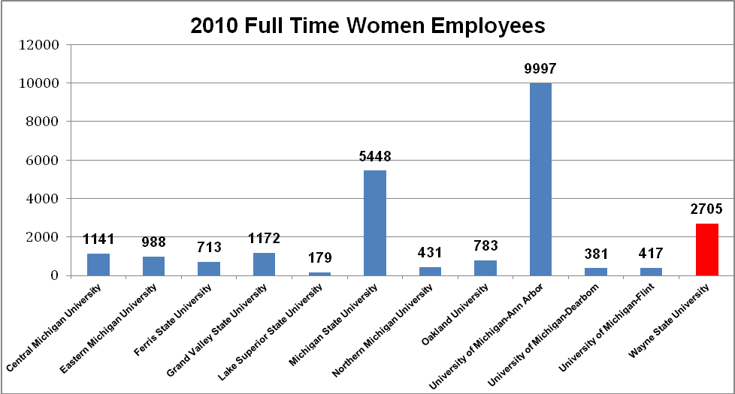

Comparative Analysis – Minority Employment

In 2010, Wayne State University employed 2150 minorities in Full Time positions. The total number of minorities employed in full time positions at Wayne State University is second only to the University of Michigan--Ann Arbor (3623). However, as a percentage of total employees, Wayne State University (41.41%) again ranks 1st among the public universities.

Michigan Public Universities
2010 Full Time Minority Employees
Institution Name | Total Full Time Employees | Total Full Time Minority Employees | Percentage of  Total Employees | Rank
Wayne State University | 5,192 | 2,150 | 41.41% | 1
University of Michigan-Dearborn | 721 | 194 | 26.91% | 2
University of Michigan-Flint | 695 | 142 | 20.43% | 3
Eastern Michigan University | 1,900 | 376 | 19.79% | 4
University of Michigan-Ann Arbor | 18,422 | 3,623 | 19.67% | 5
Oakland University | 1,416 | 277 | 19.56% | 6
Michigan State University | 10,305 | 1,680 | 16.30% | 7
Grand Valley State University | 2,186 | 310 | 14.18% | 8
Central Michigan University | 2,121 | 229 | 10.80% | 9
Lake Superior State University | 342 | 25 | 7.31% | 10
Ferris State University | 1,368 | 93 | 6.80% | 11
Northern Michigan University | 923 | 45 | 4.88% | 12

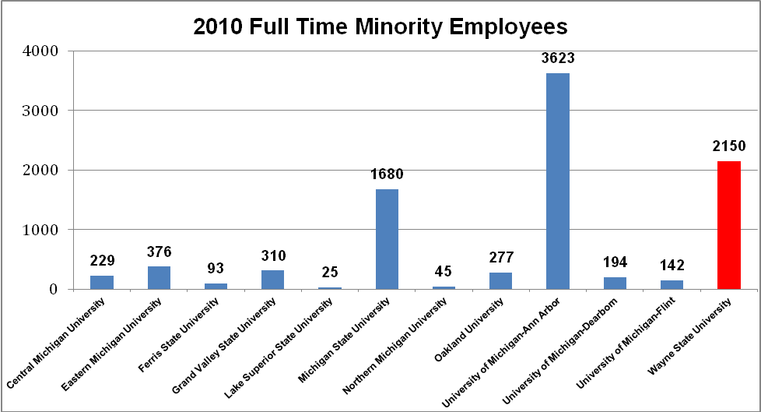

Comparative Analysis – Faculty Employment

Women Faculty

In 2010, Wayne State University employed 699 women in Full Time Faculty positions, a slight increase from 2009 (689). The total number of Full Time Women Faculty employees remains third behind the University of Michigan – Ann Arbor (2072) and Michigan State University (906), respectively. Wayne State University ranks 5th among the public universities in utilization of available women from its reasonable recruitment area/Metropolitan Statistical Area (MSA). As a percentage of total faculty employees, Wayne State University ranks 9th among the public universities with 38.49% of its full time faculty employees being women.

Michigan Public Universities
2010 Full Time Women Faculty
Institution Name | Total Full Time  Faculty Employees | Total Full Time Women Faculty | Percentage of  Total Faculty | Rank
University of Michigan-Flint | 270 | 137 | 50.74% | 1
Eastern Michigan University | 764 | 369 | 48.30% | 2
Grand Valley State University | 1,048 | 481 | 45.90% | 3
Lake Superior State University | 113 | 50 | 44.25% | 4
Oakland University | 524 | 230 | 43.89% | 5
Central Michigan University | 786 | 325 | 41.35% | 6
Ferris State University | 557 | 223 | 40.04% | 7
Northern Michigan University | 312 | 123 | 39.42% | 8
Wayne State University | 1,816 | 699 | 38.49% | 9
University of Michigan-Dearborn | 305 | 117 | 38.36% | 10
University of Michigan-Ann Arbor | 5,693 | 2,072 | 36.40% | 11
Michigan State University | 2,551 | 906 | 35.52% | 12

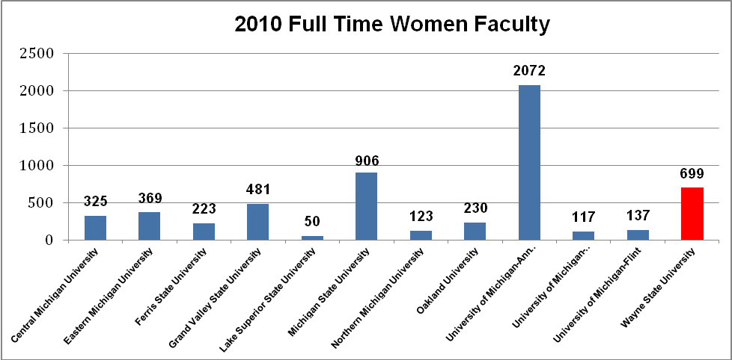
Minority Faculty

In 2010, Wayne State University employed 535 minorities in Full Time Faculty positions. The total number of minorities employed in Full Time Faculty positions is second behind the University of Michigan – Ann Arbor (1171). As a percentage of total full time faculty employees, Wayne State University (29.46%) ranks 2nd amongst the public universities.

Michigan Public Universities
2010 Full Time Minority Faculty
Institution Name | Total Full Time  Faculty Employees | Total Full Time Minority Faculty | Percentage of  Total Faculty | Rank
University of Michigan-Dearborn | 305 | 95 | 31.15% | 1
Wayne State University | 1,816 | 535 | 29.46% | 2
Oakland University | 524 | 109 | 20.80% | 3
University of Michigan-Ann Arbor | 5,693 | 1,171 | 20.57% | 4
Michigan State University | 2,551 | 482 | 18.89% | 5
University of Michigan-Flint | 270 | 50 | 18.52% | 6
Eastern Michigan University | 764 | 133 | 17.41% | 7
Central Michigan University | 786 | 127 | 16.16% | 8
Grand Valley State University | 1,048 | 152 | 14.50% | 9
Ferris State University | 557 | 54 | 9.69% | 10
Lake Superior State University | 113 | 8 | 7.08% | 11
Northern Michigan University | 312 | 18 | 5.77% | 12

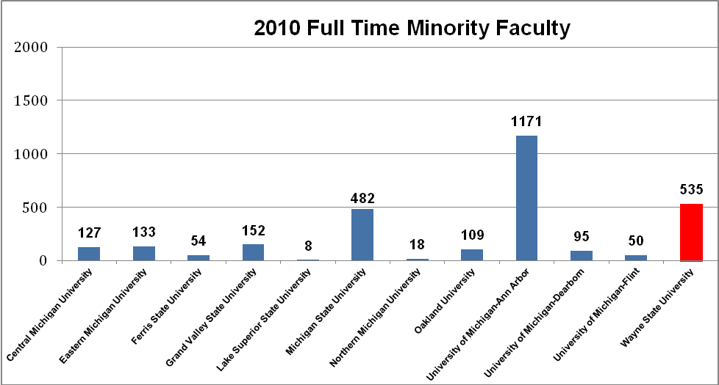

2) National Peer Institutions
Comparative Analysis – Women Employment
In 2010, Wayne State University employed 2,705 women in full time positions. Wayne State ranks 8th among its national peer institutions in percentage of total women employed with 52.10% of its employees being female.

National Peer Institutions
2010 Full Time Women Employees
Institution Name | Total Full Time Employees | Total Full Time Women | Percentage of  Total Employees | Rank
University of Illinois at Chicago | 9,766 | 6,130 | 62.77 | 1
University of Colorado Denver | 6,679 | 4,036 | 60.43 | 2
Indiana University-Purdue University-Indianapolis | 8,517 | 4,887 | 57.38 | 3
University of Alabama at Birmingham | 7,557 | 4,314 | 57.09 | 4
University of Louisville | 5,481 | 3,023 | 55.15 | 5
Michigan State University | 10,305 | 5,448 | 52.87 | 6
University of Pittsburgh-Pittsburgh Campus | 11,404 | 5,952 | 52.19 | 7
Wayne State University | 5,192 | 2,705 | 52.10 | 8
University of Houston | 4,637 | 2,411 | 51.99 | 9
University of Minnesota-Twin Cities | 14,650 | 7,568 | 51.66 | 10
University of Utah | 8,809 | 4,550 | 51.65 | 11
Temple University | 5,758 | 2,919 | 50.69 | 12
University of Cincinnati-Main Campus | 4,940 | 2,472 | 50.04 | 13
University at Buffalo | 4,112 | 1,892 | 46.01 | 14

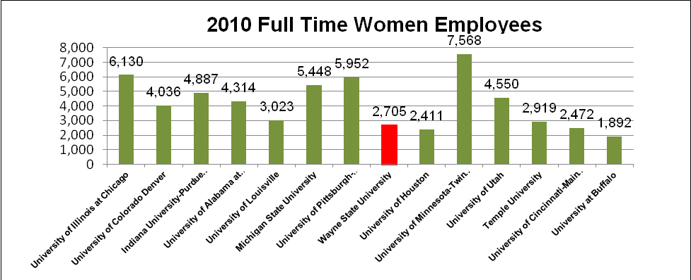
Comparative Analysis – Minority Employment

In 2010, Wayne State University employed 2,150 minorities in Full Time positions. Wayne State ranks 3rd among its national peer institutions in total minorities employed with 41.41% of its employee population being minority.

National Peer Institutions
2010 Full Time Minority Employees
Institution Name | Total Full Time Employees | Total Full Time Minority | Percentage of  Total Employees | Rank
University of Illinois at Chicago | 9,766 | 4,759 | 48.73 | 1
University of Houston | 4,637 | 2,148 | 46.32 | 2
Wayne State University | 5,192 | 2,150 | 41.41 | 3
Temple University | 5,758 | 2,150 | 37.34 | 4
University of Alabama at Birmingham | 7,557 | 2,539 | 33.60 | 5
Indiana University-Purdue University-Indianapolis | 8,517 | 2,201 | 25.84 | 6
University of Louisville | 5,481 | 1,151 | 21.00 | 7
University of Cincinnati-Main Campus | 4,940 | 886 | 17.94 | 8
University of Colorado Denver | 6,679 | 1,187 | 17.77 | 9
University of Pittsburgh-Pittsburgh Campus | 11,404 | 1,917 | 16.81 | 10
Michigan State University | 10,305 | 1,680 | 16.30 | 11
University of Minnesota-Twin Cities | 14,650 | 2,208 | 15.07 | 12
University at Buffalo | 4,112 | 612 | 14.88 | 13
University of Utah | 8,809 | 839 | 9.52 | 14

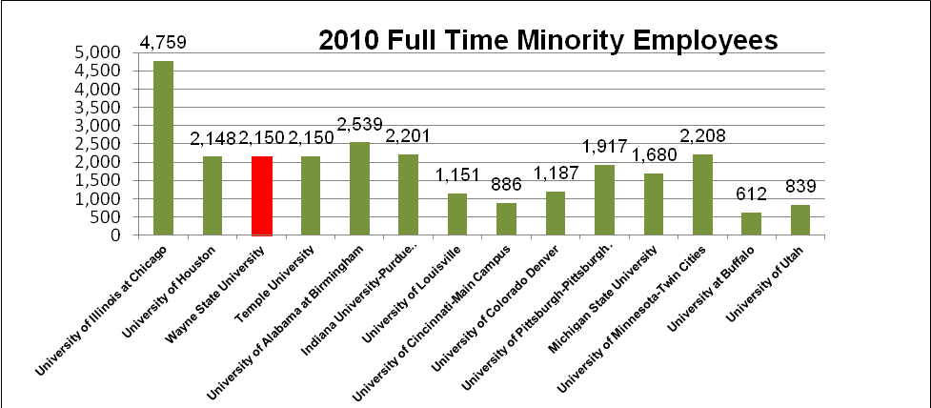

Comparative Analysis – Faculty Employment
Women Faculty
In 2010, Wayne State University employed 699 women in Full Time Faculty positions. Wayne State ranks 4th amongst its national peer institutions in total female faculty with 38.49% of its faculty being women.

National Peer Institutions
2010 Full Time Women Faculty
Institution Name | Total Full Time Employees | Total Full Time Women | Percentage of  Total Employees | Rank
University of Colorado Denver | 4,501 | 2,598 | 57.72% | 1
University of Illinois at Chicago | 1,918 | 798 | 41.61% | 2
Indiana University-Purdue University-Indianapolis | 2,651 | 1,067 | 40.25% | 3
Wayne State University | 1,816 | 699 | 38.49% | 4
University of Cincinnati-Main Campus | 2,010 | 771 | 38.36% | 5
University of Pittsburgh-Pittsburgh Campus | 4,844 | 1,857 | 38.34% | 6
University of Minnesota-Twin Cities | 4,097 | 1,547 | 37.76% | 7
University of Alabama at Birmingham | 2,044 | 771 | 37.72% | 8
University of Utah | 2,991 | 1,121 | 37.48% | 9
University of Louisville | 1,620 | 592 | 36.54% | 10
Temple University | 1,930 | 690 | 35.75% | 11
Michigan State University | 2,551 | 906 | 35.52% | 12
University of Houston | 1,309 | 460 | 35.14% | 13
University at Buffalo | 1,535 | 527 | 34.33% | 14

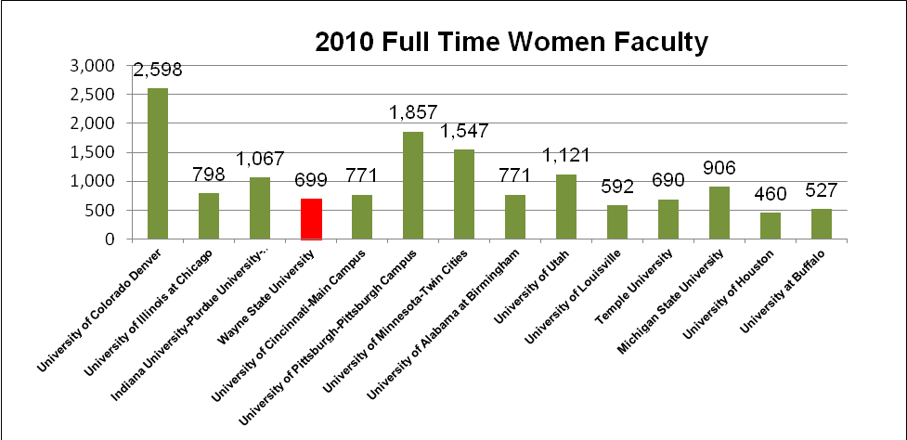

Minority Faculty
In 2010, Wayne State University employed 535 minorities in Full Time Faculty positions. In terms of minority faculty employment, Wayne State ranks second amongst its 14 national peer institutions in total minority faculty with 29.46% of its faculty being minority.

National Peer Institutions
2010 Full Time Minority Faculty
Institution Name | Total Full Time Employees | Total Full Time Minority | Percentage of  Total Employees | Rank
Indiana University-Purdue University-Indianapolis | 2,651 | 821 | 30.97% | 1
Wayne State University | 1,816 | 535 | 29.46% | 2
University of Illinois at Chicago | 1,918 | 518 | 27.01% | 3
University of Houston | 1,309 | 323 | 24.68% | 4
University of Alabama at Birmingham | 2,044 | 455 | 22.26% | 5
University of Louisville | 1,620 | 349 | 21.54% | 6
University at Buffalo | 1,535 | 315 | 20.52% | 7
University of Pittsburgh-Pittsburgh Campus | 4,844 | 927 | 19.14% | 8
Michigan State University | 2,551 | 482 | 18.89% | 9
Temple University | 1,930 | 348 | 18.03% | 10
University of Cincinnati-Main Campus | 2,010 | 353 | 17.56% | 11
University of Minnesota-Twin Cities | 4,097 | 638 | 15.57% | 12
University of Colorado Denver | 4,501 | 627 | 13.93% | 13
University of Utah | 2,991 | 301 | 10.06% | 14
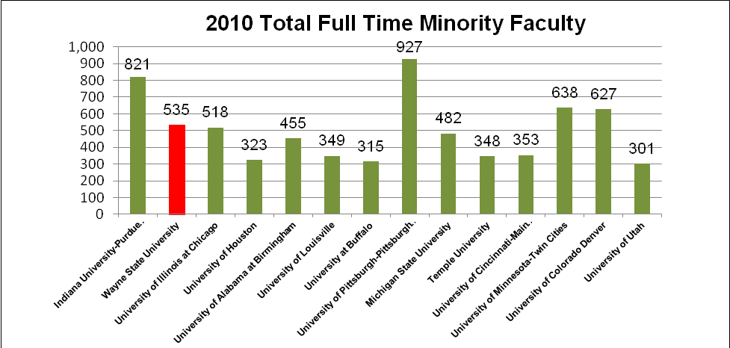

c. Analysis of Senior Leadership Positions (Executive/Administrative/Managerial Employees)

In this section, we provide a series of charts to present Wayne’s performance in a specific occupational category: Executive/Administrative/Managerial employees. As in the sections above, these charts include both a comparison of the Michigan Public Universities and the national peer institutions. The beginning charts present a comparison of women employees in total, along with a breakdown of women employees by race and ethnicity. The concluding charts present a comparison of minority employees in total, along with a breakdown of employees by racial/ethnic groups.

Michigan Public Universities – Women Employees
As of 12/31/10 (Table 12)

Michigan Public Universities
2010 Full Time Executive/Administrative/Managerial Women Employees
Institution Name | Total Full Time Executive/Administrative and Managerial Employees | Total Full Time Women Executive/  Administrative and Managerial Employees | Percentage of Total Executive/  Administrative and Managerial Employees | Rank
Lake Superior State University | 39 | 25 | 64.10% | 1
University of Michigan-Ann Arbor | 1,711 | 975 | 56.98% | 2
University of Michigan-Flint | 91 | 51 | 56.04% | 3
Grand Valley State University | 211 | 118 | 55.92% | 4
University of Michigan-Dearborn | 83 | 41 | 49.40% | 5
Michigan State University | 351 | 168 | 47.86% | 6
Central Michigan University | 125 | 58 | 46.40% | 7
Wayne State University | 246 | 112 | 45.53% | 8
Oakland University | 64 | 28 | 43.75% | 9
Ferris State University | 164 | 71 | 43.29% | 10
Eastern Michigan University | 156 | 67 | 42.95% | 11
Northern Michigan University | 64 | 24 | 37.50% | 12

Michigan Public Universities – Women Employees by Primary Ethnicity
As of 12/31/10 (Table 13)

Michigan Public Universities
2010 Full Time Executive/Administrative/Managerial Women Employees by Primary Ethnicity
Institution Name | American Indian or  Alaska Native | Asian/Native Hawaiian/  Other Pacific Islander | Black or African American/  Black  Non-Hispanic | Hispanic or  Latino/  Hispanic | Two or More Races | Total Minorities | Total Women
University of Michigan-Ann Arbor | 0 | 0 | 74 | 17 | 14 | 105 | 975
Wayne State University | 1 | 0 | 28 | 0 | 0 | 29 | 112
Grand Valley State University | 3 | 0 | 12 | 4 | 2 | 21 | 118
Michigan State University | 0 | 0 | 15 | 1 | 0 | 16 | 168
University of Michigan-Dearborn | 0 | 0 | 8 | 1 | 2 | 11 | 41
Central Michigan University | 2 | 0 | 3 | 2 | 0 | 7 | 58
Eastern Michigan University | 0 | 0 | 6 | 1 | 0 | 7 | 67
University of Michigan-Flint | 1 | 0 | 5 | 1 | 0 | 7 | 51
Oakland University | 0 | 0 | 4 | 0 | 0 | 4 | 28
Northern Michigan University | 2 | 0 | 0 | 0 | 0 | 2 | 24
Lake Superior State University | 1 | 0 | 0 | 0 | 0 | 1 | 25
Ferris State University | 0 | 0 | 0 | 0 | 0 | 0 | 71

Michigan Public Universities – Minority Employees
As of 12/31/10 (Table 14)

Michigan Public Universities
2010 Full Time Executive/Administrative/Managerial Minority Employees
Institution Name | Total Full Time Executive/ Administrative and Managerial Employees | Total Full Time Minority Executive/ Administrative and Managerial Employees | Percentage of Total Executive/ Administrative and Managerial Employees | Rank
Wayne State University | 246 | 60 | 24.39% | 1
University of Michigan-Flint | 91 | 19 | 20.88% | 2
University of Michigan-Dearborn | 83 | 16 | 19.28% | 3
Grand Valley State University | 211 | 38 | 18.01% | 4
Central Michigan University | 125 | 19 | 15.20% | 5
Eastern Michigan University | 156 | 22 | 14.10% | 6
University of Michigan-Ann Arbor | 1,711 | 234 | 13.68% | 7
Oakland University | 64 | 7 | 10.94% | 8
Michigan State University | 351 | 37 | 10.54% | 9
Northern Michigan University | 64 | 5 | 7.81% | 10
Ferris State University | 164 | 6 | 3.66% | 11
Lake Superior State University | 39 | 1 | 2.56% | 12

Michigan Public Universities – Minority Employees by Primary Ethnicity
As of 12/31/10 (Table 15)

Michigan Public Universities
2010 Full Time Executive/Administrative/Managerial Minority Employees by Primary Ethnicity
Institution Name | American Indian or  Alaska Native | Asian/ Native Hawaiian/Other Pacific Islander | Black or African American/Black  Non-Hispanic | Hispanic or Latino/ Hispanic | Two or More Races | Total Minorities
University of Michigan-Ann Arbor | 5 | 47 | 134 | 27 | 21 | 234
Wayne State University | 1 | 8 | 49 | 2 | 0 | 60
Grand Valley State University | 3 | 1 | 25 | 7 | 2 | 38
Michigan State University | 0 | 10 | 21 | 5 | 1 | 37
Eastern Michigan University | 0 | 4 | 15 | 3 | 0 | 22
Central Michigan University | 3 | 3 | 9 | 4 | 0 | 19
University of Michigan-Flint | 1 | 4 | 11 | 1 | 2 | 19
University of Michigan-Dearborn | 0 | 2 | 9 | 3 | 2 | 16
Oakland University | 0 | 3 | 4 | 0 | 0 | 7
Ferris State University | 0 | 0 | 6 | 0 | 0 | 6
Northern Michigan University | 2 | 2 | 0 | 1 | 0 | 5
Lake Superior State University | 1 | 0 | 0 | 0 | 0 | 1

National Peer Universities – Women Employees
As of 12/31/10 (Table 16)

National Peer Institutions
2010 Full Time Executive/Administrative/Managerial Women Employees
Institution Name | Total Full Time Executive/ Administrative and Managerial Employees | Total Full Time Women Executive/ Administrative and Managerial Employees | Percentage of Total Executive/ Administrative and Managerial Employees | Rank
University of Illinois at Chicago | 1,023 | 638 | 62.37% | 1
University of Colorado-Denver | 426 | 262 | 61.50% | 2
University of Cincinnati | 653 | 382 | 58.50% | 3
University of Minnesota-Twin Cities | 2,477 | 1,432 | 57.81% | 4
University of Pittsburgh | 561 | 302 | 53.83% | 5
Temple University | 927 | 493 | 53.18% | 6
University at Buffalo | 191 | 94 | 49.21% | 7
Michigan State University | 351 | 168 | 47.86% | 8
University of Houston | 157 | 75 | 47.77% | 9
Wayne State University | 246 | 112 | 45.53% | 10
University of Alabama at Birmingham | 227 | 99 | 43.61% | 11
University of Utah | 329 | 143 | 43.47% | 12
University of Louisville | 106 | 45 | 42.45% | 13
Indiana University-Purdue University-Indianapolis | 232 | 93 | 40.09% | 14

National Peer Universities – Women Employees by Primary Ethnicity
As of 12/31/10 (Table 17)

National Peer Institutions
2010 Full Time Executive/Administrative/Managerial Women Employees by Primary Ethnicity
Institution Name | American Indian or  Alaska Native | Asian/  Native Hawaiian/Other Pacific Islander | Black or African American/Black  Non-Hispanic | Hispanic or  Latino/  Hispanic | Two or More Races | Total Minorities | Total Women
University of Illinois at Chicago | 2 | 50 | 128 | 69 | 2 | 251 | 638
Temple University | 1 | 18 | 110 | 13 | 0 | 142 | 493
University of Minnesota-Twin Cities | 10 | 53 | 44 | 20 | 11 | 138 | 1432
University of Cincinnati | 0 | 6 | 55 | 3 | 1 | 65 | 382
University of Colorado-Denver | 2 | 13 | 5 | 20 | 0 | 40 | 262
Wayne State University | 1 | 0 | 28 | 0 | 0 | 29 | 112
University of Houston | 0 | 12 | 12 | 4 | 0 | 28 | 75
University of Pittsburgh | 0 | 6 | 14 | 2 | 3 | 25 | 302
Michigan State University | 0 | 6 | 15 | 1 | 0 | 22 | 168
Indiana University-Purdue University-Indianapolis | 0 | 4 | 9 | 1 | 1 | 15 | 93
University of Alabama at Birmingham | 0 | 0 | 13 | 1 | 1 | 15 | 99
University at Buffalo | 1 | 4 | 9 | 0 | 0 | 14 | 94
University of Utah | 0 | 6 | 5 | 2 | 0 | 13 | 143
University of Louisville | 0 | 0 | 3 | 0 | 2 | 5 | 45

National Peer Universities – Minority Employees
As of 12/31/10 (Table 18)

National Peer Institutions
2010 Full Time Executive/Administrative/Managerial Minority Employees
Institution Name | Total Full Time Executive/ Administrative and Managerial Employees | Total Full Time Minority Executive/ Administrative and Managerial Employees | Percentage of Total Executive/ Administrative and Managerial Employees | Rank
University of Illinois at Chicago | 1,023 | 360 | 35.19% | 1
University of Houston | 157 | 43 | 27.39% | 2
Temple University | 927 | 238 | 25.67% | 3
Wayne State University | 246 | 60 | 24.39% | 4
University of Cincinnati | 653 | 103 | 15.77% | 5
University of Colorado-Denver | 426 | 61 | 14.32% | 6
Indiana University-Purdue University-Indianapolis | 232 | 32 | 13.79% | 7
University of Alabama at Birmingham | 227 | 30 | 13.22% | 8
University at Buffalo | 191 | 24 | 12.57% | 9
University of Louisville | 106 | 13 | 12.26% | 10
University of Minnesota-Twin Cities | 2,477 | 297 | 11.99% | 11
Michigan State University | 351 | 37 | 10.54% | 12
University of Pittsburgh | 561 | 45 | 8.02% | 13
University of Utah | 329 | 20 | 6.08% | 14

National Peer Universities – Minority Employees by Primary Ethnicity
As of 12/31/10 (Table 19)

National Peer Institutions
2010 Full Time Executive/Administrative/Managerial Minority Employees by Primary Ethnicity
Institution Name | American Indian or  Alaska Native | Asian/ Native Hawaiian/Other Pacific Islander | Black or African American/Black  Non-Hispanic | Hispanic or Latino/ Hispanic | Two or More Races | Total Minorities
University of Illinois at Chicago | 2 | 64 | 183 | 107 | 4 | 360
University of Minnesota-Twin Cities | 14 | 136 | 92 | 38 | 17 | 297
Temple University | 4 | 41 | 170 | 23 | 0 | 238
University of Cincinnati | 1 | 12 | 81 | 6 | 3 | 103
University of Colorado-Denver | 2 | 18 | 11 | 30 | 0 | 61
Wayne State University | 1 | 8 | 49 | 2 | 0 | 60
University of Pittsburgh | 0 | 11 | 29 | 2 | 3 | 45
University of Houston | 0 | 15 | 18 | 10 | 0 | 43
Michigan State University | 0 | 10 | 21 | 5 | 1 | 37
Indiana University-Purdue University-Indianapolis | 0 | 12 | 17 | 1 | 2 | 32
University of Alabama at Birmingham | 0 | 0 | 26 | 2 | 2 | 30
University at Buffalo | 1 | 6 | 15 | 2 | 0 | 24
University of Utah | 1 | 7 | 6 | 5 | 1 | 20
University of Louisville | 0 | 1 | 9 | 0 | 3 | 13

II. UNIVERSITY COMPLAINTS OF DISCRIMINATION AND HARASSMENT

The Office of Equal Opportunity (“OEO”) is responsible for investigating complaints arising under the University’s Non-Discrimination Policy and Sexual Harassment Statute. When contacted by a potential Complainant, the OEO first assesses whether the allegations fall within the scope of the Non-Discrimination or Sexual Harassment policies. If not, the OEO will refer the Complainant to the proper forum to address the issue, such as Human Resources, Labor Relations, the Ombudsperson or the Dean of Students Office. If the allegations fall within OEO’s jurisdiction, the OEO conducts an initial inquiry into the complaint. Initial inquires are used to determine if there is sufficient factual support for the allegations to warrant a full investigation. In some cases, the initial inquiry itself resolves the matter.
If the initial inquiry has merit and OEO determines that the allegations, if substantiated, would be reasonably likely to result in the need for the University to take prompt remedial measures, a formal complaint is initiated. Formal complaints are adjudicated by using the formal procedures expressed in University Policy 2005-03.

The OEO also serves as the university point of contact in the response to complaints of discrimination and harassment brought to external agencies, such as the Michigan Department of Civil Rights (“MDCR”), the United States Equal Employment Opportunity Commission (“EEOC”), the United States Department of Education, Office of Civil Rights (“OCR”), and the Department of Labor, Office of Federal Contract Compliance Programs (“OFCCP”). For purposes of this report, such charges are included as “formal complaints.”

During the 2010 calendar year, the OEO received 19 initial inquiries, 4 of which became formal complaints. An additional 18 complaints were filed externally with governmental agencies, for a total of 22 formal complaints.

Comparison of Inquiries vs. Formal Complaints
For calendar year 2010 – Chart 9

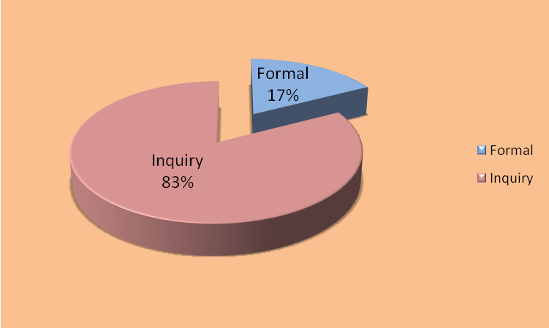

7 of the total 22 formal complaints filed in 2010 were closed without a finding of a University policy or statutory violation. There was a finding of “cause to believe a discriminatory act occurred” in one external complaint. This case is still pending disposition by the governmental agency where it was filed. There were no findings of violations of University policy in the internal complaints filed with the OEO.

Three-Year Initial Inquiries and Formal Complaint Activity Comparison
For calendar Year 2010 - Chart 10

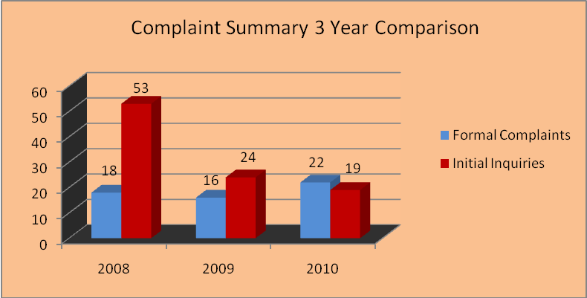

The 2010 data represents a 21% decrease from 24 inquiries in 2009. While the number of inquiries decreased, the number of formal complaints increased from 16 to 22 in 2010, which reflects a 27% rise in the number of formal complaints with outside government agencies.

Complaints are categorized by the primary type of discrimination claim made by the Complainant, e.g., race discrimination, sexual harassment, or age discrimination. 8 of the 22 total formal complaints received in the year 2010 involved claims of race discrimination, 4 were for sexual harassment, and 6 were discrimination based on disability. In addition, there were 2 retaliation complaints and 2 age discrimination complaints filed in 2010. In 2009, the top three claims were race discrimination (8), sexual harassment (5), and disability (2).

Complaints are categorized by the primary nature of the complaint, even if multiple claims of discrimination are also included. For example, a complaint of race discrimination and retaliation is simply categorized as a race discrimination complaint for purposes of Chart 11, below. In 2010, 8 of the 22 formal complaints also included multiple claims.

Total Complaint Activity by Type of Claim
For calendar year 2010 – Chart 11

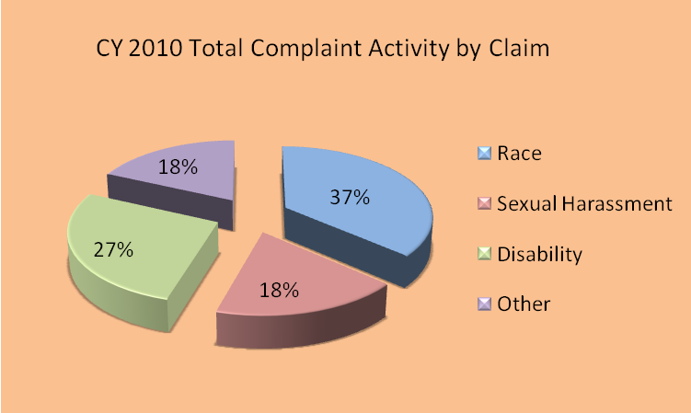

The OEO also categorizes complaints by the federal statute that includes each protected classification. In 2010, there was an increase in disability claims being filed. In 2010, 73% of the complaints involved classifications protected by Title VII and 27% by the Americans with Disabilities Act (“ADA”). This increase in disability claims stands in contrast to the claims filed in 2009, where 87% of the claims potentially fell under Title VII of the Civil Rights Act of 1991, and none fell under the Age Discrimination in Employment Act (“ADEA”).

Total Complaint Activity by Federal Statute
For calendar year 2010 – Chart 12

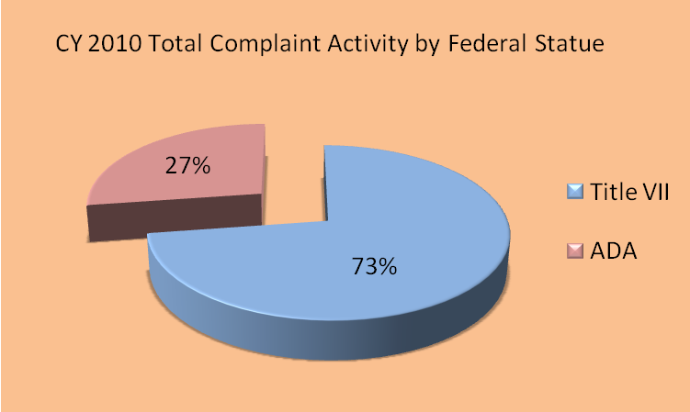

Since the majority of OEO's complaint activity falls under Title VII, the chart below also depicts how the complaints are distributed in the classifications protected by Title VII.
Breakdown of Complaints under Title VII
For calendar year 2010 – Chart 13

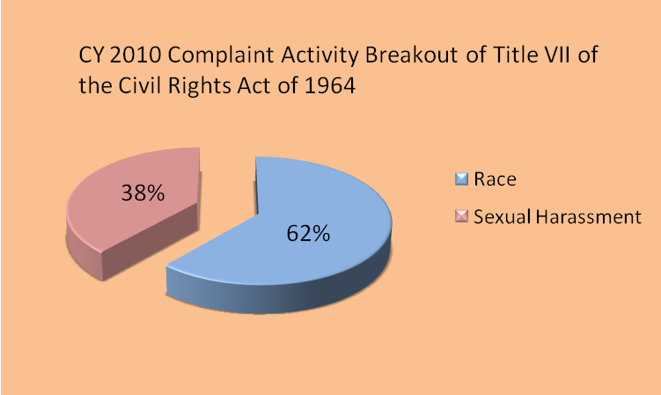

The OEO is proactive in matters of discrimination and harassment by working closely with Human Resources and Labor Relations. The OEO collaborates with these offices to design and implement employee education programs on a University-wide basis. Specific training about sexual harassment which emphasizes the duty of care owed by managers and supervisors and their role in taking proactive and preventative measures to ensure a workplace free from harassment and discrimination is offered regularly. OEO also continues to provide customized training to departments and units upon request and as a remedial measure following a complaint.

III. WAYNE STATE UNIVERSITY SUPPLIER DIVERSITY PROGRAM

Through the Supplier Diversity Program, Wayne State University actively reaches out to minority, woman-owned, and physically challenged business enterprises (M/W/PCBE). The program provides outreach, mentoring, and networking opportunities, and in many cases has led to successful business relationships. We have undertaken a number of initiatives to build upon the program successes and to encourage greater participation of the minority, woman-owned and the physically challenged enterprises. These initiatives are described at the end of this section. Overall expenditures increased by 9.8%. Construction/renovation expenditures increased by fourfold from the previous year primarily due to the A. Paul Schapp Chemistry Building expansion and renovation and the construction of the Judge Damon Keith Center for Civil Rights. General purchases for goods and services decreased by 26.3%.

A. Construction and Professional Service Contracts Related to Construction

Total dollars awarded for all construction and professional service contracts (primary and subcontracts) amounted to $61.3 Million in FY 2009-10 compared to $12.9 million in FY 2008-9. In FY 2009-10, $526,000 was awarded to minority-owned construction businesses, compared to $234,000 in FY 2008-9. Women-owned construction firms captured $587,000 in FY 2009-10, compared to $748,000 in FY 2008-9.

Comparison of Total Construction Contract Awards
(Charts 14 and 15)

Total Awards of $12,900,000
Total Awards of $61,300,000

B. General Purchasing (Goods and Services excluding construction)

Funds expended for general purchases of goods and services decreased to $96.2 million in FY2009-10 from $130.6 million in FY2008-9. In FY 2009-10, $5.3 million was awarded to minority-owned businesses, compared to $4.5 million in FY 2008-9. Women-owned firms captured $6.5 million in FY 2009-10, compared to $7.1 million in FY 2008-9.

Comparison of Total General Purchasing Awards
(Charts 16 and 17)
Total Awards of $130,600,000
Total Awards of $96,200,000

C. Outside Counsel Fees

In fiscal year 2010, Wayne State University made direct payments in outside counsel fees in the gross amount of $1,343,365. A breakdown reflects $897,557 supported patent licenses and technology transfer and $445,808 was for all other legal matters. Wayne also authorized payments to outside counsel through the Michigan University Self-Insurance Corporation (MUSIC) in the amount of $91,514. The Office of General Counsel received departmental reimbursements of $192,862 for matters pertaining to immigration residencies. WSU received $129,200 in reimbursements for legal fees arising from licenses but was not applied to the outside legal fees account until FY 2011. With these reimbursements, the net direct payments would be $1,021,303.

Direct payments in the amount of $176,337 and MUSIC payments in the amount of $20,058 were made to women and minority-owned law firms. In actual dollars, women-owned firms were paid $110,832 and minority-owned firms were paid $85,564.

Minority Firms

Phifer & White handle nearly all of Wayne’s personal injury work not done within the Office of General Counsel, our landlord-tenant matters, and much of our worker’s compensation cases. The firm of Albert Nelson, Jr. also handles worker’s compensation cases. Lewis & Munday represent Wayne in litigation and complex real property transactions. The firm of Allen Brothers also represents Wayne in litigation.

Women-owned Firms

Afaf Vicky Farah, a solo practitioner, does the majority of the university’s immigration work. Two firms, Rohm & Monsanto and Jane Potter Law represent the university in patent matters. Nemeth Burwell represented the university in litigation. Wayne retained female equity partners in the law firm of Kienbaum, Opperwall, Hardy & Pelton to provide representation in litigation.

D. INVESTMENTS, DEBT, and RISK UNIT

External Investment Management Firms

Of the fifteen external investment management firms contracted to manage University endowment funds, one is minority-owned. The endowment funds invested by the minority-owned firm in FY 2008-09 had a year-end value of $28.1 million, or 12.6 % of the total. In FY 2009-10, the minority-owned firm invested $30.3 million, or 12.7 % of the total. The value of the funds invested with the minority-owned firm increased by 8 %.

Banking Relationships

First Independence Bank, a minority-owned bank, was used to process University Federal tax payments and the self insured health care plan vendor payments for the DMC-Preferred Provider Organization (PPO).

Debt Issues

Loop Capital Markets LLC and Siebert Brandford Shank & Co., LLC, minority-owned firms, served as bond underwriter co-managers on the $112.4 million Series 2009A (tax-exempt) bond issue in October 2009 (FY2009-10). Siebert Brandford Shank & Co., LLC, served as a bond underwriter co-manager on the $30.9 million, Series 2009B (tax-exempt) bond issue in December 2009 (FY2009-10).

E. Other Supplier Diversity Program Initiatives

Michigan Minority Business Development Council (MMBDC)

The MMBDC recognizes Wayne as a statewide leader for actively seeking out and extending business opportunities to the minority and women-owned business enterprise community. Wayne State University has received the coveted MMBDC Corporation of the Year – Education Sector Award nine times and is the leader of all educational institutions in earning this statewide recognition. One of the key components to the consideration for the Award is the WSU/Pepsi Project ONE Team. This team was formed more than eight years ago and is the most engaged of all the 19 Project ONE Teams sponsored by the MMBDC.

22nd Annual Minority Conference on Purchasing

On October 8, 2010, Wayne welcomed more than 190 minority-owned enterprises to this annual event. It brought together representatives from across the campus to meet with minority business owners offering a wide variety of goods and services such as construction, snow removal, consulting, and technical support. Representatives from the Computing and Information Technology, Facilities Planning and Management, Marketing, Housing and Purchasing units engaged in networking, information gathering and business-to-business referrals for the minority business owners in attendance. In addition to University representatives, other dialogue hosts included the Detroit Medical Center, the Michigan State-wide Minority Business Development Center, St. John Health System, and the Michigan Minority Business Development Council.

Council of Supplier Diversity Professionals (CSDP)

Wayne is a member of the Council of Supplier Diversity Professionals, an organization established in 1988 that is devoted to sharing information, ideas, and issues relative to supplier diversity and to the growth and development of minority and women-owned businesses. Membership in this Council gives us access to directories, seminars, webinars and workshops that expand and enhance our relationships with minority owned business enterprises.

NAWBO and CEED

Wayne’s memberships in the National Association of Women Business Owners (NAWBO) and the Center for Empowerment and Economic Development (CEED) provide access to the strongest and most active women business owners networking groups. Through their training and certification programs, we connect with the most viable female owned companies.

Wayne actively participates in Corporate Connect and Round Table events throughout the year to meet women business owners and share information on how to do business with the University. These memberships have reaped a tremendous return on our investments. Our expenditures with women owned companies have greatly increased.

Small Business Workshops

The University has a strong presence in the small business community. Our goal is to educate small business owners on our policies and procedures in order to work more effectively with the University. In addition to hosting the Michigan Statewide Minority Business Development Center at a WSU sponsored event (the October Minority Conference), Wayne is actively engaged in a wide variety of conferences and workshops sponsored by the State of Michigan, the City of Detroit, Targeted Business Sector, the Detroit Regional Chamber, the Oakland Regional Chamber and the National Conference for Community and Justice (NCCJ).

IV. HIGHLIGHTS OF OFFICE OF EQUAL OPPORTUNITY ACTIVITIES

The Office of Equal Opportunity is led by a Director and staffed by two Equal Opportunity Specialists. The professional staff is supported by an Administrative Assistant and a student assistant. In 2010, the OEO had no staff changes.

During 2010, OEO staff participated in local organizations, including the Michigan Diversity Leadership Council, and national conferences. Outreach efforts continued to promote a diverse environment. OEO continued to provide Faculty Search Committee Training to Colleges and Schools upon request. This training is designed to assist the Search Committees in preparing to search for qualified faculty from a diverse pool. This training also explains the use of the On-line Hiring System in implementing an automated system to execute the hiring of academic staff and the updated technology for the Applicant/Hire process, as well as the OEO Faculty Hiring Plan forms, which require each division to evaluate their full-time faculty data and national availability statistics to demonstrate our efforts to seek diversity in our academic staff.

Training initiatives were continued throughout 2010. The OEO continued to provide training sessions on Sexual Harassment Prevention to both management-level personnel and other staff, in addition to Diversity Training through the Organization and Employee Development Office.

The OEO continues to serve as the ADA Title I Coordinator for Wayne. In this role, the OEO evaluates disability accommodation requests from employees, and serves as a resource regarding issues of accessibility on campus. The OEO Director also serves on the ADA Advisory Committee to address issues of accessibility at Wayne.

Proposal 2

The “Michigan Civil Rights Initiative”, commonly known as “Proposal 2”, was a ballot initiative that became Michigan law on December 22, 2006. The ballot proposal amended the Michigan Constitution to become Article I, Section 26 to bar the use of “preferences” based on race, sex, color, ethnicity or national origin in public employment, contracting, or education. Wayne, Michigan, and Michigan State did not challenge the amendment itself, but asked the court for more time for implementation, which was unsuccessful.

Following the adoption of Proposal 2 in 2006, Wayne, like other universities, conducted extensive reviews of our admissions, financial aid, gift, and contracting policies to ensure compliance with the law. Proposal 2 does not prohibit Federal contractors from “action that must be taken to establish or maintain eligibility.” As a federal contractor, Wayne must comply with the affirmative action efforts in hiring set forth in Executive Order 11246. It is worth noting that as used in Executive Order 11246; “affirmative action” is a term of art akin to “equal opportunity” and does not have the scope traditionally attached to the term.

In 2010, it appears to be safe to say that Proposal 2 has had an impact on construction contracts. It is worth noting that as Wayne was required to discontinue the use of preferences in its public contracting, there has been a decline in the monies awarded to minority suppliers. This decline was first noted in 2009 and continued in 2010. While we need to continue to measure various indicators to assess the impact of Proposal 2 on Wayne, it seems that Proposal 2 has had an impact on the supplier diversity at Wayne.
APPENDICES

- Definition of EEO Job Categories

- Executive, Administrative and Managerial
Persons whose assignments require primary and major responsibility for management of the institution, or a customarily recognized department or subdivision. Assignments require the performance of work directly related to management policies or general business operations of the institution department or subdivision, etc. Reported in this category are employees holding such positions as president, vice president, dean, director or the equivalent, as well as management employees such as associate and assistant deans, division and academic department heads (chairs), or the equivalent if their principal responsibilities are administrative in nature.

- Faculty (Instruction / Research / Public Service)
Persons whose principal responsibilities customarily are for the purpose of instruction, research or public service and who hold academic-rank titles of professor, associate professor, assistant professor, instructor, lecturer or the equivalent Reported in this category are deans, directors or the equivalent, as well as associate deans, assistant deans and executive officers of academic departments (chairs, heads, or the equivalent). This definition does not include student teaching or research assistants or medical interns or residents.

- Other Professionals (Support / Service)
Persons employed for the primary purpose of performing academic support, student service and institutional support activities, and whose assignments would require either college graduation or experience that would provide a comparable background. Includes positions such as librarians, accountants, personnel professionals, counselors, systems analysts, coaches and assistant general counsel.

- Clerical / Secretarial
Includes administrative support occupations, including all clerical-type work regardless of level of difficulty, where the activities are predominately non-manual, though some manual work not directly involved with altering or transporting the products is included.

- Technical / Paraprofessional
Persons whose assignments require special knowledge or skills that may be acquired through experience or academic work as offered in many two-year technical institutions and junior colleges, or through equivalent on-the-job training. Includes computer programmers and operators, drafters, engineering aides, junior engineers, mathematical aides, licensed practical or vocational nurses, dietitians, photographers, radio operators, scientific assistants, technical illustrators, technicians (medical, dental, electronic, physical sciences), and similar occupational-activity categories that are institutionally defined as technical assignments.

- Skilled Trades / Crafts
Persons whose assignments typically require special manual skills, and a thorough and comprehensive knowledge of the processes involved in the work, as acquired through on-the-job training and experience, or through apprenticeship or other formal training programs. Includes mechanical operators and repairers, electricians, stationary engineers, skilled machinists, carpenters, compositors and typesetters, and upholsterers.

- Service / Maintenance
Persons whose assignments require limited degrees of previously acquired skills and knowledge. Persons who perform duties that result in or contribute to the comfort, convenience and hygiene of personnel and students, or that contribute to the upkeep and care of buildings, facilities or grounds of the institution. Includes chauffeurs, laundry and dry-cleaning operators, cafeteria and restaurant workers, truck drivers, bus drivers, garage laborers, custodial personnel, gardeners and groundskeepers, refuse collectors, construction laborers and security personnel.

II. Responsibility for Affirmative Action

Wayne State University’s President has overall responsibility for implementation of the Wayne State University Affirmative Action/Equal Opportunity Program. Wayne has assigned primary management responsibility and accountability for ensuring full compliance with the program to the Office of Equal Opportunity, which reports to the Vice President and General Counsel. The Director of Equal Opportunity has the authority and resources, as well as the support of and access to the executive management, to ensure effective implementation of the Affirmative Action Program. The President actively supports the program and provides assistance whenever needed, making managers and supervisors aware of the program and requesting their cooperation and assistance.

Office of Equal Opportunity is responsible for the following:

- Developing policy statements, Affirmative Action Plan programs, methods, and internal and external communication techniques. Policies and procedures will continue to be developed to ensure an efficient and positive interaction between the Office of Equal Opportunity and managers charged with hiring staff.

- Assisting management and supervisors in devising solutions to equal employment problems, including counseling and training, to ensure full understanding of affirmative action and equal employment opportunity (“EEO”) policies and procedures.

- Designing and implementing monitoring and reporting methods to measure the effectiveness of Wayne’s program; to indicate need for remedial action; and to determine the degree to which Wayne’s goals and objectives are being met.

- Providing management a working understanding of the goals and objectives in Wayne's Affirmative Action Plan.
- Meeting with managers, supervisors, and employees to assure that Wayne's EEO policies are being followed.

- Acting as a liaison between Wayne and enforcement agencies.

- Acting as a liaison between Wayne and appropriate minority and women's organizations and community action groups concerned with employment opportunities for minorities and women.
13
- Supporting contact between Wayne and predominately female and minority high schools, colleges, and technical schools in the area as needed.

- Keeping management informed of developments in the EEO and affirmative action field.

- Conducting a periodic audit to ensure that Wayne complies in the following ways:

- Making sure EEO posters are properly displayed.

- Making sure that all University employees have the opportunity and are encouraged to participate in University-sponsored educational, training, recreational and social activities.

III. Definition of Terms

Black: A person having origins in any of the black racial groups of Africa, but not Hispanic.

Asian or Pacific Islander: A person having origins in any of the original people of the Far East, Southeast Asia, the Indian subcontinent or the Pacific Islands.

Hispanic: A person of Mexican, Puerto Rican, Cuban, Central or South American, or other Spanish culture or origin, regardless of race.

Native American or Alaskan Native: A person having origins in any of the original peoples of North America, and who maintains cultural identification through tribal affiliation or community recognition.

Caucasian or White: A person who is not included in any of the four ethnic identifications listed above.

Disability: Defined by both state and federal law. Generally, refers to a person who has a physical or mental impairment that substantially limits one or more major life activities, or has a record of such impairment, or is regarded as having such impairment.

Americans with Disabilities Act:
In the first instance, disability status is self-identified by faculty, staff and students.

IV. Academic Classifications

Professor: Includes full professor, distinguished professor, visiting professor, university professor, and professor (clinical), professor (research).

Associate Professor: Includes visiting associate professor, associate professor (clinical), associate professor (research).
Assistant Professor: Includes visiting assistant professor, assistant professor (clinical), assistant professor (research).

V. Other Employee Definitions

Full-time Employee: Academic staff and non-academic employees whose assignments add up to a full-time equivalency (“FTE”) of 1.0.

Full-time Faculty: Faculty whose assignments are tenure or non-tenure system with a FTE of .50 or above.

Tenure-System Faculty: Faculty appointed to the tenure-system or granted tenure by Board of Governors Statute. Faculty in the tenure-system may hold an academic rank of Professor, Associate Professor and Assistant Professor.

Fractional-time Employee: Academic and non-academic employees whose assignments add up to a FTE of 0.50 to 0.99.

Casual or Part-time Employee: Academic and non-academic employees whose assignments add up to 0.49 or less assignments add up to 0.49 or less.

VI. 2009 Data Tables

2009 Total Full Time Academic and Non Academic Employee Headcount
As of 12/31/09 - Table 19

Category | 2009 Total | Black | Asian / Pacific Islander | Hispanic | Native American | Total Minorities | Women
Faculty | 1,810 | 128 | 364 | 43 | 3 | 538 | 689
Faculty |  | 7.07% | 20.11% | 2.38% | 0.17% | 29.72% | 38.07%
Executive / Administrative / Managerial | 240 | 44 | 7 | 2 | 0 | 53 | 103
Executive / Administrative / Managerial |  | 18.33% | 2.92% | 0.83% | 0.00% | 22.08% | 42.92%
Other Professionals | 2,106 | 495 | 373 | 44 | 4 | 916 | 1,267
Other Professionals |  | 23.50% | 17.71% | 2.09% | 0.19% | 43.49% | 60.16%
Technical / Paraprofessional | 72 | 12 | 0 | 0 | 0 | 12 | 31
Technical / Paraprofessional |  | 16.67% | 0.00% | 0.00% | 0.00% | 16.67% | 43.06%
Clerical / Secretarial | 524 | 337 | 6 | 10 | 3 | 356 | 460
Clerical / Secretarial |  | 64.31% | 1.15% | 1.91% | 0.57% | 67.94% | 87.79%
Skilled Crafts | 111 | 31 | 2 | 0 | 0 | 33 | 5
Skilled Crafts |  | 27.93% | 1.80% | 0.00% | 0.00% | 29.73% | 4.50%
Service / Maintenance | 292 | 225 | 3 | 7 | 2 | 237 | 110
Service / Maintenance |  | 77.05% | 1.03% | 2.40% | 0.68% | 81.16% | 37.67%
Total | 5,155 | 1,272 | 755 | 106 | 12 | 2,145 | 2,665
Total |  | 24.68% | 14.65% | 2.06% | 0.23% | 41.61% | 51.70%
2009 Full Time Faculty - Tenure and Non-Tenure System
Rank | 2009 Faculty Total | Black | Asian / Pacific Islander | Hispanic | Native American | Total Minority | Women
Tenure System | 1,044 | 57 | 208 | 31 | 2 | 298 | 315
Tenure System |  | 5.5% | 19.9% | 3.0% | 0.2% | 28.5% | 30.2%
Non-Tenure System | 766 | 71 | 156 | 12 | 1 | 240 | 374
Non-Tenure System |  | 9.3% | 20.4% | 1.6% | 0.1% | 31.3% | 48.8%
Total | 1,810 | 128 | 364 | 43 | 3 | 538 | 689
Total |  | 7.1% | 20.1% | 2.4% | 0.2% | 29.7% | 38.1%
As of 12/31/09 - Table 20
Rank | 2009 Faculty Total | Black | Asian / Pacific Islander | Hispanic | Native American | Total Minority | Women
Professor | 459 | 13 | 89 | 9 | 0 | 111 | 87
Professor |  | 2.8% | 19.4% | 2.0% | 0.0% | 24.2% | 19.0%
Associate  Professor | 336 | 18 | 58 | 10 | 1 | 87 | 122
Associate  Professor |  | 5.4% | 17.3% | 3.0% | 0.3% | 26% | 36.3%
Assistant  Professor | 249 | 26 | 61 | 12 | 1 | 100 | 106
Assistant  Professor |  | 10.4% | 24.5% | 4.8% | 0.4% | 40.2% | 42.6%
Total | 1,044 | 57 | 208 | 31 | 2 | 298 | 315
Total |  | 5.5% | 19.9% | 3.0% | 0.2% | 28.5% | 30.2%
2009 Total Tenure System Faculty by Rank
As of 12/31/09- Table 21

VII. Five Year Comparison Graphs – 2005-2009

Total Employee Headcount by EEO Category –
Academic and Non-Academic Full Time

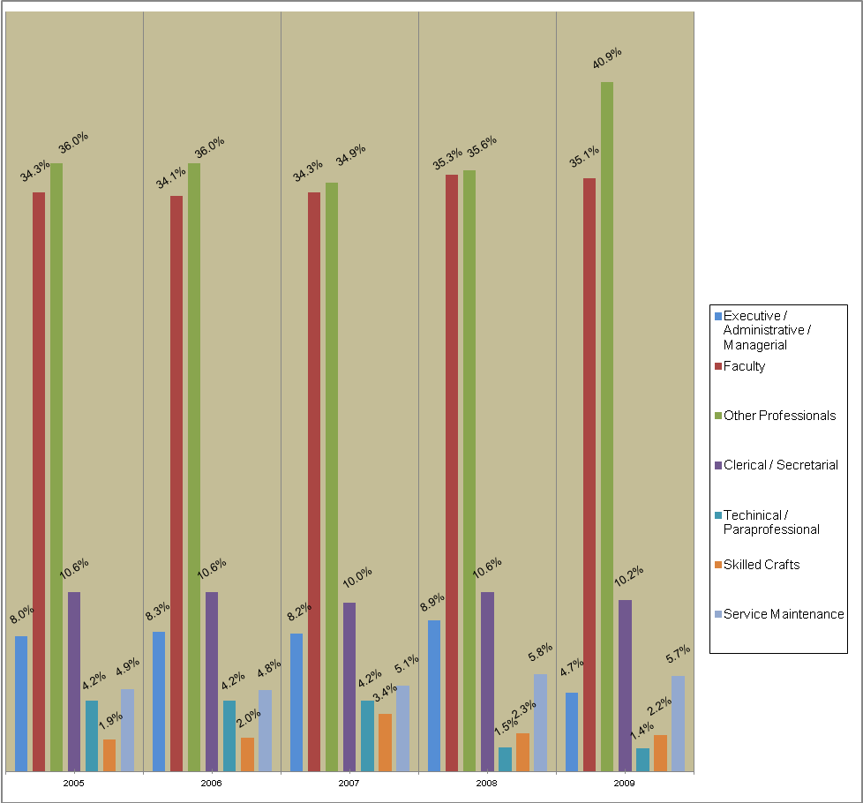

Black Full Time Employee Headcount by EEO Category –
Academic and Non-Academic Full Time
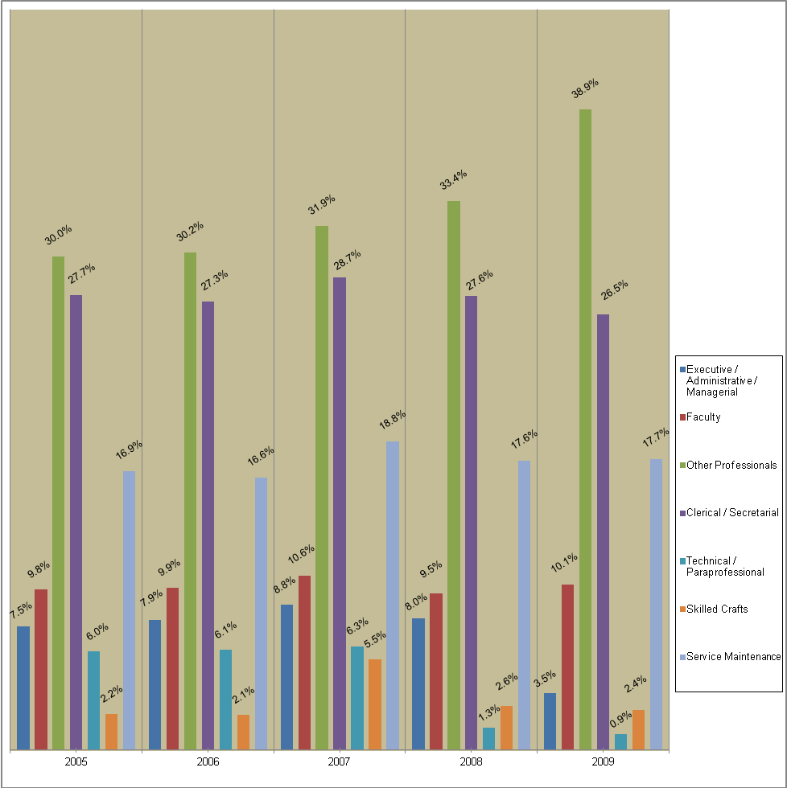

Asian Full Time Employee Headcount by EEO Category –
Academic and Non-Academic Full Time

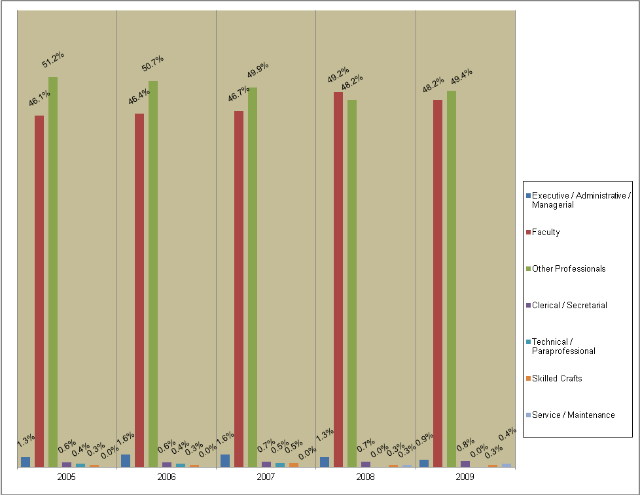

Hispanic Full Time Employee Headcount by EEO Category –
Academic and Non-Academic Full Time

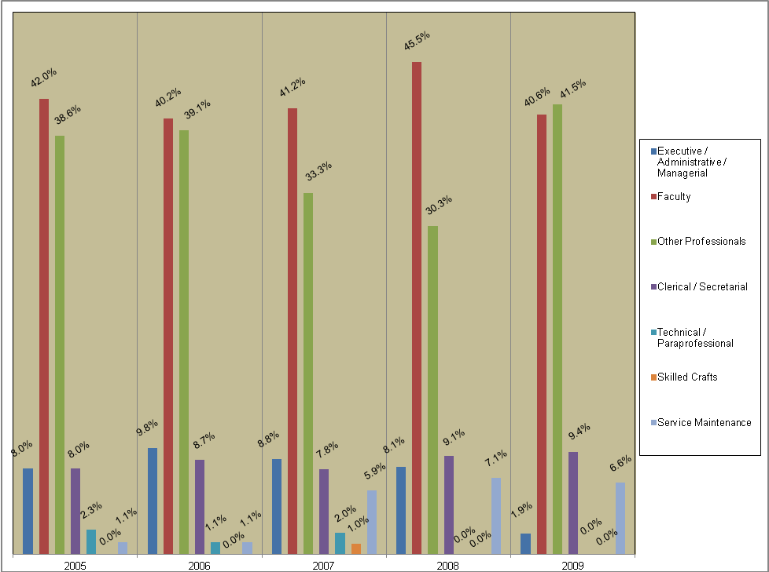

Native American Full Time Employee Headcount by EEO Category –
Academic and Non-Academic Full Time

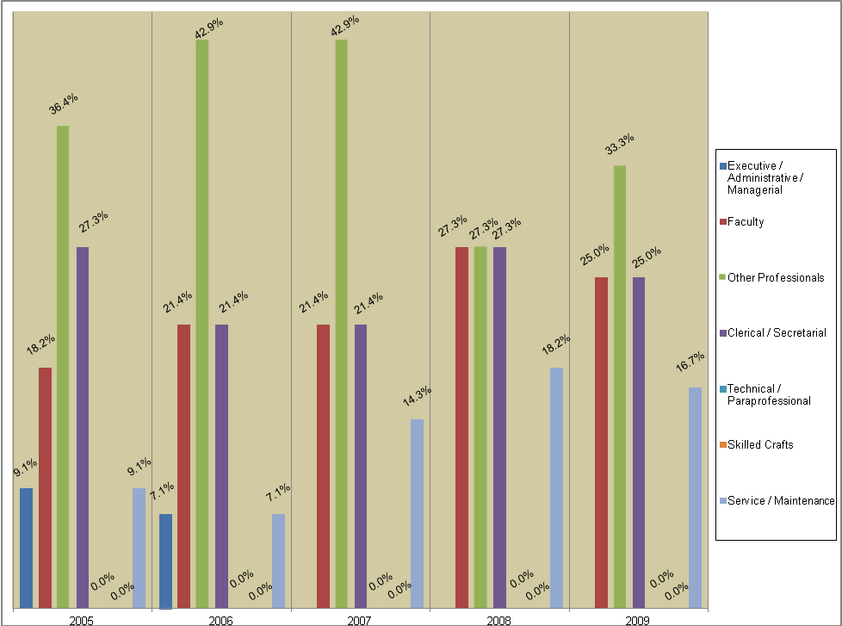

Women Full Time Employee Headcount by EEO Category –
Academic and Non-Academic Full Time

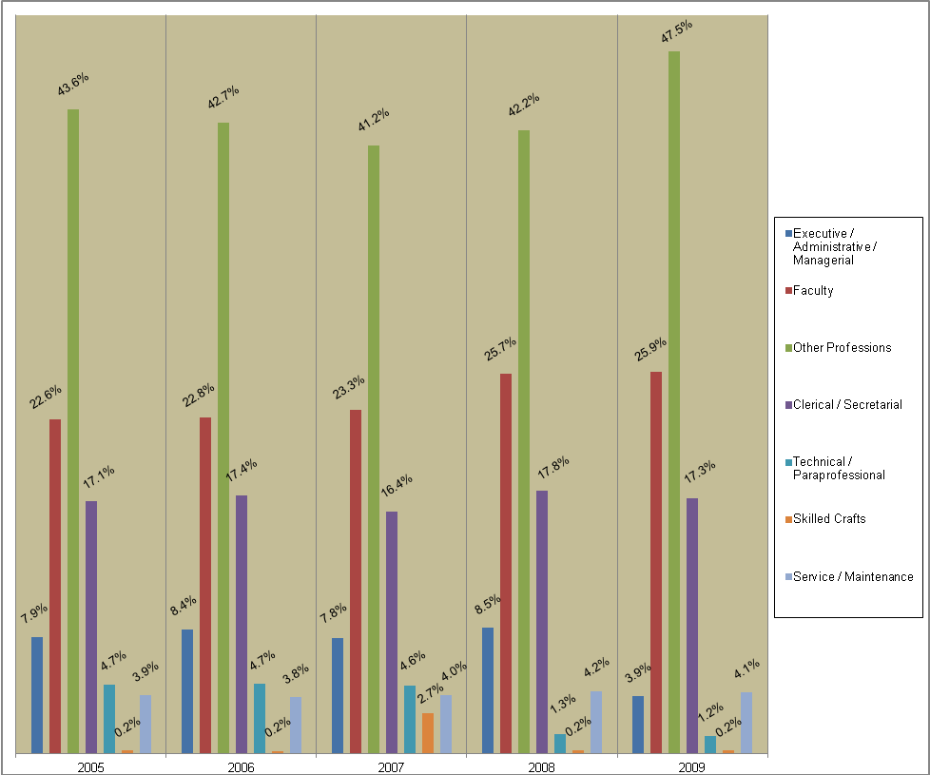

VIII. Comparison by Occupational Category

Here, we provide an additional series of charts that set forth the percentage of employees in each of the following defined occupational categories: Faculty, Executive/Administrative, Managerial, Other Professionals, Technical and Paraprofessionals, Clerical and Secretarial, Skilled Crafts, and Service/Maintenance. The charts for the Michigan Public Universities present three areas for comparison: (1) the Wayne percentage, (2) the average for all Michigan Public Universities, and (3) the average for the Michigan Public Universities, excluding those institutions in the Upper Peninsula. The reason for this exclusion in the third area is to account for the difference in population demographics for these distinct regions of the state. The charts for the national peer institutions present a comparison of Wayne against the average for all peer institutions.

Michigan Public Universities

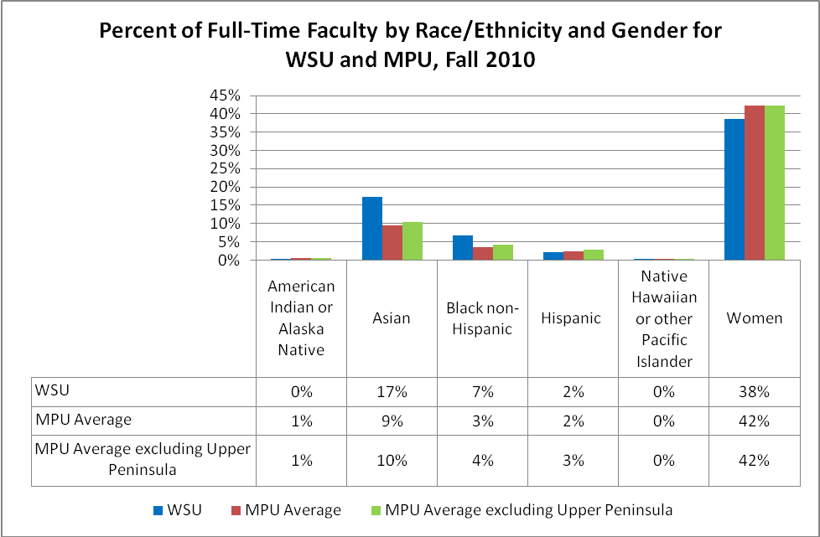

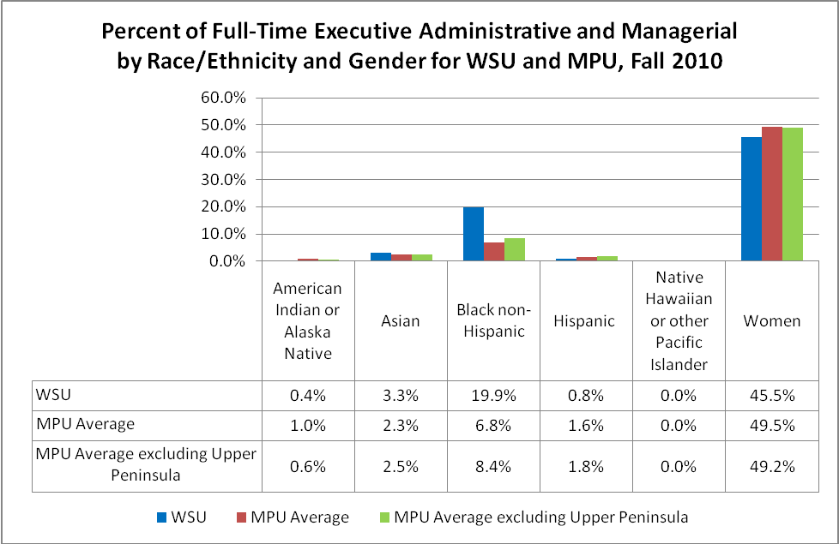

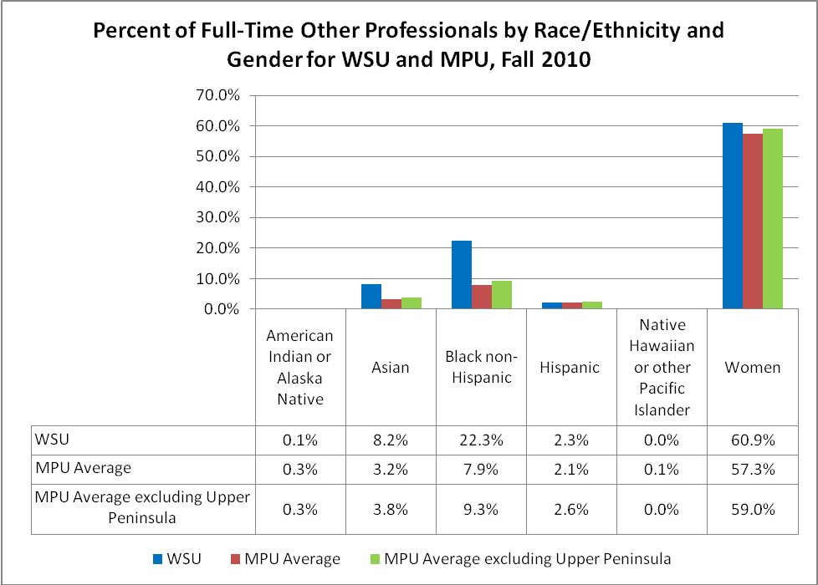

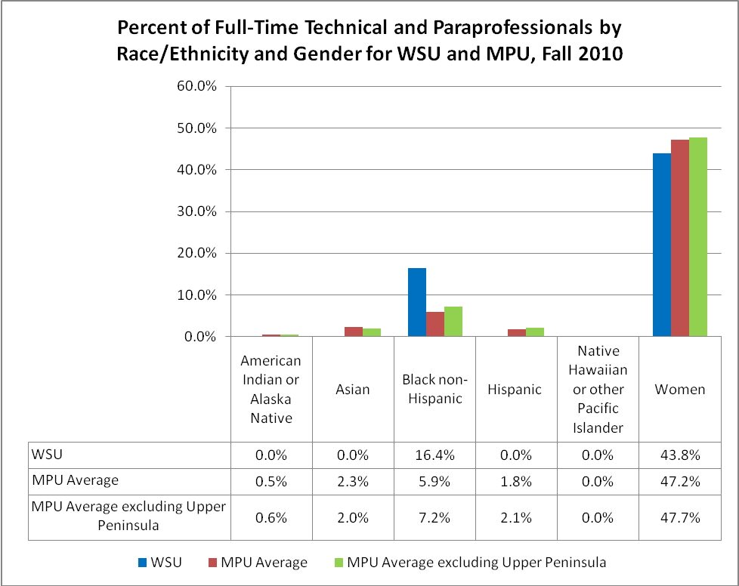

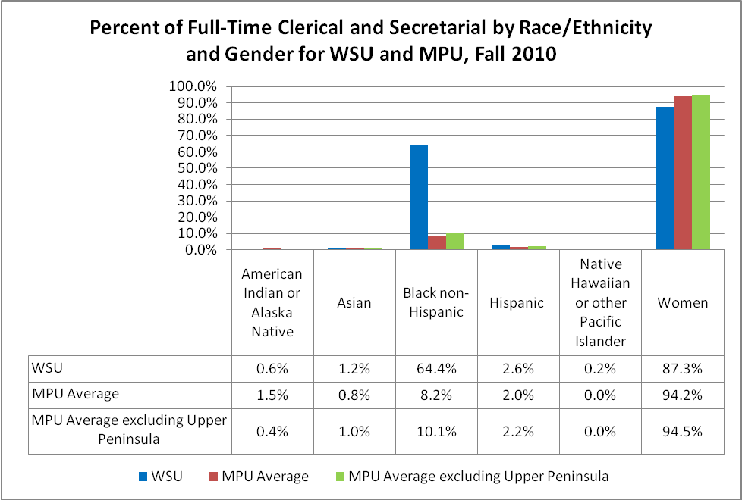

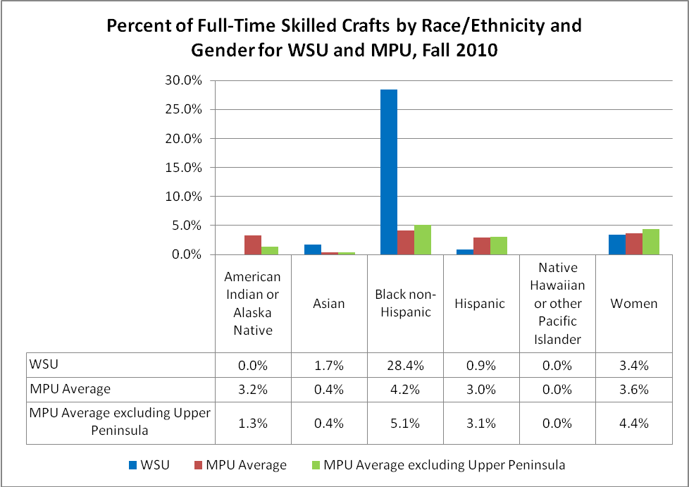

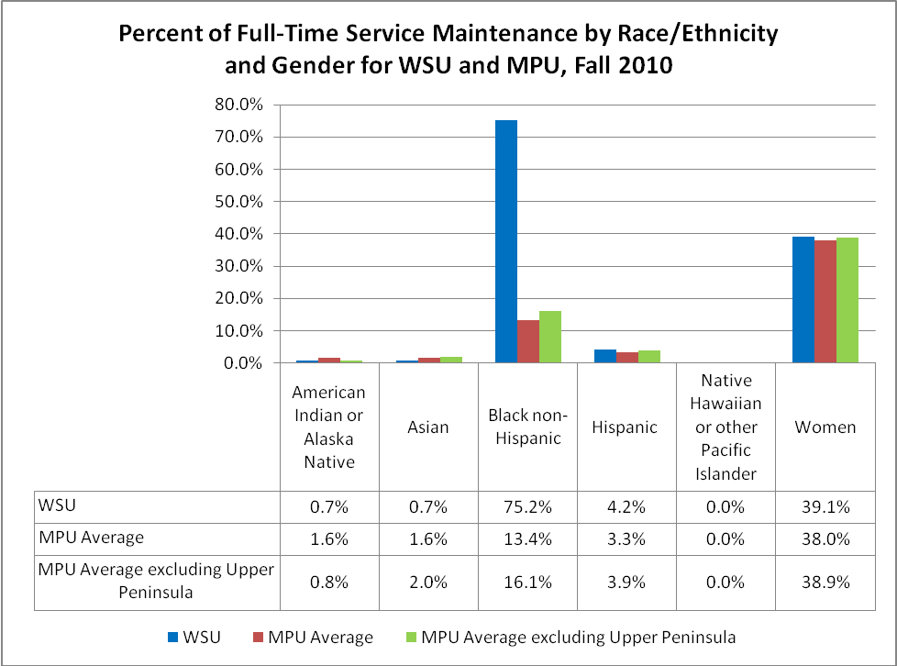

15 Peer Institutions

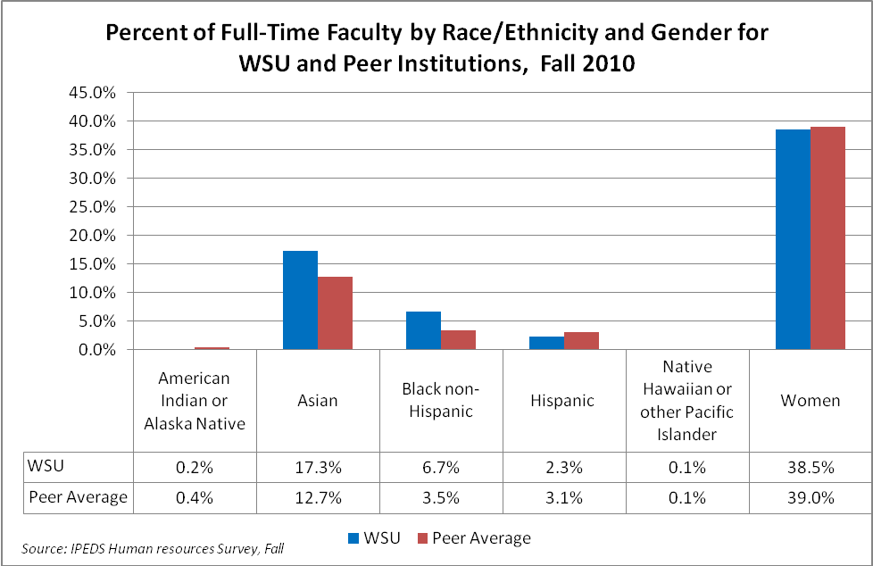

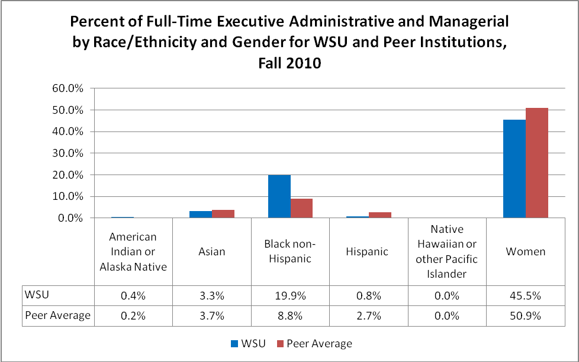
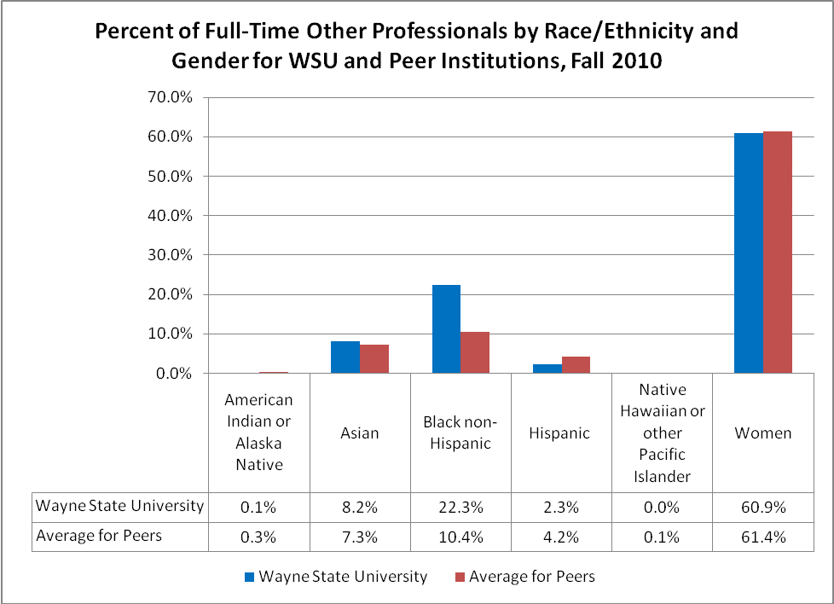

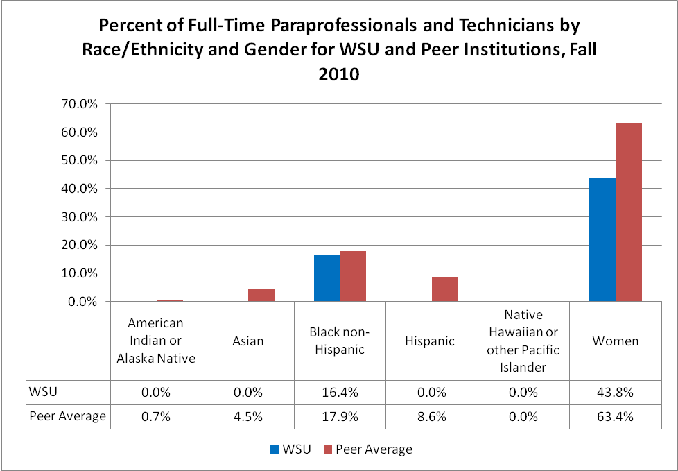

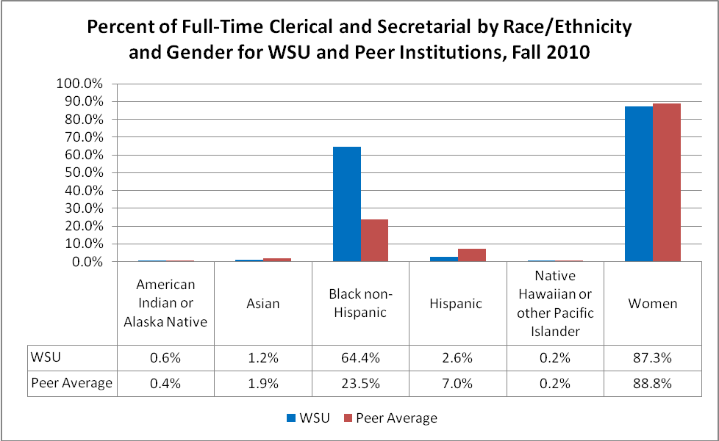

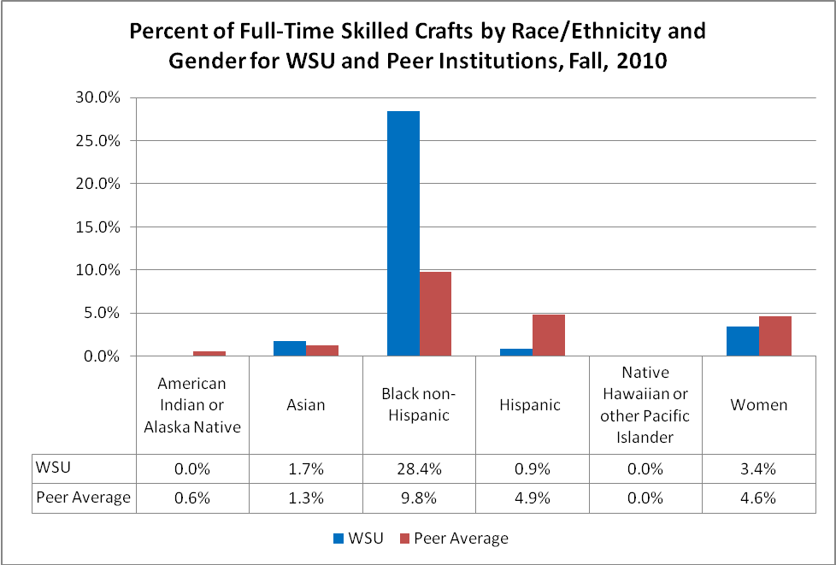

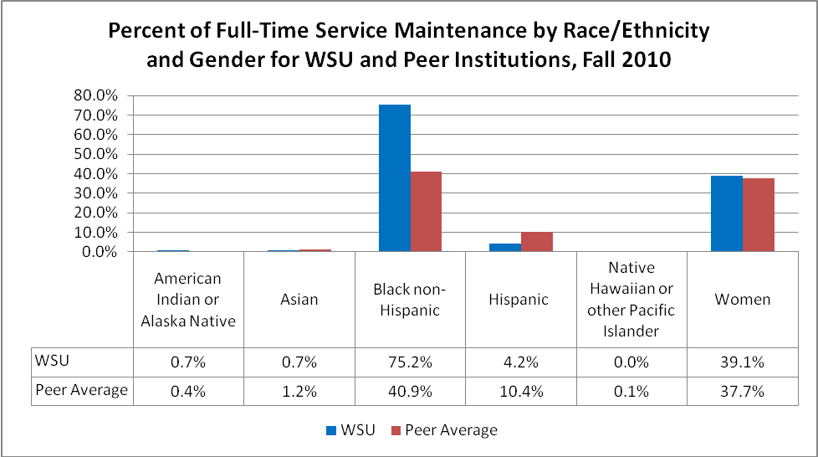



OFFICE OF EQUAL OPPORTUNITY
656 W. Kirby, Suite 4324 F/AB
Detroit, MI 48202
www.oeo.wayne.edu

This “regional availability” is based on the 2000 Michigan Department of Career Development’s Labor Market Report, the most recent data available. Southeast Michigan is defined as a four-county regional statistical area (Macomb, Oakland, Washtenaw and Wayne Counties). “Minority” and “Women” are distinct classifications. “Women” includes both minority and non-minority women.
The number of faculty includes those department chairs whose primary responsibility is “Instructional” as defined by federal law (See EEO Categories at Appendix 1 of this report).
This total includes those department chairs whose primary responsibility is Instructional as defined by the federal definition (See EEO Categories at Appendix 1 of this report). Table 4 reflects net changes, and so does not correspond precisely to the preceding text.
Wayne runs two different reports regarding temporary employees: a report listing those individuals who are classified as “temporary employee” or “TE”, and a report listing the number of temporary employees who work in a specific pay period. The snapshot in this section is the number of individuals classified TE. As of November 1, 2011, only 501 temporary employees actually had worked at least 0.5 hours in that pay period.
The methodology for the analysis was to compare Wayne in accordance with employment data submitted by IPED for 2009. IPEDS is a common university reporting data set. While this comparison may be imperfect, in that there may be variance in the ways individual institutions may arrive at the numbers they report in IPEDS, this method provides the best available data to provide a solid picture of where Wayne stands in relation to our colleagues.
There are 15 Public Universities in the state of Michigan; however institutions submitted data with Integrated Postsecondary Education Data System (IPEDS) voluntarily for the reporting year 2010. Therefore, data are not available for all institutions. Michigan Technological University, Saginaw Valley State University and Western Michigan University opted not to submit data for the 2010 reporting year.
There are 15 universities in the Board of Governors’ National Peer Institutions list; however, reporting for Integrated Postsecondary Education Data System (IPEDS) was voluntary for the reporting year 2010. Therefore, data are not available for all intuitions. The University of New Mexico and Virginia Commonwealth University opted not to submit data for 2010 and, thus, are not included in this analysis or any of the analysis that follows. Therefore, including Wayne State, there are fourteen (14) institutions in this analysis.

