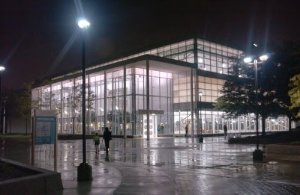

2009
Affirmative Action Status Report

Presented to the
Wayne State University Board of Governors
on December 8, 2010

Louis Lessem, Vice President and General Counsel
Christopher Jones, Director, Office of Equal Opportunity
TABLE OF CONTENTS

PREFACE,
President Allan D. Gilmour 3
INTRODUCTION 4
REPORTING REQUIREMENTS 4
I. UNIVERSITY EMPLOYMENT 5
A. FULL-TIME ACADEMIC AND NON-ACADEMIC EMPLOYMENT 7
B. FACULTY EMPLOYMENT 8
C. UNIVERSITY NON-ACADEMIC EMPLOYEES (STAFF) 13
D. TEMPORARY POSITIONS 15
E. COMPARISON WITH OTHER UNIVERSITIES……………………………… 16
II. UNIVERSITY COMPLAINTS 33
III. WAYNE STATE UNIVERSITY SUPPLIER DIVERSITY PROGRAM 37
IV. HIGHLIGHTS OF EQUAL OPPORTUNITY ACTIVITIES 41

Appendices

I. Definitions of EEO Categories

II. Responsibility for Affirmative Action

III. Definition of Terms

IV. Academic Classifications

V. Other Employee Definitions

VI. 2008 Data Tables

VII. Five Year Comparison Graphs

OFFICE OF THE PRESIDENT
4200 Faculty/Administration Building
313.577.2230 / 313.577.3200 Fax

MEMORANDUM

TO: Members of the Wayne State University Community

FROM: Allan D. Gilmour, President

SUBJECT: 2009 Affirmative Action Status Report to the Board of Governors

DATE: December 8, 2010

Wayne State University has a strong tradition of support for the principles of equal opportunity, non-discrimination and affirmative action. As a university of opportunity, we pride ourselves on providing educational opportunities for a diverse student body that varies widely in terms of age, race, ethnicity and economic status.

Diversity among our faculty, students and staff is a major source of our intellectual vitality and innovative spirit. We believe that a broad spectrum of informed perspectives enhances the educational and work experience on campus, and prepare our graduates to succeed in an increasingly interdependent and multicultural world.

Wayne State strives to be a place where people from varied walks of life can reach their full potential. Our commitment to the core values of inclusiveness and opportunity are essential to the fulfillment of our mission as a model urban research institution.

The following report summarizes Wayne’s affirmative action status for 2009, and provides examples of some of our achievements and direction for the future.

INTRODUCTION

Wayne State University is a national leader in providing equal access and employment opportunities to women and minorities. This report highlights the efforts of our schools, colleges and divisions in providing equal opportunity in employment and in enhancing diversity throughout Wayne State University. Even during difficult economic times, we have achieved many successes.

Wayne State University is the most diverse public university in the State of Michigan. The 2009 Affirmative Action Status Report (“AASR”) to the Wayne State University Board of Governors demonstrates that Wayne State University continues to lead in ensuring equality of opportunity. Our continued commitment to diversity is a significant strength in the educational experience we provide to our students.

This report is intended to present a comprehensive, cross-divisional view of Wayne State University’s performance in this important area.

REPORTING REQUIREMENTS

This report is provided pursuant to Board of Governors statute (WSUCA 2.28.01.070 - 120), which provides that a report be made on an annual basis to the Board on Wayne’s affirmative action efforts. In many respects, the report is derived from data compiled pursuant to federal reporting requirements. The Office of Federal Contract Compliance Programs (“OFCCP”) in the U.S. Department of Labor, which regulates federal grant expenditures, requires that federal contractors with 50 or more employees who receive $50,000 or more in federal funds have an Affirmative Action Plan (“AAP”) and prepare an annual report to the contractor’s governing board and executives.

This report includes information from four major areas of University activity, with national and/or regional comparisons where available. These areas are (I) overall University employment, including detailed information on full-time, academic and non-academic staff and supplemental information on part time and temporary employees, including a comparison of Wayne and other universities in the state and around the country; (II) internal and external discrimination and harassment complaints; (III) the Wayne State University Supplier Diversity Program; and (IV) highlights of campus affirmative action and equal opportunity activities.

This report was compiled by the Office of Equal Opportunity (“OEO”) with input from and the collaborative efforts of many units, including the Office of the General Counsel, Office of the Provost, the Office of Budget Planning and Analysis, Division of Finance and Facilities Management and the Division of Human Resources.

Information regarding staffing levels and discrimination complaint data contained in this report are based on personnel actions reported on a calendar year basis from January 1, 2009 to December 31, 2009. Data related to supplier diversity and external financial management is reported on a fiscal year basis beginning on October 1, 2008 and ending September 30, 2009. The report includes additional headcount data tables for the previous twelve month period (January 1, 2008 – December 31, 2008) at Appendix VI. Graphs of five-year comparisons on staffing levels have been provided in Appendix VII. Finally, the report also includes a breakdown of Minority and Women Faculty by College/School/Division in Section B, Table 5.

I. UNIVERSITY EMPLOYMENT

As the tenth largest employer in Detroit, Wayne State University is a major hiring force in southeastern Michigan. As of December 31, 2009, Wayne employed 8,124 persons, both full and part time, including temporary employees. While the report’s focus is on full time employees in permanent positions with the University, it includes a snapshot of temporary employees as well.

In 2009, Wayne employed 5,155 persons in full time positions. Wayne recruits approximately 60% of its workforce from a four-county statistical area consisting of Macomb, Oakland, Washtenaw and Wayne counties. Applicants for most non-academic positions are residents of one of these counties.

Wayne recruits its faculty from a national labor pool that is specific to individuals who hold doctoral and specialty degrees (Ph.D., M.F.A, etc.). Executive and some management-category positions also are recruited from a national labor employment pool. For the most part, other staff is recruited from a local labor pool.

Wayne also has a large number of student employees. Wayne State employs undergraduate students as student assistants through college work-study and other programs. Graduate students frequently are employed as graduate assistants and sometimes as part-time faculty. In addition, approximately 750 temporary employees are employed at any given time each year. The majority of these employees work in professional or research classifications.

Wayne State’s workforce exceeds the regional availability in the percentage of women, Black and Asian/Pacific Islanders it employs. Among total full-time employees, over 51% of Wayne’s employees are female, compared to the regional average of just below 47%. Nearly 25% of Wayne’s full-time employees are Black, compared to 20.4% regional availability, and slightly more than 14% are Asian/Pacific Islanders, which is over four times the regional availability. Wayne has been less successful in recruiting Hispanic and Native American employees, and lags behind regional availability with regard to both of these minority groups.

Minority Representation Compared to Regional Availability
As of 12/31/09 (Table 1)
Race/Ethnicity/Gender | 2008 Full Time Employee Headcount | % of WSU Workforce | Regional Availability | Difference Between Workforce % and Availability
Black | 1,272 | 24.70% | 20.40% | 4.30%
Asian / Pacific Islander | 755 | 14.60% | 2.80% | 11.80%
Hispanic | 106 | 2.10% | 2.70% | -0.60%
White, Non-Hispanic | 2993 | 58.10% | N/A | N/A
Native American | 12 | 0.20% | 0.30% | -0.10%
Not Identified | 17 | 0.30% | N/A | N/A
Women | 2,665 | 51.70% | 46.80% | 4.90%

The classifications utilized in this report are drawn from federally-established terminology utilized for EEOC reporting purposes. (For purposes of this report the term “minority” includes Blacks, Asian/Pacific Islanders, Hispanics, and Native Americans.) Overall, minorities comprise 41.6% of Wayne’s workforce and are represented in 90 percent of Wayne State University's 254 departments and in 99%of the departments that employ 10 or more people. Women represent nearly 52% of Wayne’s full-time workforce, and are represented in 94% of all departments, and 99% of all departments that employ 10 or more people. These results reflect the diversity that Wayne State University has been able to achieve in its workforce.

A. FULL TIME ACADEMIC AND NON-ACADEMIC EMPLOYMENT

In 2009, Wayne State University employed 5,155 persons in both academic (1,810) and non-academic (3,345) full time positions. Of the 5,155 full time employees, 2,665 were women employees and 2,145 were minority employees.

Year | Women | % of total Headcount | Minority | % of total Headcount
2009 | 2,665 | 51.70% | 2,145 | 41.61%
2008 | 2,645 | 52.25% | 2,123 | 41.94%
2007 | 2,852 | 53.27% | 2,221 | 41.49%
2006 | 2,769 | 53.10% | 2,113 | 40.52%
2005 | 2,760 | 52.34% | 2,109 | 40.00%

Most full-time employees are employed as “Faculty” (1,810 employees) or “Other Professionals” (2,106 employees).

2009 Total Full Time Academic and Non Academic Employee Headcount
As of 12/31/09 (Table 2)
Category | 2009 Total | Black | Asian / Pacific Islander | Hispanic | Native American | Total Minorities | Women
Faculty | 1,810 | 128 | 364 | 43 | 3 | 538 | 689
 |  | 7.07% | 20.11% | 2.38% | 0.17% | 29.72% | 38.07%
Executive / Administrative / Managerial | 240 | 44 | 7 | 2 | 0 | 53 | 103
 |  | 18.33% | 2.92% | 0.83% | 0.00% | 22.08% | 42.92%
Other Professionals | 2,106 | 495 | 373 | 44 | 4 | 916 | 1,267
 |  | 23.50% | 17.71% | 2.09% | 0.19% | 43.49% | 60.16%
Technical / Paraprofessional | 72 | 12 | 0 | 0 | 0 | 12 | 31
 |  | 16.67% | 0.00% | 0.00% | 0.00% | 16.67% | 43.06%
Clerical / Secretarial | 524 | 337 | 6 | 10 | 3 | 356 | 460
 |  | 64.31% | 1.15% | 1.91% | 0.57% | 67.94% | 87.79%
Skilled Crafts | 111 | 31 | 2 | 0 | 0 | 33 | 5
 |  | 27.93% | 1.80% | 0.00% | 0.00% | 29.73% | 4.50%
Service / Maintenance | 292 | 225 | 3 | 7 | 2 | 237 | 110
 |  | 77.05% | 1.03% | 2.40% | 0.68% | 81.16% | 37.67%
Total | 5,155 | 1,272 | 755 | 106 | 12 | 2,145 | 2,665
 |  | 24.68% | 14.65% | 2.06% | 0.23% | 41.61% | 51.70%

Female employees comprise over half of the Wayne State University workforce. Almost half of all women employed at Wayne are concentrated in the Other Professionals category, and approximately 25% are faculty. These categories are followed by the Clerical/Secretarial category and the Service/Maintenance category.

2009 Total Full-Time Women Employee Headcount
Category | Black | Asian / Pacific Islander | Hispanic | Native American | White | Unknown Race/Ethnicity | 2009 Total
Faculty | 73 | 116 | 17 | 3 | 476 | 4 | 689
 | 10.60% | 16.84% | 2.47% | 0.44% | 69.09% | 0.58%
Executive / Administrative / Managerial | 23 | 2 | 0 | 0 | 78 | 0 | 103
 | 22.33% | 1.94% | 0.00% | 0.00% | 75.73% | 0.00%
Other | 372 | 169 | 30 | 3 | 689 | 4 | 1,267
Professionals | 29.36% | 13.34% | 2.37% | 0.24% | 54.38% | 0.32%
Clerical / Secretarial | 304 | 3 | 9 | 1 | 141 | 2 | 460
 | 66.09% | 0.65% | 1.96% | 0.22% | 30.65% | 0.43%
Technical / Paraprofessional | 4 | 0 | 0 | 0 | 27 | 0 | 31
 | 12.90% | 0% | 0% | 0% | 87% | 0%
Skilled Crafts | 2 | 0 | 0 | 0 | 3 | 0 | 5
 | 40.00% | 0% | 0% | 0% | 60.00% | 0.00%
Service / Maintenance | 95 | 0 | 0 | 2 | 13 | 0 | 110
 | 86.36% | 0% | 0.00% | 1.82% | 11.82% | 0.00%
Total | 873 | 290 | 56 | 9 | 1,427 | 10 | 2,665
 | 32.76% | 10.88% | 2.10% | 0.34% | 53.55% | 0.38% | 100%
As of 12/31/09 (Table 3)

B. FACULTY EMPLOYMENT

Wayne State University strives to provide an efficient and user-friendly faculty hiring process that contributes to a diverse pool of qualified candidates. The Online Hiring System provides applicants with global access to employment opportunities 365 days of the year, 24 hours a day. The OEO acts as a resource for departments conducting academic searches by providing all academic departments with hiring plans to assist in identifying staffing needs and the OEO publishes information in the “Guide for Successful Searches.” Additionally, the OEO also provides diversity resources for publicizing employment opportunities and training in the faculty hiring process.

Wayne State University continues to promote diversity within its faculty. As shown in Table 4 below, the recruitment of women and minority faculty at Wayne State University has been successful in producing diversity within the faculty, despite difficult economic pressures and a highly competitive environment.
a. Full Time Faculty – Tenured and Non-Tenured

In 2009, Wayne employed 1,810 tenured and non-tenured full time faculty. Tenured faculty made up 1,044 of the total faculty, of whom 315, or slightly more than 30% of tenured faculty are women. Minorities hold 298 tenured faculty positions.

In 2009, the non-tenured faculty totaled 766. The number of women holding non-tenure system faculty appointments comprised 374 of the total non-tenure positions. Minorities also held a significant number of non-tenure positions in 2009, standing at 240.

2009 Full Time Faculty - Tenure and Non-Tenure System
Table 4

Rank | 2009 Faculty Total | Black | Asian / Pacific Islander | Hispanic | Native American | Total Minority | Women
Tenure System | 1,044 | 57 | 208 | 31 | 2 | 298 | 315
Tenure System |  | 5.5% | 19.9% | 3.0% | 0.2% | 28.5% | 30.2%
Non-Tenure System | 766 | 71 | 156 | 12 | 1 | 240 | 374
Non-Tenure System |  | 9.3% | 20.4% | 1.6% | 0.1% | 31.3% | 48.8%
Total | 1,810 | 128 | 364 | 43 | 3 | 538 | 689
Total |  | 7.1% | 20.1% | 2.4% | 0.2% | 29.7% | 38.1%

2009 Full Time Faculty – Minority Representation
Chart 1
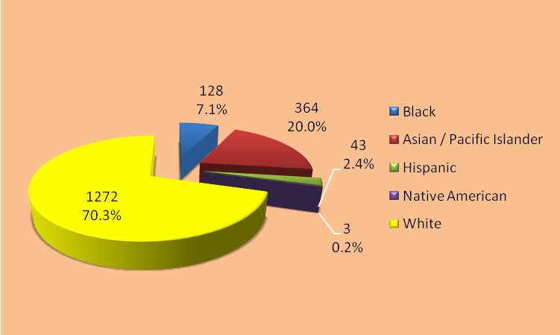

2009 Full Time Faculty – Gender Representation
Chart 2

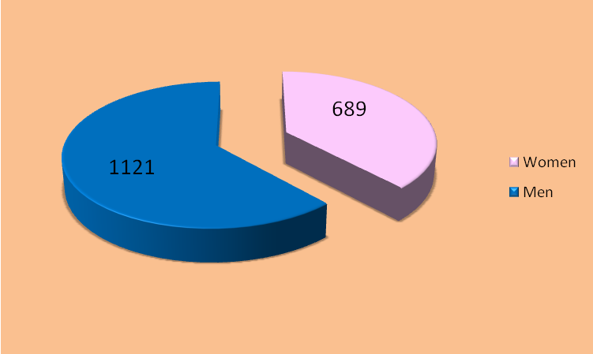

b. Tenure-System Faculty by Rank

Wayne State University promoted 48 tenured faculty during 2009, the same as in 2008. The 48 promotions included a modest increase in the number of women faculty who were promoted (19, an increase of 2 from the previous year). 16 minority faculty received promotions, the same number as in 2008.

Nearly 44% of the 1,044 tenured faculty, hold the rank of Professor. The majority of women and minorities are concentrated in the ranks of Associate Professor and Assistant Professor. In 2009, Wayne had 459 Professors, of which 87 were women and 111 were minorities. The total number of Associate Professors was 336 in 2009, of which 122 were women and 87 were minorities. The total number of Assistant Professors was 249, of which 106 were women and 100 were minorities.

2009 Tenure-System Faculty by Rank
Table 5

Rank | 2009 Faculty Total | Black | Asian / Pacific Islander | Hispanic | Native American | Total Minority | Women
Professor | 459 | 13 | 89 | 9 | 0 | 111 | 87
Professor |  | 2.8% | 19.4% | 2.0% | 0.0% | 24.2% | 19.0%
Associate | 336 | 18 | 58 | 10 | 1 | 87 | 122
Professor |  | 5.4% | 17.3% | 3.0% | 0.3% | 26% | 36.3%
Assistant | 249 | 26 | 61 | 12 | 1 | 100 | 106
Professor |  | 10.4% | 24.5% | 4.8% | 0.4% | 40.2% | 42.6%
Total | 1,044 | 57 | 208 | 31 | 2 | 298 | 315
Total % |  | 5.5% | 19.9% | 3.0% | 0.2% | 28.5% | 30.2%

Full Professors – Gender and minority representation
Charts 3 and 4

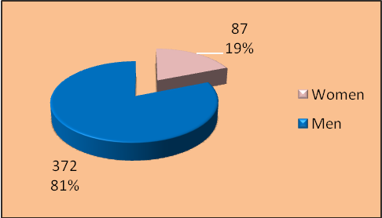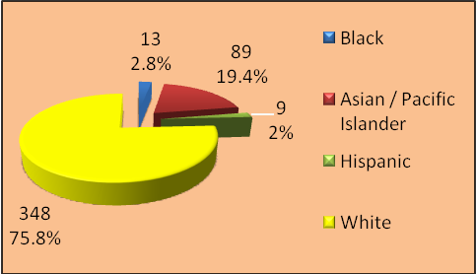

Associate Professors - Gender and minority representation
Charts 5 and 6

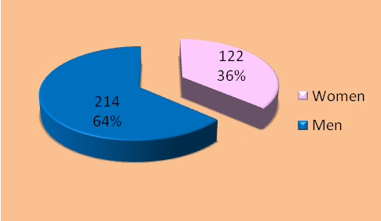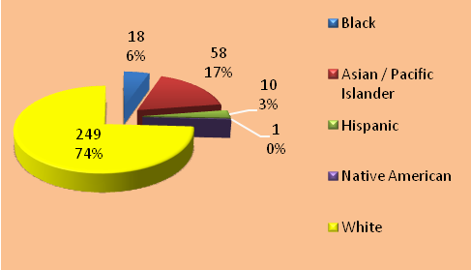

Assistant Professors - Gender and minority representation
Charts 7 and 8

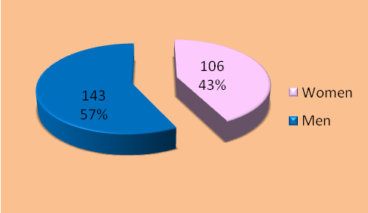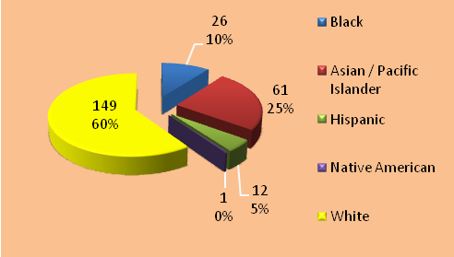

While women and minorities are represented throughout the faculty ranks, as seen in Table 6, minority and female faculty are not distributed uniformly throughout the schools, colleges, and divisions of Wayne State University.

2009 Tenured Faculty by School/College/Division – Minorities and Females
Table 6
School/College/ | Black | Asian | Hispanic | Native American | Total Minorities | White | Female | Total
Division
School of Business Administration | 5 | 12 | 0 | 0 | 17 | 22 | 6 | 39
College of Education | 7 | 8 | 2 | 1 | 18 | 42 | 29 | 60
College of Engineering | 5 | 40 | 1 | 0 | 46 | 32 | 6 | 78
College of Fine & Performing Arts | 4 | 2 | 3 | 0 | 9 | 68 | 30 | 77
Law School | 2 | 1 | 0 | 0 | 3 | 25 | 10 | 28
College of Liberal Arts & Science | 20 | 59 | 13 | 0 | 92 | 280 | 116 | 372
School of Library & Information Science | 1 | 0 | 1 | 0 | 2 | 10 | 6 | 12
School of Medicine | 5 | 73 | 7 | 0 | 85 | 204 | 64 | 289
College of Nursing | 3 | 2 | 1 | 0 | 6 | 21 | 24 | 27
College of Pharmacy & Health Science | 1 | 5 | 0 | 0 | 6 | 21 | 5 | 27
School of Social Work | 4 | 0 | 2 | 1 | 7 | 12 | 13 | 19
Division of Research | 0 | 6 | 1 | 0 | 7 | 9 | 6 | 16
Total: | 57 | 208 | 31 | 2 | 298 | 746 | 315 | 1,044

C. UNIVERSITY NON-ACADEMIC EMPLOYEES (STAFF)

The term “staff” refers to individuals in positions ranging from maintenance personnel to executive officers. The non-academic staff at Wayne State University is diverse in its representation of women and minorities. Of the 3,345 non-academic staff at Wayne State University in 2009, women totaled 1,976 (59%) and minorities totaled 1,607 (48%). Blacks are the largest minority group with 1,144 employees (34%), followed by Asian/Pacific Islanders with 391 (12%), and Hispanics with 63 (1.9%). Native Americans increased in numbers to 9 (.3%).

Full-Time Non-Academic Employees by EEO Categories

The EEO categories in this report are based upon Federal Department of Labor Standard Occupational Classifications (“SOC”) according to the nature of the work performed and educational level (degree obtained) and are related to occupations of a similar nature. There are 23 major groups in the SOC and 821 detailed occupations within those groups. As shown in Table 7 below, Wayne State University’s non-academic employment population is comprised of six of these categories: Executive/Administrative/Managerial; Other Professionals; Clerical/Secretarial; Technical/Paraprofessional; Skilled Crafts; and Service/Maintenance.

2009 Total Full-Time Non-Academic Employee Headcount
As of 12/31/09 Table 7

Category | 2009 Total | Black | Asian / Pacific Islander | Hispanic | Native American | Total Minorities | Women
Executive / Administrative / Managerial | 240 | 44 | 7 | 2 | 0 | 53 | 103
Executive / Administrative / Managerial |  | 18.3% | 2.9% | 0.8% | 0.0% | 22% | 42.9%
Other | 2,106 | 495 | 373 | 44 | 4 | 916 | 1,267
Professionals |  | 23.5% | 17.7% | 2.1% | 0.2% | 43.5% | 60.2%
Clerical / Secretarial | 524 | 337 | 6 | 10 | 3 | 356 | 460
Clerical / Secretarial |  | 64.3% | 1.1% | 1.9% | 0.6% | 67.9% | 87.8%
Technical / Paraprofessional | 72 | 12 | 0 | 0 | 0 | 12 | 31
Technical / Paraprofessional |  | 16.7% | 0.0% | 0.0% | 0.0% | 16.7% | 43.1%
Skilled Crafts | 111 | 31 | 2 | 0 | 0 | 33 | 5
Skilled Crafts |  | 27.9% | 1.8% | 0.0% | 0.0% | 29.7% | 4.5%
Service / Maintenance | 292 | 225 | 3 | 7 | 2 | 237 | 110
Service / Maintenance |  | 77.1% | 1.0% | 2.4% | 0.7% | 81.2% | 37.7%
Total | 3,345 | 1,144 | 391 | 63 | 9 | 1,607 | 1,976
Total |  | 34.2% | 11.7% | 1.9% | 0.3% | 48.0% | 59.1%

With 48% minority and more than 59% female representation in the non-academic employee group, Wayne State continues to retain and employ a diverse workforce.

It is significant that minorities and women are heavily represented throughout all levels of job categories at Wayne. In 2009, 240 employees were classified in the “Executive/Administrative/Managerial” category. This roughly corresponds to non-academic employees holding the rank of Director or above. Minorities represent just over 22% of this high-level group. The number of women represented in this group was 103 in 2009, which represents over 40% of the total employee group.

Full-time employees in the “Other Professional” category include academic support personnel as well as those job assignments that require a college degree. The population of the “Other Professional” category fluctuates with enrollment and grant funding trends.

Of the 2,106 employed in this category, 916 were minorities. Blacks were more heavily represented than any other minority, at 495, followed by Asian/Pacific Islanders at 373. Hispanics and Native Americans in this group total 44 and 4 respectively. More than 60% (1,267) were women.

There were 524 full-time employees in the “Clerical/Secretarial” category in 2009, of which 337, or just over 64%, were Black. Other minorities are very modestly represented, with 10 Hispanic employees 6 Asians and Pacific Islanders, and 3 Native American employees. Female employees comprise over 87% of the Clerical/Secretarial job category.

The number of full-time employees categorized as “Technical/Paraprofessional” was 72 employees. This category includes Library Assistants, Archivist Assistants, Graphic Designers, Facility Coordinators, Multimedia Specialists, Environmental Health Specialist, Lab Techs and other similar positions. Women comprise just over 43% and total minorities are nearly 17% of this reporting group.

The “Skilled Crafts” category included 111 employees in 2009. Minority representation within the group was 33, with Blacks making up the bulk of this group. In the “Service/Maintenance” category, the number of full-time personnel was at 292. 237 of these employees were minorities, which represents just over 81% of the service group. Women represent 4.5% of the Skilled Crafts category and nearly 38% of Service categories.

D. TEMPORARY POSITIONS

This employee group often fluctuates over the course of a given year, as the positions are based on a unit’s specific needs or projects. University policy limits temporary employees to a total of 1000 hours employment in a fiscal year. With this in mind, the following data provides a snapshot of active temporary positions on the payroll as of October 1, 2009.

Temporary employees by position classification and gender
FY 2009 – Table 8

Type | Female | Male | Total
Other Professional | 359 | 198 | 557
Clerical and Secretarial | 125 | 48 | 173
Skilled Crafts | 10 | 5 | 15
Service/Maintenance | 6 | 16 | 22
Totals: | 500 | 267 | 767
% of total: | 65.2% | 34.8% | 100.0%

Temporary employees by position classification and race
FY 2009 – Table 8

Type | Black | Asian / Pacific Islander | Hispanic | Native American | White | Unknown Race/  Ethnicity | Total
Other Professional | 179 | 35 | 14 | 1 | 323 | 5 | 557
Clerical/Secretarial | 90 | 11 | 2 | 0 | 69 | 1 | 173
Skilled Crafts | 14 | 0 | 1 | 0 | 0 | 0 | 15
Service/Maintenance | 16 | 0 | 0 | 0 | 6 | 0 | 22
Totals: | 299 | 46 | 17 | 1 | 398 | 6 | 767
% of total: | 39.0% | 6.0% | 2.2% | 0.1% | 51.9% | 0.8% | 100.0%

As demonstrated by the data outlined above, the temporary employee population generally reflects the University at large in its distribution of women and minorities. Minorities comprise nearly half of this employment group. Black technicians represent over 39% of the group, in excess of the 20.4% regional availability. Asian/Pacific Islander represents 6% of the group, which also exceeds the regional availability of 2.8%. Hispanics and Native Americans both fall below our regional availability and the University employee population overall.
E. COMPARISON WITH OTHER UNIVERSITIES
In this section, we have included a two-part comparison of Wayne against other universities. This comparison is intended to provide a look at Wayne’s performance in the representation of women and minorities as related to other educational institutions using a commonly-defined set of data. The first part (subsection “a”) compares Wayne with other Michigan Public Universities. The second part (subsection “b”) compares Wayne with Wayne’s fifteen national peer institutions. In the final section (subsection “c”), we provide a series of charts that break down individual occupational categories by race and sex.
a. Michigan Public Universities
Comparative Analysis – Women Employment
In 2009, Wayne State University employed 2,665 women in full time positions. Wayne is third in employment of women behind the University of Michigan-Ann Arbor (9,805) and Michigan State University (5,582), respectively. In all but three institutions, women make up more than half of the total workforce. Michigan Public Universities are closely clustered in their employment of women as a percentage of total employees – less than 6% separates the 2nd ranked from the 13th ranked institution. Although 51.57% of Wayne’s employees are women, by percentage of total employees, Wayne ranks 11th among the Michigan Public Universities.

2009 Full Time Women Employees
Institution Name | Total Full Time Employees | Total Full Time Women | Percentage of  Total Employees | Rank
University of Michigan-Flint | 670 | 409 | 61.04% | 1
Oakland University | 1,412 | 784 | 55.52% | 2
Central Michigan University | 2,173 | 1,183 | 54.44% | 3
University of Michigan-Dearborn | 709 | 386 | 54.44% | 4
University of Michigan-Ann Arbor | 18,213 | 9,805 | 53.84% | 5
Grand Valley State University | 2,155 | 1,150 | 53.36% | 6
Michigan State University | 10,483 | 5,582 | 53.25% | 7
Western Michigan University | 2,640 | 1,391 | 52.69% | 8
Ferris State University | 1,522 | 797 | 52.37% | 9
Eastern Michigan University | 1,887 | 978 | 51.83% | 10
Wayne State University | 5,155 | 2,665 | 51.70% | 11
Lake Superior State University | 339 | 175 | 51.62% | 12
Saginaw Valley State University | 746 | 371 | 49.73% | 13
Northern Michigan University | 944 | 442 | 46.82% | 14
Michigan Technological University | 1,296 | 569 | 43.90% | 15

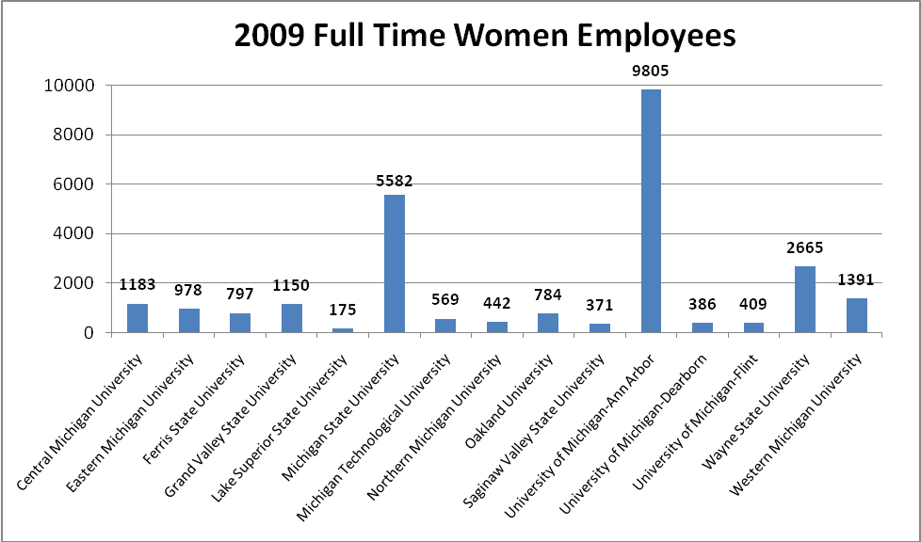
Comparative Analysis – Minority Employment

In 2009, Wayne State University employed 2,145 minorities in Full Time positions. The total number of minorities employed in full time positions at Wayne State University is second only to the University of Michigan-Ann Arbor (3,337). However, as a percentage of total employees, Wayne State University (41.61%) ranks 1st among the Michigan Public Universities.

2009 Full Time Minority Employees
Institution Name | Total Full Time Employees | Total Full Time Minority Employees | Percentage of  Total Employees | Rank
Wayne State University | 5,155 | 2,145 | 41.61% | 1
University of Michigan-Dearborn | 709 | 184 | 25.95% | 2
Oakland University | 1,412 | 299 | 21.18% | 3
Eastern Michigan University | 1,887 | 358 | 18.97% | 4
University of Michigan-Flint | 670 | 126 | 18.81% | 5
University of Michigan-Ann Arbor | 18,213 | 3,337 | 18.32% | 6
Michigan State University | 10,483 | 1,694 | 16.16% | 7
Western Michigan University | 2,640 | 362 | 13.71% | 8
Grand Valley State University | 2,155 | 290 | 13.46% | 9
Saginaw Valley State University | 746 | 97 | 13.00% | 10
Central Michigan University | 2,173 | 211 | 9.71% | 11
Lake Superior State University | 339 | 26 | 7.67% | 12
Michigan Technological University | 1,296 | 80 | 6.17% | 13
Ferris State University | 1,522 | 76 | 4.99% | 14
Northern Michigan University | 944 | 40 | 4.24% | 15

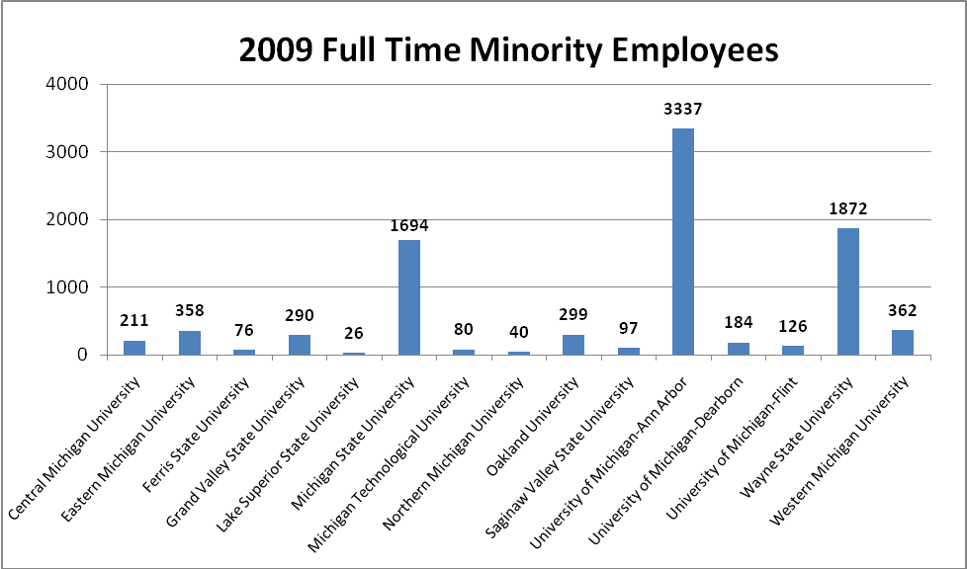
Women Faculty

In 2009, Wayne State University employed 689 women in Full Time Faculty positions. The total number of Full Time Women Faculty employees is third behind the University of Michigan – Ann Arbor (1,978) and Michigan State University (926), respectively. Again, MPUs are closely clustered. As a percentage of total full time faculty employees, Wayne State University (38.07%) ranks 11th among the Michigan Public Universities.

Full Time Women Faculty
Institution Name | Total Full Time Faculty | Total Full Time Women Faculty | Percentage of  Total Faculty | Rank
University of Michigan - Flint | 257 | 134 | 52.14% | 1
Eastern Michigan University | 755 | 365 | 48.34% | 2
Grand Valley State University | 472 | 141 | 45.56% | 3
Lake Superior State University | 115 | 51 | 44.35% | 4
Oakland University | 515 | 228 | 44.27% | 5
Saginaw Valley State University | 288 | 127 | 44.10% | 6
Northern Michigan University | 319 | 131 | 41.07% | 7
Ferris State University | 613 | 251 | 40.95% | 8
Central Michigan University | 787 | 322 | 40.91% | 9
Western Michigan University | 876 | 338 | 38.58% | 10
Wayne State University | 1,810 | 689 | 38.07% | 11
University of Michigan - Dearborn | 306 | 114 | 37.25% | 12
University of Michigan - Ann Arbor | 5,587 | 1,978 | 35.40% | 13
Michigan State University | 2,623 | 926 | 35.30% | 14
Michigan Technological University | 467 | 130 | 27.84% | 15

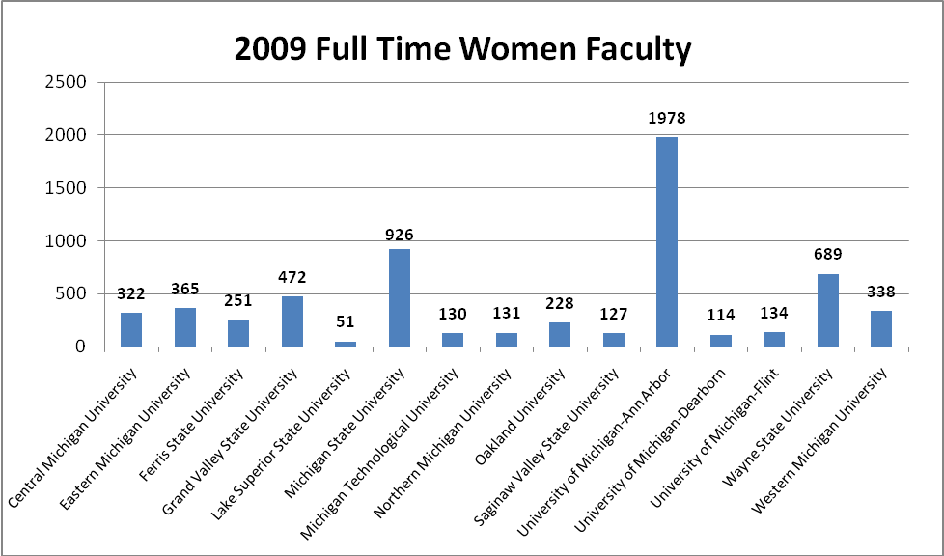

Minority Faculty

In 2009, Wayne State University employed 538 minorities in Full Time Faculty positions. The total number of minorities employed in Full Time Faculty positions is second behind the University of Michigan – Ann Arbor (1,053). However, as a percentage of total full time faculty employees, Wayne State University (29.72%) ranks 1st among the Michigan Public Universities.

Full Time Minority Faculty
Institution Name | Total Full Time Faculty | Total Full Time Minority Faculty | Percentage of  Total Faculty | Rank
Wayne State University | 1810 | 538 | 29.72% | 1
University of Michigan - Dearborn | 306 | 90 | 29.41% | 2
Oakland University | 515 | 109 | 21.17% | 3
University of Michigan - Ann Arbor | 5,587 | 1,053 | 18.85% | 4
Michigan State University | 2,623 | 491 | 18.72% | 5
Eastern Michigan University | 755 | 131 | 17.35% | 6
University of Michigan - Flint | 257 | 43 | 16.73% | 7
Saginaw Valley State University | 288 | 44 | 15.28% | 8
Central Michigan University | 787 | 117 | 14.87% | 9
Grand Valley State University | 1,036 | 141 | 13.61% | 10
Western Michigan University | 876 | 116 | 13.24% | 11
Michigan Technological University | 467 | 54 | 11.56% | 12
Lake Superior State University | 115 | 10 | 8.70% | 13
Ferris State University | 613 | 45 | 7.34% | 14
Northern Michigan University | 319 | 18 | 5.64% | 15

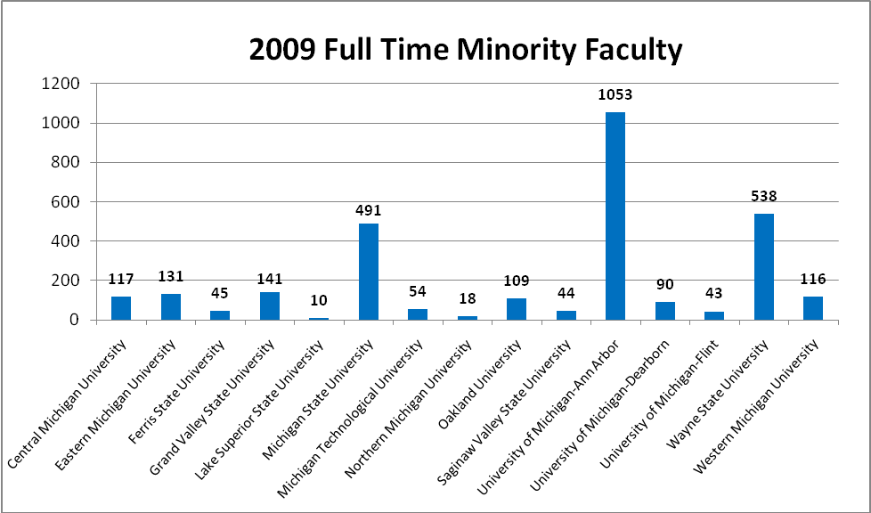

b. National Peer Institutions
Comparative Analysis – Women Employment

Wayne State ranks 9th among its fifteen national peer institutions in utilization of available women from its Metropolitan Statistic Area. Wayne State ranks 11th among its national peer institutions in percentage of total women employed with 51.7% of its employees being female.

Total Women Employees
TOTAL WOMEN | Total Full Time Employees | Total Women Employees | Percentage | Rank
College
University of Illinois at Chicago | 9,893 | 6,233 | 63% | 1
University of Colorado-Denver | 6,166 | 3,739 | 61.13% | 2
University of New Mexico | 6,281 | 3,694 | 58.81% | 3
Indiana University-Purdue University-Indianapolis | 8,536 | 4,950 | 57.99% | 4
University of Alabama at Birmingham | 7,583 | 4,340 | 57.23% | 5
University of Louisville | 5,307 | 2,951 | 55.61% | 6
Virginia Commonwealth University | 5,352 | 2,955 | 55.21% | 7
Michigan State University | 10,483 | 5,582 | 53.25% | 8
University of Pittsburgh | 10,548 | 5,610 | 53.19% | 9
University of Utah | 8,485 | 4,423 | 52.13% | 10
Wayne State University | 5,155 | 2,665 | 51.7% | 11
University of Minnesota-Twin Cities | 14,661 | 7,580 | 51.7% | 12
Temple University | 5,726 | 2,919 | 50.98% | 13
University of Cincinnati | 4,982 | 2,461 | 49.4% | 14
University at Buffalo | 4,275 | 1,966 | 45.99% | 15
University of Houston | 4,623 | 2,030 | 43.91% | 16

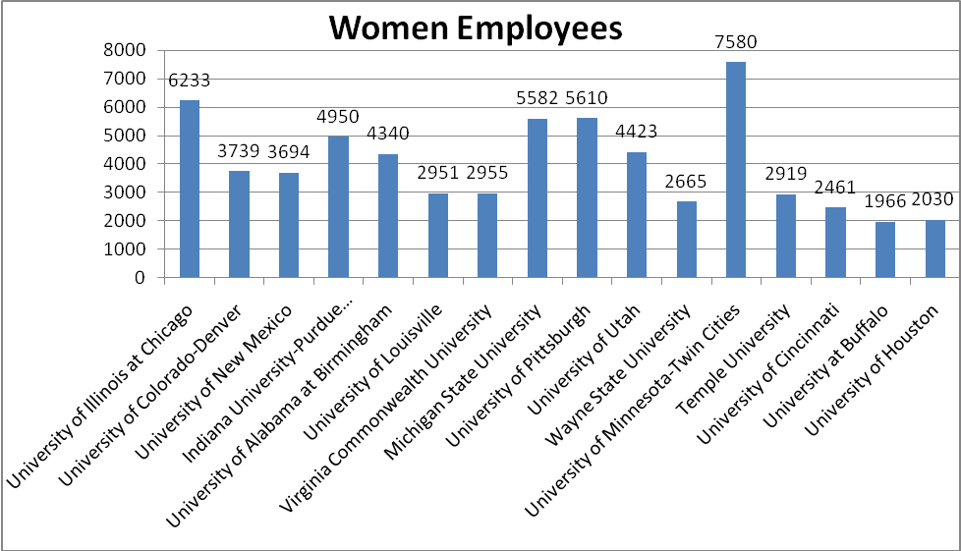
Comparative Analysis – Minority Employment

In 2009, Wayne State University employed 2,145minorities in Full Time positions. It ranks 3rd among its national peer institutions in total minorities employed with 41.61% of its employee population being minority.

Total Minority Employees
College | Total Full Time Employees | Total Minority Employees | Percentage | Rank
University of Illinois at Chicago | 9,893 | 4,843 | 48.95% | 1
University of Houston | 4,623 | 2,088 | 45.17% | 2
Wayne State University | 5,155 | 2,145 | 41.61% | 3
University of New Mexico | 6,281 | 2,408 | 38.34% | 4
Temple University | 5,726 | 2,174 | 37.97% | 5
University of Alabama at Birmingham | 7,583 | 2,509 | 33.09% | 6
Virginia Commonwealth University | 5,352 | 1,449 | 27.07% | 7
Indiana University-Purdue University-Indianapolis | 8,536 | 2,127 | 24.92% | 8
University of Louisville | 5,307 | 1,073 | 20.22% | 9
University of Pittsburgh | 10,548 | 2,086 | 19.78% | 10
University of Colorado-Denver | 6,116 | 1,112 | 18.18% | 11
University of Cincinnati | 4,982 | 892 | 17.9% | 12
Michigan State University | 10,483 | 1,694 | 16.16% | 13
University at Buffalo | 4,275 | 622 | 14.55% | 14
University of Minnesota-Twin Cities | 14,661 | 2,122 | 14.47% | 15
University of Utah | 8,485 | 785 | 9.25% | 16

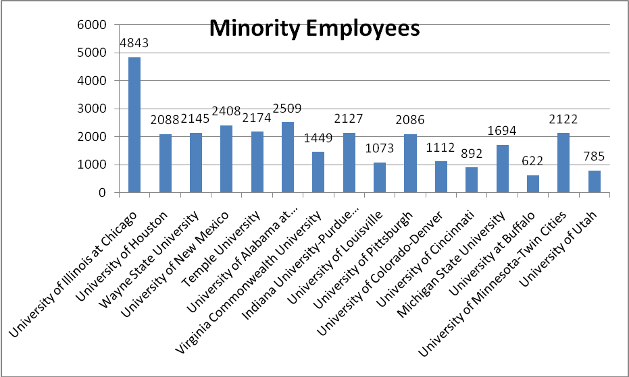

Comparative Analysis – Faculty Employment

Women Faculty
In 2009, Wayne State University employed 689 women in Full Time Faculty positions. Wayne State ranks 7th among its national peer institutions.

Total Women Faculty
Total Women Faculty | Total Full Time Faculty | Total Women Faculty | Percentage | Rank
College
University of Colorado-Denver | 3,961 | 2,314 | 58.42% | 1
University of New Mexico | 1,731 | 760 | 43.91% | 2
Virginia Commonwealth University | 2,121 | 897 | 42.29% | 3
University of Illinois at Chicago | 1,925 | 802 | 41.66% | 4
Indiana University-Purdue University-Indianapolis | 2,567 | 1,012 | 39.42% | 5
University of Pittsburgh | 4,110 | 1,575 | 38.32% | 6
Wayne State University | 1,810 | 689 | 38.07% | 7
University of Cincinnati | 2,025 | 768 | 37.93% | 8
University of Alabama at Birmingham | 2,027 | 757 | 37.35% | 9
University of Minnesota-Twin Cities | 4,100 | 1,527 | 37.24% | 10
University of Utah | 2,945 | 1,085 | 36.84% | 11
University of Louisville | 1,561 | 558 | 35.75% | 12
Michigan State University | 2,623 | 926 | 35.3% | 13
Temple University | 1,896 | 664 | 35.02% | 14
University at Buffalo | 1,554 | 522 | 33.59% | 15
University of Houston | 1,269 | 44 | 3.47% | 16

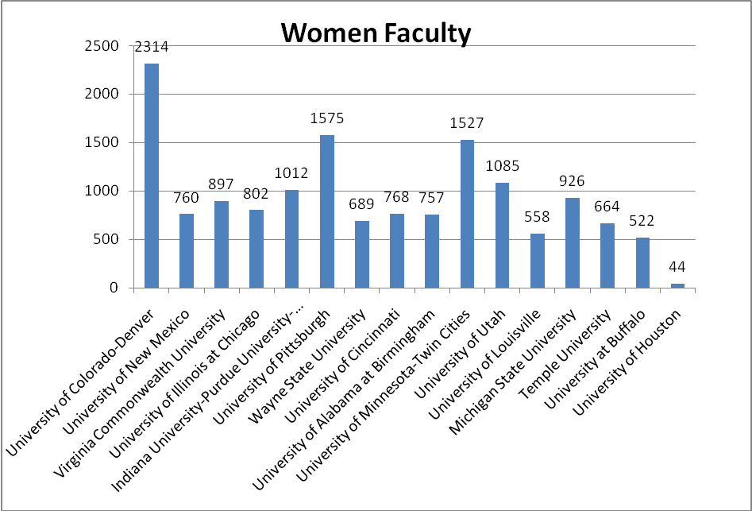
Minority Faculty
In 2009, Wayne State University employed 538 minorities in Full Time Faculty positions. In terms of faculty diversity, Wayne State ranks 2nd among its national peer institutions in total minority faculty with 29.72% of its faculty being minority.

2009 Total Minority Faculty
College | Total Full Time Faculty | Total Minority Faculty | Percentage | Rank
Indiana University-Purdue University-Indianapolis | 2,567 | 774 | 30.15% | 1
Wayne State University | 1,810 | 538 | 29.72% | 2
University of Illinois at Chicago | 1,925 | 505 | 26.23% | 3
University of Pittsburgh | 4,110 | 1,043 | 25.38% | 4
University of New Mexico | 1,731 | 401 | 23.17% | 5
University of Alabama at Birmingham | 2,027 | 451 | 22.25% | 6
University of Louisville | 1,561 | 334 | 21.4% | 7
University of Houston | 1,269 | 268 | 21.12% | 8
University at Buffalo | 1,554 | 308 | 19.82% | 9
Michigan State University | 2,623 | 491 | 18.72% | 10
Temple University | 1,896 | 334 | 17.62% | 11
University of Cincinnati | 2,025 | 346 | 17.09% | 12
Virginia Commonwealth University | 2,121 | 352 | 16.6% | 13
University of Minnesota-Twin Cities | 4,100 | 614 | 14.98% | 14
University of Colorado-Denver | 3,961 | 551 | 13.91% | 15
University of Utah | 2,945 | 299 | 10.15% | 16

Total Minority Faculty
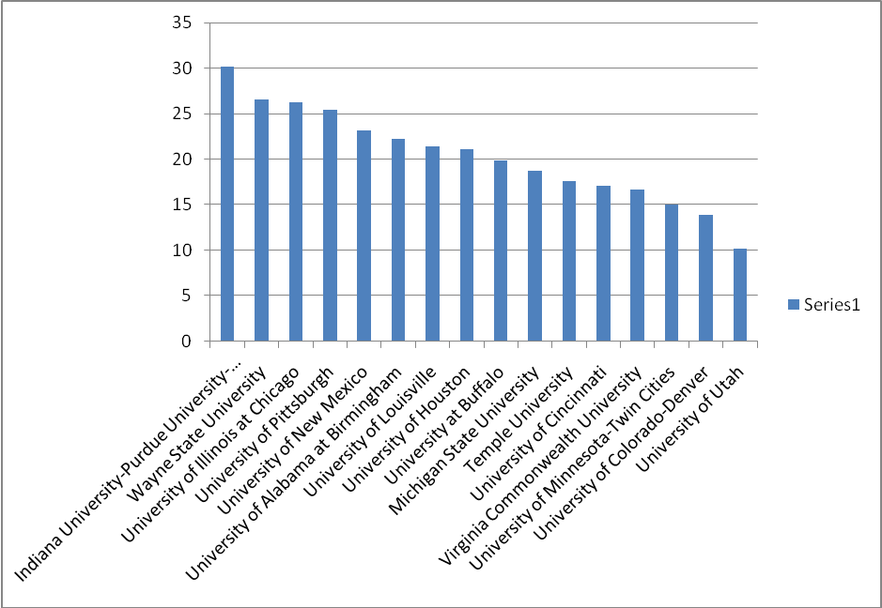

Minority Women Faculty
In 2009, Wayne State University employed 188 minority women faculty members. Wayne State ranks 4th among its national peer institutions in total minority women faculty with 10.39% of the faculty population being minority females.

2009 Minority Women Faculty
College | Total Faculty | Total Minority Women Faculty | Percentage | Rank
University of Illinois at Chicago | 1,925 | 218 | 11.32% | 1
University of New Mexico | 1,731 | 190 | 10.98% | 2
Indiana University-Purdue University-Indianapolis | 2,567 | 280 | 10.91% | 3
Wayne State University | 1,810 | 188 | 10.39% | 4
University of Pittsburgh | 4,110 | 379 | 9.22% | 5
University of Alabama at Birmingham | 2,027 | 182 | 8.98% | 6
University of Colorado-Denver | 3,961 | 336 | 8.48% | 7
University of Houston | 1,269 | 95 | 7.49% | 8
University of Louisville | 1,561 | 112 | 7.17% | 9
Virginia Commonwealth University | 2,121 | 150 | 7.07% | 10
University at Buffalo | 1,554 | 108 | 6.95% | 11
Michigan State University | 2,623 | 179 | 6.82% | 12
Temple University | 1,896 | 127 | 6.7% | 13
University of Cincinnati | 2,025 | 126 | 6.22% | 14
University of Minnesota-Twin Cities | 4,100 | 227 | 5.54% | 15
University of Utah | 2,945 | 110 | 3.74% | 16

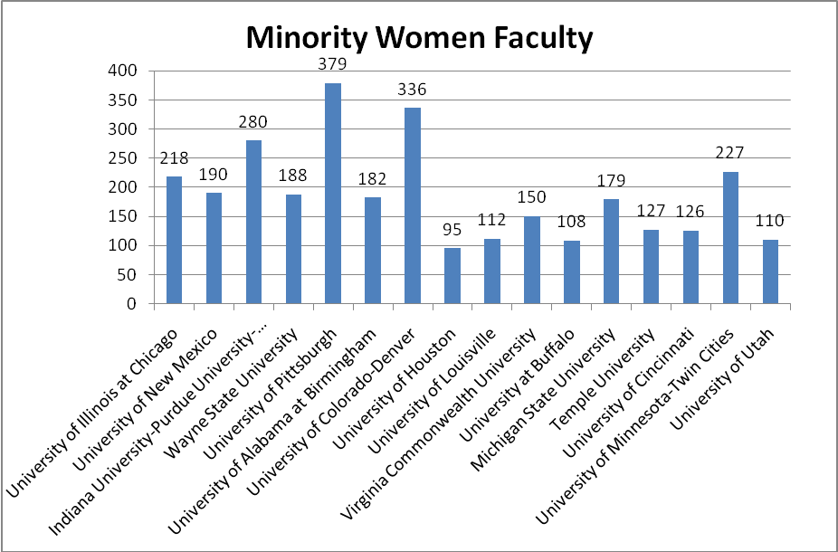

c. Analysis of Senior Leadership Positions (Executive/Administrative/Managerial Employees)

In this section, we provide a series of charts to present Wayne’s performance in a specific occupational category: Executive/Administrative/Managerial employees. As in the sections above, these charts include both a comparison of the Michigan Public Universities and the national peer institutions. The beginning charts present a comparison of women employees in total, along with a breakdown of women employees by race and ethnicity. The concluding charts present a comparison of minority employees in total, along with a breakdown of employees by racial/ethnic groups.

Michigan Public Universities – Women Employees

Michigan Public Universities
Full Time Executive/Administrative and Managerial Women Employees
Institution Name | Total Full time Executive/  Administrative/ Managerial Employees | Total Full Time Women  Executive/  Administrative/ Managerial Employees | Percentage of Total Executive/  Administrative/ Managerial Employees | Rank
Lake Superior State University | 37 | 23 | 62.16% | 1
University of Michigan-Flint | 91 | 55 | 60.44% | 2
University of Michigan-Ann Arbor | 1,699 | 965 | 56.80% | 3
Grand Valley State University | 204 | 112 | 54.90% | 4
University of Michigan-Dearborn | 83 | 42 | 50.60% | 5
Central Michigan University | 129 | 63 | 48.84% | 6
Michigan State University | 343 | 157 | 45.77% | 7
Ferris State University | 168 | 75 | 44.64% | 8
Wayne State University | 240 | 103 | 42.92% | 9
Oakland University | 59 | 25 | 42.37% | 10
Western Michigan University | 80 | 33 | 41.25% | 11
Saginaw Valley State University | 95 | 39 | 41.05% | 12
Eastern Michigan University | 153 | 62 | 40.52% | 13
Northern Michigan University | 65 | 24 | 36.92% | 14
Michigan Technological University | 79 | 24 | 30.38% | 15

Michigan Public Universities – Women Employees by Primary Ethnicity

Michigan Public Universities
2009 Full Time Executive/Administrative/Managerial Women Employees by Primary Ethnicity
Institution Name | American Indian or  Alaska Native | Asian/  Native Hawaiian/  Other Pacific Islander | Black or African American/  Black  Non-Hispanic | Hispanic or Latino/  Hispanic | Total  Full Time  Minority Women
University of Michigan-Ann Arbor | 4 | 24 | 75 | 15 | 118
Wayne State University | 0 | 2 | 23 | 0 | 25
Grand Valley State University | 3 | 1 | 12 | 5 | 21
Michigan State University | 0 | 4 | 16 | 1 | 21
Eastern Michigan University | 0 | 3 | 6 | 1 | 10
Central Michigan University | 2 | 2 | 5 | 0 | 9
University of Michigan-Flint | 1 | 1 | 6 | 1 | 9
University of Michigan-Dearborn | 0 | 0 | 7 | 1 | 8
Western Michigan University | 0 | 0 | 5 | 1 | 6
Oakland University | 0 | 0 | 4 | 0 | 4
Saginaw Valley State University | 0 | 0 | 2 | 1 | 3
Northern Michigan University | 2 | 0 | 0 | 0 | 2
Ferris State University | 0 | 1 | 0 | 0 | 1
Lake Superior State University | 1 | 0 | 0 | 0 | 1
Michigan Technological University | 0 | 1 | 0 | 0 | 1

National Peer Universities – Women Employees

National Peer Universities
2009 Full Time Executive/Administrative and Managerial Women Employees
Institution Name | Total Full time Executive/  Administrative/  Managerial Employees | Total Full time Women Executive/  Administrative/ Managerial Employees | Percentage of Total Executive/  Administrative/ Managerial Employees | Rank
University of Illinois at Chicago | 1,025 | 651 | 63.51% | 1
University of Colorado-Denver | 403 | 253 | 62.78% | 2
University of Minnesota-Twin Cities | 2,396 | 1,387 | 57.89% | 3
University of Cincinnati | 625 | 351 | 56.16% | 4
University of Pittsburgh | 549 | 296 | 53.92% | 5
Temple University | 904 | 474 | 52.43% | 6
University at Buffalo | 189 | 92 | 48.68% | 7
University of Houston | 127 | 61 | 48.03% | 8
Michigan State University | 343 | 157 | 45.77% | 9
Virginia Commonwealth University | 247 | 112 | 45.34% | 10
University of New Mexico | 139 | 62 | 44.60% | 11
University of Utah | 293 | 128 | 43.69% | 12
Wayne State University | 240 | 103 | 42.92% | 13
University of Alabama at Birmingham | 252 | 107 | 42.46% | 14
University of Louisville | 128 | 54 | 42.19% | 15
Indiana University-Purdue University-Indianapolis | 237 | 95 | 40.08% | 16

National Peer Universities– Women Employees by Primary Ethnicity

National Peer Universities
2009 Full Time Executive/Administrative and Managerial Women by Primary Ethnicity
Institution Name | American Indian or  Alaska Native | Asian/  Native Hawaiian/  Other Pacific Islander | Black or African American/Black  Non-Hispanic | Hispanic or Latino/Hispanic | Total  Full Time  Minority Women
University of Illinois at Chicago | 2 | 51 | 132 | 60 | 245
University of Minnesota-Twin Cities | 10 | 52 | 48 | 22 | 132
Temple University | 0 | 18 | 100 | 13 | 131
University of Cincinnati | 0 | 4 | 55 | 2 | 61
University of Colorado-Denver | 2 | 10 | 4 | 17 | 33
Wayne State University | 0 | 2 | 23 | 0 | 25
University of Pittsburgh | 0 | 6 | 16 | 1 | 23
Michigan State University | 0 | 4 | 16 | 1 | 21
University of Houston | 0 | 8 | 8 | 5 | 21
Virginia Commonwealth University | 1 | 0 | 15 | 3 | 19
University of Alabama at Birmingham | 0 | 0 | 14 | 1 | 15
University of New Mexico | 2 | 0 | 1 | 11 | 14
Indiana University-Purdue University-Indianapolis | 0 | 4 | 8 | 1 | 13
University at Buffalo | 0 | 3 | 10 | 0 | 13
University of Utah | 0 | 5 | 4 | 2 | 11
University of Louisville | 0 | 0 | 3 | 0 | 3

Michigan Public Universities – Minority Employees

Michigan Public Universities
2009 Full Time Executive/Administrative and Managerial Minority Employees
Institution Name | Total Full Time Executive/  Administrative/ Managerial Employees | Total Full Time Minority Executive/  Administrative/ Managerial Employees | Percentage of Total Executive/  Administrative/ Managerial Employees | Rank
Wayne State University | 240 | 53 | 22.08% | 1
University of Michigan-Flint | 91 | 17 | 18.68% | 2
Grand Valley State University | 204 | 35 | 17.16% | 3
University of Michigan-Dearborn | 83 | 13 | 15.66% | 4
Western Michigan University | 80 | 12 | 15.00% | 5
Eastern Michigan University | 153 | 22 | 14.38% | 6
Central Michigan University | 129 | 18 | 13.95% | 7
Oakland University | 59 | 8 | 13.56% | 8
University of Michigan-Ann Arbor | 1,699 | 216 | 12.71% | 9
Michigan State University | 343 | 34 | 9.91% | 10
Saginaw Valley State University | 95 | 9 | 9.47% | 11
Northern Michigan University | 65 | 4 | 6.15% | 12
Michigan Technological University | 79 | 4 | 5.06% | 13
Ferris State University | 168 | 5 | 2.98% | 14
Lake Superior State University | 37 | 1 | 2.70% | 15

Michigan Public Universities – Minority Employees by Primary Ethnicity

Michigan Public Universities
2009 Full Time Executive/Administrative/Managerial Minority Employees by Primary Ethnicity
Institution Name | American Indian or  Alaska Native | Asian/  Native Hawaiian/  Other Pacific Islander | Black or African American/Black  Non-Hispanic | Hispanic or Latino/Hispanic | Total  Full Time  Minority
University of Michigan-Ann Arbor | 8 | 46 | 134 | 28 | 216
Wayne State University | 0 | 7 | 44 | 2 | 53
Grand Valley State University | 3 | 1 | 23 | 8 | 35
Michigan State University | 1 | 7 | 21 | 5 | 34
Eastern Michigan University | 0 | 4 | 15 | 3 | 22
Central Michigan University | 3 | 3 | 10 | 2 | 18
University of Michigan-Flint | 2 | 1 | 13 | 1 | 17
University of Michigan-Dearborn | 0 | 2 | 8 | 3 | 13
Western Michigan University | 0 | 2 | 9 | 1 | 12
Saginaw Valley State University | 0 | 0 | 6 | 3 | 9
Oakland University | 0 | 4 | 4 | 0 | 8
Ferris State University | 0 | 1 | 4 | 0 | 5
Michigan Technological University | 0 | 4 | 0 | 0 | 4
Northern Michigan University | 2 | 1 | 0 | 1 | 4
Lake Superior State University | 1 | 0 | 0 | 0 | 1

National Peer Universities – Minority Employees

National Peer Universities
2009 Full Time Executive/Administrative and Managerial Minority Employees
Institution Name | Total Full time Executive/  Administrative/ Managerial Employees | Total Full Time Minority Executive/  Administrative/ Managerial Employees | Percentage of Total Executive/  Administrative/ Managerial Employees | Rank
University of Illinois at Chicago | 1,025 | 349 | 34.05% | 1
Temple University | 904 | 232 | 25.66% | 2
University of Houston | 127 | 32 | 25.20% | 3
University of New Mexico | 139 | 34 | 24.46% | 4
Wayne State University | 240 | 53 | 22.08% | 5
University of Cincinnati | 625 | 96 | 15.36% | 6
University at Buffalo | 189 | 25 | 13.23% | 7
University of Alabama at Birmingham | 252 | 33 | 13.10% | 8
Indiana University-Purdue University-Indianapolis | 237 | 31 | 13.08% | 9
Virginia Commonwealth University | 247 | 32 | 12.96% | 10
University of Colorado-Denver | 403 | 52 | 12.90% | 11
University of Minnesota-Twin Cities | 2396 | 276 | 11.52% | 12
University of Louisville | 128 | 14 | 10.94% | 13
Michigan State University | 343 | 34 | 9.91% | 14
University of Pittsburgh | 549 | 44 | 8.01% | 15
University of Utah | 293 | 17 | 5.80% | 16

National Peer Universities – Minority Employees by Primary Ethnicity

National Peer Universities
2009 Full Time Executive/Administrative and Managerial Minority Employees by Primary Ethnicity
Institution Name | American Indian or  Alaska Native | Asian/  Native Hawaiian/  Other Pacific Islander | Black or African American/Black  Non-Hispanic | Hispanic or Latino/Hispanic | Total  Full Time  Minority
University of Illinois at Chicago | 2 | 68 | 184 | 95 | 349
University of Minnesota-Twin Cities | 16 | 120 | 96 | 44 | 276
Temple University | 3 | 39 | 166 | 24 | 232
University of Cincinnati | 1 | 9 | 82 | 4 | 96
Wayne State University | 0 | 7 | 44 | 2 | 53
University of Colorado-Denver | 2 | 14 | 11 | 25 | 52
University of Pittsburgh | 0 | 10 | 32 | 2 | 44
Michigan State University | 1 | 7 | 21 | 5 | 34
University of New Mexico | 4 | 2 | 3 | 25 | 34
University of Alabama at Birmingham | 0 | 0 | 31 | 2 | 33
University of Houston | 0 | 10 | 13 | 9 | 32
Virginia Commonwealth University | 2 | 5 | 22 | 3 | 32
Indiana University-Purdue University-Indianapolis | 1 | 13 | 16 | 1 | 31
University at Buffalo | 1 | 5 | 15 | 4 | 25
University of Utah | 1 | 5 | 5 | 6 | 17
University of Louisville | 0 | 1 | 13 | 0 | 14

II. UNIVERSITY COMPLAINTS OF DISCRIMINATION AND HARASSMENT

The Office of Equal Opportunity (“OEO”) is responsible for investigating complaints arising under the University’s Non-Discrimination Policy and Sexual Harassment Statute. When contacted by a potential Complainant, the OEO first assesses whether the allegations fall within the scope of the Non-Discrimination or Sexual Harassment policies. If not, the OEO will refer the Complainant to the proper forum to address the issue, such as Human Resources, Labor Relations, the Ombudsperson or the Dean of Students Office.

If the allegations fall within OEO’s jurisdiction, the OEO conducts an initial inquiry into the complaint. Initial inquires are used to determine if there is sufficient factual support for the allegations to warrant a full investigation. Initial inquires are typically completed within two weeks. In some cases, the initial inquiry itself resolves the matter.

If the initial inquiry has merit and OEO determines that the allegations, if substantiated, would be reasonably likely to result in the need for the University to take prompt remedial measures, a formal complaint is initiated. Formal complaints are adjudicated by using the formal procedures structured by University Policy 2005-03.

The OEO also serves as the university point of contact in the response to complaints of discrimination and harassment brought to external agencies, such as the Michigan Department of Civil Rights (“MDCR”), the United States Equal Employment Opportunity Commission (“EEOC”), the United States Department of Education, Office of Civil Rights (“OCR”), and the Department of Labor, Office of Federal Contract Compliance Programs (“OFCCP”). For purposes of this report, such charges are included as “formal complaints.”

During the 2009 calendar year, the OEO received 24 initial inquiries 3 of which became formal complaints. An additional 13 complaints were filed externally with governmental agencies, for a total of 16 formal complaints.

Comparison of Inquiries vs. Formal Complaints
For calendar year 2009 – Chart 9

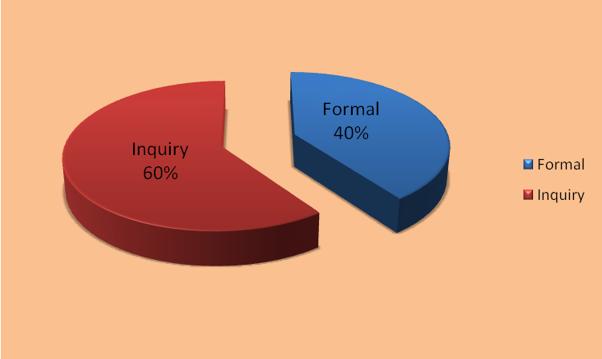

9 of the total 16 formal complaints filed in 2009 were closed without a finding of a University policy or statutory violation. There were findings of “no violation” by governmental agencies in 100% of the external complaints handled by the OEO. The OEO found a violation of University policy in an internal complaint case a sexual harassment case involving two complainants against one respondent, and in a retaliation complaint, and recommended disciplinary action and appropriate remedial measures in each case to ensure that the violation did not recur.

Three-Year Initial Inquiries and Formal Complaint Activity Comparison
For calendar Year 2009 - Chart 10

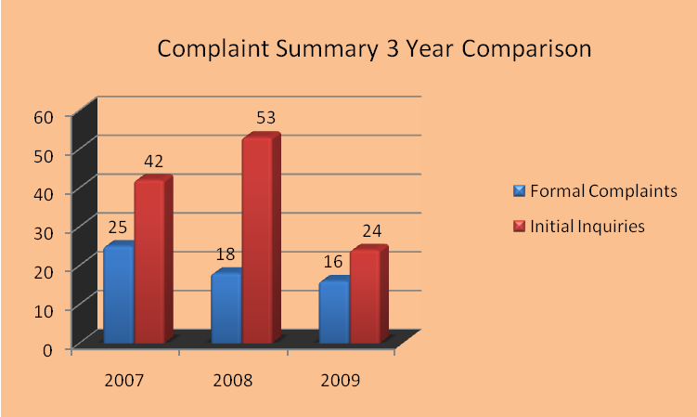

The 2009 data represents a 55% decrease from 53 inquiries in 2008. While the number of inquiries decreased, the number of formal complaints also decreased from 18 to 16 in 2009, which reflects a 11% reduction in the number of formal complaints with outside government agencies.

Complaints are categorized by the primary type of discrimination claim made by the Complainant, e.g., race discrimination, sexual harassment, or age discrimination. 8 of the 16 total formal complaints received in the year 2009 involved claims of race discrimination, 5 were for sexual harassment, and 2 were discrimination based on disability. In addition, there was 1 failure to promote claim based on arrest record. In 2007, the top three claims were race discrimination (7), sexual harassment (8), and disability (3).

Complaints are categorized by the primary nature of the complaint, even if multiple claims of discrimination are also included. For example, a complaint of race discrimination and retaliation is simply categorized as a race discrimination complaint for purposes of Chart 11, below. In 2009, 6 of the 16 formal complaints also included multiple claims.

Total Complaint Activity by Type of Claim
For calendar year 2009 – Chart 11

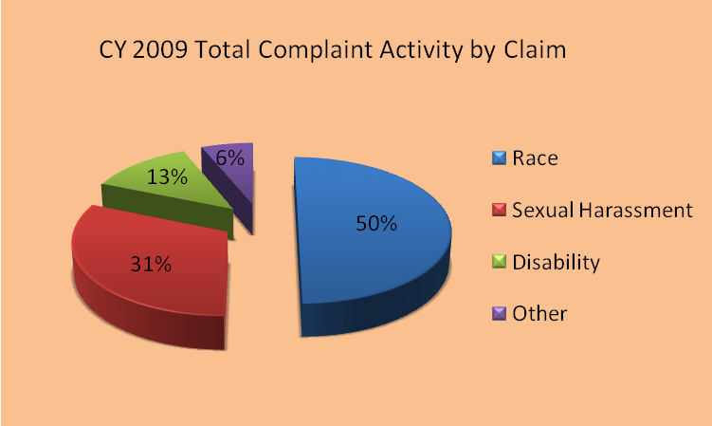

The OEO also categorizes complaints by the federal statute that includes each protected classification. In 2009, there was a decrease in disability claims being filed. In 2009, 87% of the complaints involved classifications protected by Title VII and 13% by the Americans with Disabilities Act (“ADA”). This decrease in disability claims stands in contrast to the claims filed in 2008, where 83% of the claims potentially fell under Title VII of the Civil Rights Act of 1991, and 17% fell under the Age Discrimination in Employment Act (“ADEA”).

Total Complaint Activity by Federal Statute
For calendar year 2009 – Chart 12

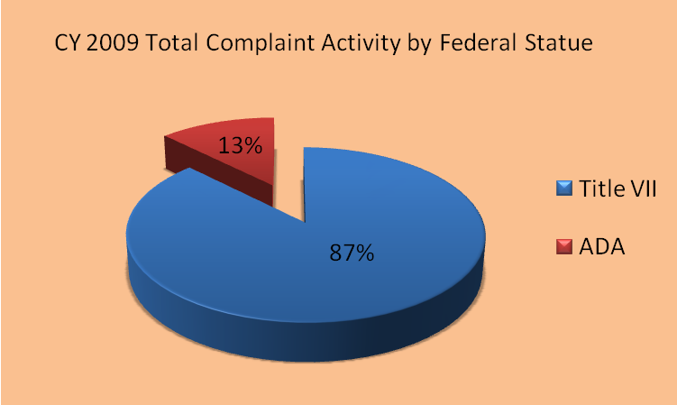

Since the majority of OEO's complaint activity falls under Title VII, the chart below also depicts how the complaints are distributed in the classifications protected by Title VII.

Breakdown of Complaints under Title VII
For calendar year 2009 – Chart 13

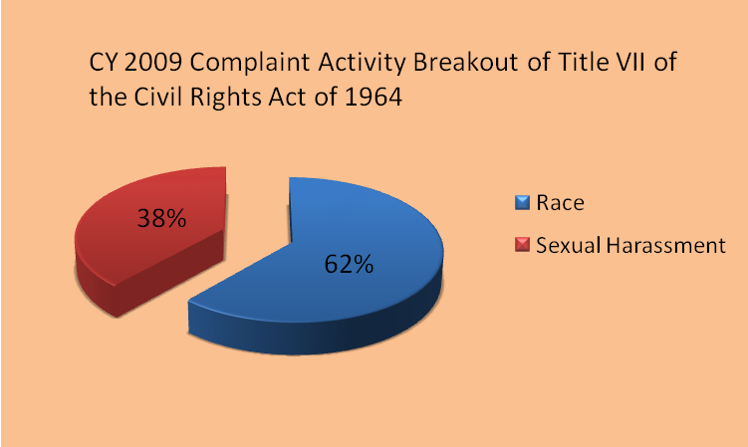

The OEO is proactive in matters of discrimination and harassment by working closely with Human Resources and Labor Relations. The OEO collaborates with these offices to design and implement employee education programs on a University-wide basis. Specific training about sexual harassment which emphasizes the duty of care owed by managers and supervisors and their role in taking proactive and preventative measures to ensure a workplace free from harassment and discrimination is offered regularly. OEO also continues to provide customized training to departments and units upon request and as a remedial measure following a complaint.

III. WAYNE STATE UNIVERSITY SUPPLIER DIVERSITY PROGRAM

Through the Supplier Diversity Program, Wayne actively reaches out to minority, woman-owned, and physically challenged business enterprises (“M/W/PCBE”). The program provides outreach, mentoring, and networking opportunities, and in many cases has led to successful business relationships. We have undertaken a number of initiatives to build upon the program successes and to encourage greater participation of the minority, woman-owned and the physically challenged enterprises. These initiatives are described at the end of this section. Overall expenditures decreased by 11.2%. Construction/renovation expenditures decreased by 80.7% from the previous year primarily due to the completion of the construction of the Marvin I. Danto Engineering Development Center, the Richard Mazurek Medical Education Commons and the steam boiler projects. General purchases for goods and services increased by 32.73%.

A. Construction and Professional Service Contracts Related to Construction

Total dollars awarded for all construction and professional service contracts (primary and subcontracts) amounted to $12.9 million in FY 2008-09 compared to $66.6 million in FY 2007-08. In FY 2008-09, 2% of the contracts were awarded to minority-owned construction businesses, compared to 5% in FY 2007-08. Women-owned construction firms captured 6% of the contracts in FY 2008-09, compared to 1% in FY 2007-08.

Comparison of Total Construction Contract Awards
(Charts 14 and 15)

Total Awards of $66,600,000
Total Awards of $12,900,000

B. General Purchasing (Goods and Services excluding construction)

Funds expended for general purchases of goods and services increased to $130.6 million in FY2008-09 from $98.4 million in FY2007-08. In FY 2008-09, 4% of the general purchases were awarded to minority-owned businesses, compared to 1% in FY 2007-08. Women-owned firms captured 5% in FY 2008-09, compared to 9% in FY 2007-08.

Comparison of Total General Purchasing Awards
(Charts 16 and 17)
Total Awards of $98,400,000
Total Awards of $130,600,000

C. Outside Counsel Fees

In fiscal year 2009, Wayne State University made direct payments in outside counsel fees in the gross amount of $1,471,000. Approximately 60% of these payments were made for patent, technology-transfer, and other research-related specialties. The Office of General Counsel received reimbursements in the amount of $236,000 for a net of $1,235,000. Wayne also authorized payments to outside counsel through the Michigan University Self-Insurance Corporation (“MUSIC”) in the amount of $386,000. Of these amounts, direct payments in the amount of $262,000 and MUSIC payments in the amount of $209,000 were made to women and minority-owned law firms.

In actual dollars, women-owned firms were paid $369,000 and minority owned firms were paid $102,000.

Minority Firms

Phifer & White handle nearly all of Wayne’s personal injury work not done within the Office of General Counsel, our landlord-tenant matters, and much of our worker’s compensation legal work. The firm of Albert Nelson, Jr. also handles worker’s compensation cases. Lewis & Munday represent Wayne in litigation and complex real property transactions. The firm of Allen Brothers represents the University in litigation.

Women-owned Firms

Afaf Vicky Farah, a solo practitioner, does the majority of the University’s immigration work. Two firms, Rohm & Monsanto, and Jane Potter Law represent the University in patent matters. Nemeth Burwell represents the University in litigation. Wayne retained female equity partners in the law firms of Cummings, McClorey, Davis & Acho and Kienbaum, Opperwall, Hardy & Pelton to provide representation in various litigation.

D. INVESTMENTS, DEBT, and RISK UNIT

External Investment Management Firms

Of the fourteen external investment management firms contracted to manage University endowment funds, one is minority-owned. The endowment funds invested by the minority-owned firm in FY 2007-08 had a year-end value of $23.7 million, or 10.8% of the total. In FY 2008-09, the minority-owned firm invested $28.1 million, or 12.6% of the total. The value of the funds invested with the minority-owned firm increased by 18.3 %.

Banking Relationships

First Independence Bank, a minority-owned bank, was used to process University Federal tax payments and the self insured health care plan vendor payments for the DMC-PPO.

Debt Issues

Loop Capital Markets LLC and Siebert Brandford Shank & Co., LLC, minority-owned firms, served as bond underwriter co-managers on the $112.4 million Series 2009A (tax-exempt) bond issue in October 2009. Siebert Brandford Shank & Co., LLC, served as a bond underwriter co-manager on the $30.9 million, Series 2009B (tax-exempt) bond issue in December 2009.

E. Other Supplier Diversity Program Initiatives

Michigan Minority Business Development Council (“MMBDC”)

The MMBDC recognizes Wayne as a statewide leader for actively seeking out and extending business opportunities to the minority and women-owned business enterprise community. Wayne State University has received the coveted MMBDC Corporation of the Year – Education Sector Award eight times and is the leader of all educational institutions in earning this statewide recognition. One of the key components to the consideration for the Award is the WSU/Pepsi Project ONE Team. This team was formed more than seven years ago and is the largest of all the 19 Project ONE Teams sponsored by the MMBDC.

21st Annual Minority Conference on Purchasing

On October 8, 2009, Wayne welcomed more than 190 minority-owned enterprises to this annual event. It brought together representatives from across the campus to meet with minority business owners offering a wide variety of goods and services such as construction, snow removal, consulting, and technical support. Representatives from the Computing and Information Technology, Facilities Planning and Management, Marketing, Housing and Purchasing units engaged in networking, information gathering and business-to-business referrals for the minority business owners in attendance. In addition to University representatives, other dialogue hosts included the Detroit Medical Center, the Michigan State-wide Minority Business Development Center, St. John Health System, the Michigan Minority Business Development Council, and the Small Business Administration.

Council of Supplier Diversity Professionals (“CSDP”)

Wayne is a member of the Council of Supplier Diversity Professionals, an organization established in 1988 that is devoted to sharing information, ideas, and issues relative to supplier diversity and to the growth and development of minority and women-owned businesses. Membership in this Council gives us access to directories, seminars, webinars and workshops that expand and enhance our relationships with minority owned business enterprise.

NAWBO and CEED

Wayne’s memberships in the National Association of Women Business Owners (“NAWBO”) and the Center for Empowerment and Economic Development (“CEED”) provide access to the strongest and most active women business owners networking groups. Through their training and certification programs, we connect with the most viable female owned companies.

Wayne actively participates in Corporate Connect and Round Table events throughout the year to meet women business owners and share information on how to do business with the University. These memberships have reaped a tremendous return on our investments. Our expenditures with women owned companies have greatly increased.

Small Business Workshops

The University has a strong presence in the small business community. Our goal is to educate small business owners on our policies and procedures in order to work more effectively with the University. In addition to hosting the Michigan Statewide Minority Business Development Center at a WSU sponsored event (the October Minority Conference), Wayne is actively engaged in a wide variety of conferences and workshops sponsored by the State of Michigan, the City of Detroit, Targeted Business Sector, the Detroit Regional Chamber, the Oakland Regional Chamber and the National Conference for Community and Justice (“NCCJ”).

IV. HIGHLIGHTS OF OFFICE OF EQUAL OPPORTUNITY ACTIVITIES

A. OEO Professional Staff

During 2009, OEO Director Christopher Jones served as a member of the Editorial Board of the Affirmative Action Register (“AAR”) (currently known as Insight into Diversity). The AAR is a leading national equal opportunity employment magazine that connects employers to professionals who are at the forefront of diversity recruiting. As a member of the AAR Editorial Board, Director Jones served with other professionals providing thought leadership and advice on issues of diversity and inclusion on a national level. In staff changes, Ms. Amy Stirling left her position as an equal opportunity specialist (“EOS”) with the OEO to take a position with the Office of General Counsel. Her position was filled by Ms. Kimberly Saks. EOS Saks holds a Juris Doctor, and joins EOS Tanesia Hearon, who holds a Masters of Business Administration from Wayne State University. The addition of Ms. Saks rounds out a full complement of OEO’s professional staff.

B. OEO services and outreach

Outreach efforts continued to promote a diverse environment. OEO continued to provide Faculty Search Committee Training to Colleges and Schools upon request. This training is designed to assist the Search Committees in preparing to search for qualified faculty from a diverse pool. This training also explains the use of the On-line Hiring System in implementing an automated system to execute the hiring of academic staff and the updated technology for the Applicant/Hire process, as well as the OEO Faculty Hiring Plan forms, which require each division to evaluate their full-time faculty data to national availability statistics to demonstrate our efforts to seek diversity in our academic staff.

Training initiatives were continued throughout 2009. In late 2009, the OEO continued to provide training sessions on Sexual Harassment Prevention to both management-level personnel and other staff, in addition to Diversity Training through the Organization and Employee Development Office.

The OEO continues to serve as the ADA Title I Coordinator for Wayne. In this role, the OEO evaluates disability accommodation requests from employees, and serves as a resource regarding issues of accessibility on campus. The OEO Director also serves on the ADA Advisory Committee to address issues of disability at Wayne.

C. Proposal 2

The “Michigan Civil Rights Initiative”, commonly known as “Proposal 2”, was a ballot initiative that became Michigan law on December 22, 2006. The ballot proposal amended the Michigan Constitution to become Article I, Section 26 to bar the use of “preferences” based on race, sex, color, ethnicity or national origin in public employment, contracting, or education. Wayne, Michigan, and Michigan State did not challenge the amendment itself, but asked the court for more time for implementation, which was unsuccessful.

Following the adoption of Proposal 2 in 2006, Wayne, like other universities, conducted extensive reviews of our admissions, financial aid, gift, and contracting policies to ensure compliance with the law. Proposal 2 does not prohibit Federal contractors from “action that must be taken to establish or maintain eligibility.” As a federal contractor, Wayne must comply with the affirmative action efforts in hiring set forth in Executive Order 11246. It is worth noting that as used in Executive Order 11246; “affirmative action” is a term of art akin to “equal opportunity” and does not have the scope traditionally attached to the term.

This is only the second full year for which data have been available since Proposal 2, was adopted. It is increasingly apparent that Proposal 2 has had a significant impact on construction contracts. It is worth noting that as Wayne was required to discontinue the use of preferences in its public contracting, there has been a decline in the monies awarded to minority suppliers. There has been a more modest decline in expenditures with minority firms in other areas, although given the economic conditions and the likelihood of variation from year to year, it would be presumptuous to conclude that this is the direct result of Proposal 2. At this point, we need to continue to measure various indicators to assess the impact of Proposal 2 on Wayne.
APPENDICES

- Definition of EEO Job Categories

- Executive, Administrative and Managerial
Persons whose assignments require primary and major responsibility for management of the institution, or a customarily recognized department or subdivision. Assignments require the performance of work directly related to management policies or general business operations of the institution department or subdivision, etc. Reported in this category are employees holding such positions as president, vice president, dean, director or the equivalent, as well as management employees such as associate and assistant deans, division and academic department heads (chairs), or the equivalent if their principal responsibilities are administrative in nature.

- Faculty (Instruction / Research / Public Service)
Persons whose principal responsibilities customarily are for the purpose of instruction, research or public service and who hold academic-rank titles of professor, associate professor, assistant professor, instructor, lecturer or the equivalent Reported in this category are deans, directors or the equivalent, as well as associate deans, assistant deans and executive officers of academic departments (chairs, heads, or the equivalent). This definition does not include student teaching or research assistants or medical interns or residents.

- Other Professionals (Support / Service)
Persons employed for the primary purpose of performing academic support, student service and institutional support activities, and whose assignments would require either college graduation or experience that would provide a comparable background. Includes positions such as librarians, accountants, personnel professionals, counselors, systems analysts, coaches and assistant general counsel.

- Clerical / Secretarial
Includes administrative support occupations, including all clerical-type work regardless of level of difficulty, where the activities are predominately non-manual, though some manual work not directly involved with altering or transporting the products is included.

- Technical / Paraprofessional
Persons whose assignments require special knowledge or skills that may be acquired through experience or academic work as offered in many two-year technical institutions and junior colleges, or through equivalent on-the-job training. Includes computer programmers and operators, drafters, engineering aides, junior engineers, mathematical aides, licensed practical or vocational nurses, dietitians, photographers, radio operators, scientific assistants, technical illustrators, technicians (medical, dental, electronic, physical sciences), and similar occupational-activity categories that are institutionally defined as technical assignments.

- Skilled Trades / Crafts
Persons whose assignments typically require special manual skills, and a thorough and comprehensive knowledge of the processes involved in the work, as acquired through on-the-job training and experience, or through apprenticeship or other formal training programs. Includes mechanical operators and repairers, electricians, stationary engineers, skilled machinists, carpenters, compositors and typesetters, and upholsterers.

- Service / Maintenance
Persons whose assignments require limited degrees of previously acquired skills and knowledge. Persons who perform duties that result in or contribute to the comfort, convenience and hygiene of personnel and students, or that contribute to the upkeep and care of buildings, facilities or grounds of the institution. Includes chauffeurs, laundry and dry-cleaning operators, cafeteria and restaurant workers, truck drivers, bus drivers, garage laborers, custodial personnel, gardeners and groundskeepers, refuse collectors, construction laborers and security personnel.

II. Responsibility for Affirmative Action

Wayne State University’s President has overall responsibility for implementation of the Wayne State University Affirmative Action/Equal Opportunity Program. Wayne has assigned primary management responsibility and accountability for ensuring full compliance with the program to the Office of Equal Opportunity, which reports to the Vice President and General Counsel. The Director of Equal Opportunity has the authority and resources, as well as the support of and access to the executive management, to ensure effective implementation of the Affirmative Action Program. The President actively supports the program and provides assistance whenever needed, making managers and supervisors aware of the program and requesting their cooperation and assistance.

Office of Equal Opportunity is responsible for the following:

- Developing policy statements, Affirmative Action Plan programs, methods, and internal and external communication techniques. Policies and procedures will continue to be developed to ensure an efficient and positive interaction between the Office of Equal Opportunity and managers charged with hiring staff.

- Assisting management and supervisors in devising solutions to equal employment problems, including counseling and training, to ensure full understanding of affirmative action and equal employment opportunity (“EEO”) policies and procedures.

- Designing and implementing monitoring and reporting methods to measure the effectiveness of Wayne’s program; to indicate need for remedial action; and to determine the degree to which Wayne’s goals and objectives are being met.

- Providing management a working understanding of the goals and objectives in Wayne's Affirmative Action Plan.

- Meeting with managers, supervisors, and employees to assure that Wayne's EEO policies are being followed.

- Acting as a liaison between Wayne and enforcement agencies.

- Acting as a liaison between Wayne and appropriate minority and women's organizations and community action groups concerned with employment opportunities for minorities and women.
13
- Supporting contact between Wayne and predominately female and minority high schools, colleges, and technical schools in the area as needed.

- Keeping management informed of developments in the EEO and affirmative action field.

- Conducting a periodic audit to ensure that Wayne complies in the following ways:

- Making sure EEO posters are properly displayed.

- Making sure that all University employees have the opportunity and are encouraged to participate in University-sponsored educational, training, recreational and social activities.

III. Definition of Terms

Black: A person having origins in any of the black racial groups of Africa, but not Hispanic.

Asian or Pacific Islander: A person having origins in any of the original people of the Far East, Southeast Asia, the Indian subcontinent or the Pacific Islands.

Hispanic: A person of Mexican, Puerto Rican, Cuban, Central or South American, or other Spanish culture or origin, regardless of race.

Native American or Alaskan Native: A person having origins in any of the original peoples of North America, and who maintains cultural identification through tribal affiliation or community recognition.

Caucasian or White: A person who is not included in any of the four ethnic identifications listed above.

Disability: Defined by both state and federal law. Generally, refers to a person who has a physical or mental impairment that substantially limits one or more major life activities, or has a record of such impairment, or is regarded as having such impairment.

Americans with Disabilities Act:

In the first instance, disability status is self-identified by faculty, staff and students.

IV. Academic Classifications

Professor: Includes full professor, distinguished professor, visiting professor, university professor, and professor (clinical), professor (research).

Associate Professor: Includes visiting associate professor, associate professor (clinical), associate professor (research).
Assistant Professor: Includes visiting assistant professor, assistant professor (clinical), assistant professor (research).

V. Other Employee Definitions

Full-time Employee: Academic staff and non-academic employees whose assignments add up to a full-time equivalency (“FTE”) of 1.0.

Full-time Faculty: Faculty whose assignments are tenure or non-tenure system with a FTE of .50 or above.

Tenure-System Faculty: Faculty appointed to the tenure-system or granted tenure by Board of Governors Statute. Faculty in the tenure-system may hold an academic rank of Professor, Associate Professor and Assistant Professor.

Fractional-time Employee: Academic and non-academic employees whose assignments add up to a FTE of 0.50 to 0.99.

Casual or Part-time Employee: Academic and non-academic employees whose assignments add up to 0.49 or less assignments add up to 0.49 or less.

VI. 2008 Data Tables

2008 Total Full Time Academic and Non Academic Employee Headcount
As of 12/31/2008 - Table 9

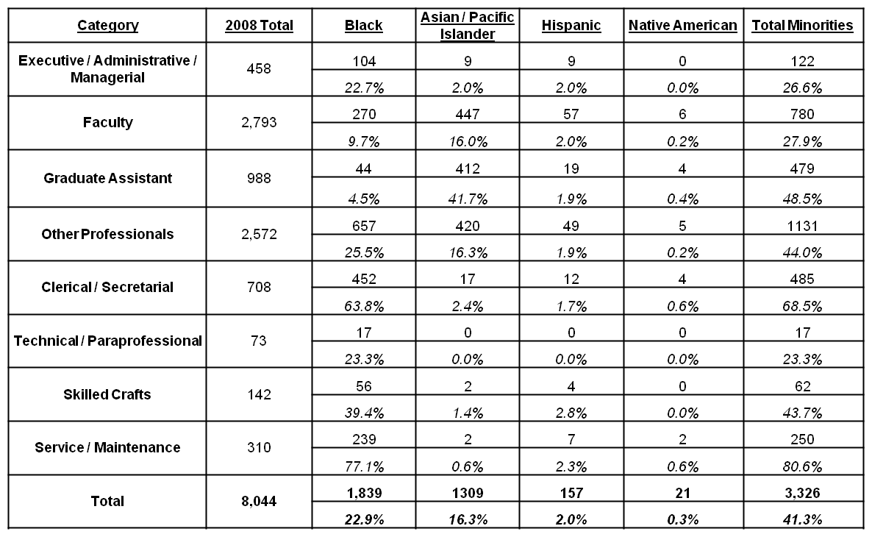

2008 Full-Time Tenure and Non-Tenure System Faculty
As of 12/31/08 - Table 10

Rank | 2008 Faculty Total | Difference from 2007 | Black | Asian / Pacific Islander | Hispanic | Native American | Total Minority | Women
Tenure System | 1,032 | 17 | 57 | 199 | 30 | 2 | 288 | 312
Tenure System |  |  | 5.5% | 19.3% | 2.9% | 0.2% | 27.9% | 30.2%
Non-Tenure System | 743 | 29 | 65 | 150 | 15 | 1 | 231 | 362
Non-Tenure System |  |  | 8.7% | 20.2% | 2.0% | 0.1% | 31.1% | 48.7%
Total | 1,835 | 46 | 122 | 349 | 45 | 3 | 519 | 674
Total |  |  | 6.9% | 19.7% | 2.5% | 0.2% | 29.2% | 38.0%

2008 Total Tenure-System Faculty by Rank
As of 12/31/08 - Table 11

Rank | Faculty Total | Difference from 2007 | Black | Asian / Pacific Islander | Hispanic | Native American | Total Minority | Women
Professor | 449 | -5 | 88 | 91 | 10 | 0 | 111 | 79
Professor |  |  | 2.9% | 19.6% | 2.2% | 0.00% | 24.7% | 17.6%
Associate  Professor | 342 | 20 | 19 | 51 | 9 | 1 | 80 | 128
Associate  Professor |  |  | 5.6% | 14.9% | 2.6% | 0.3% | 23.4% | 37.4%
Assistant  Professor | 241 | 2 | 25 | 60 | 11 | 1 | 97 | 105
Assistant  Professor |  |  | 10.4% | 24.9% | 4.6% | 0.4% | 40.2% | 43.6%
Total | 1,032 | 17 | 62 | 198 | 28 | 2 | 290 | 318
Total |  |  | 5.5% | 19.3% | 2.9% | 0.2% | 27.9% | 30.2%

VII. Five Year Comparison Graphs – 2004-2008

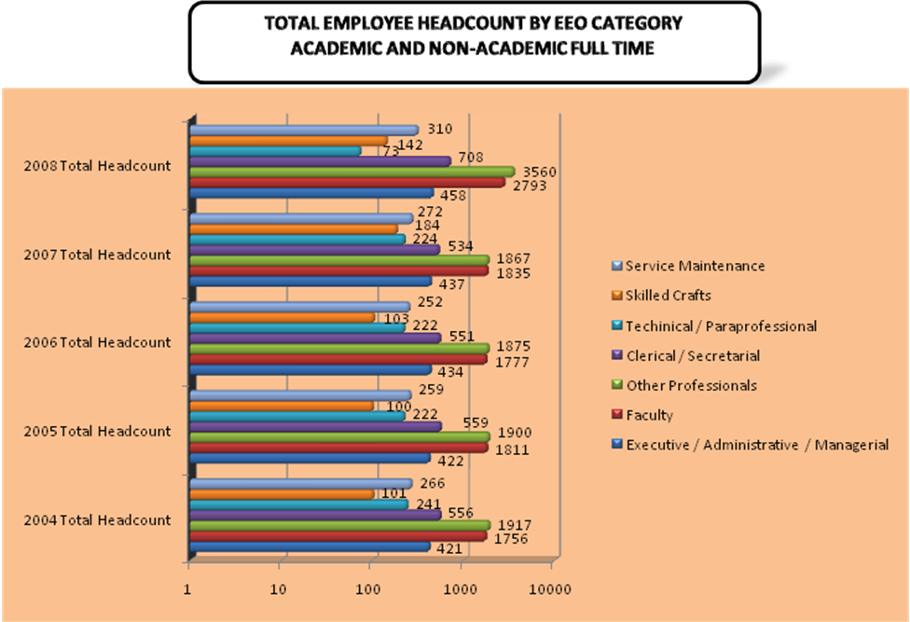

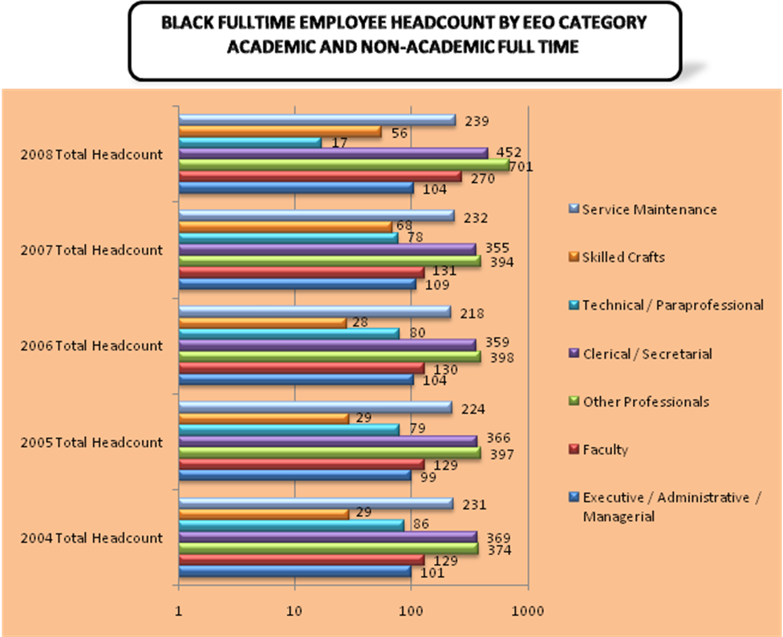
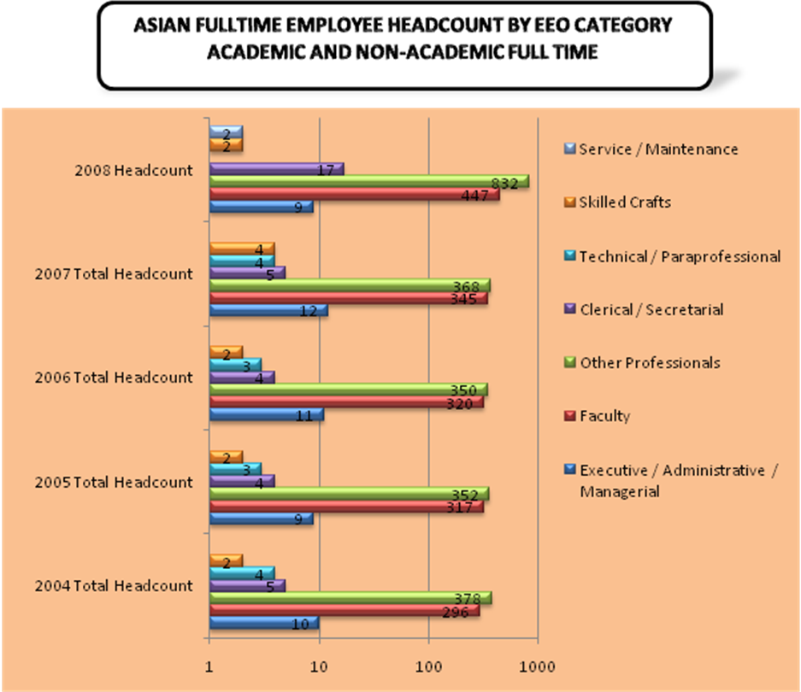

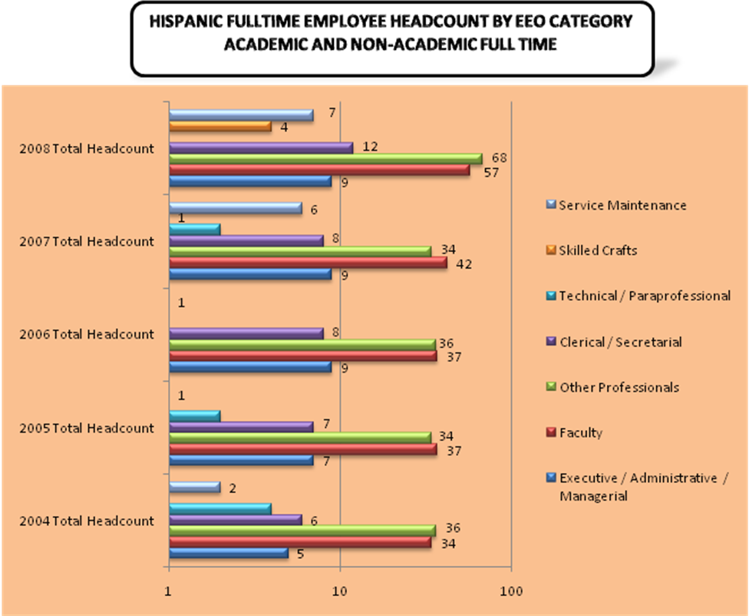

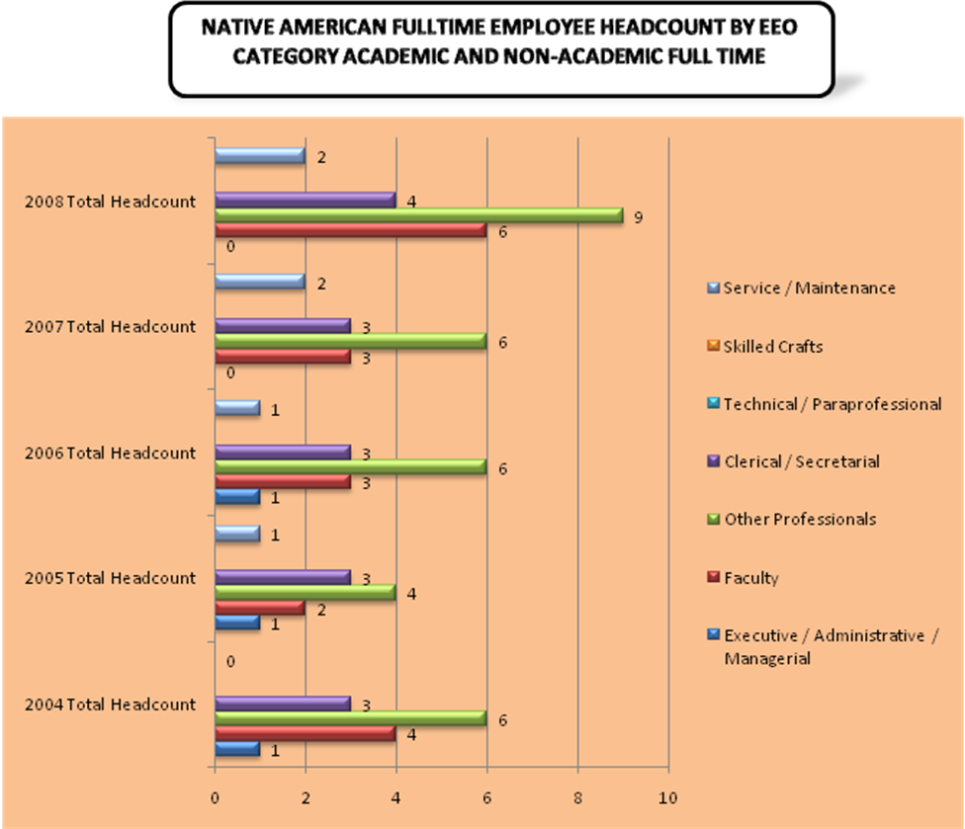

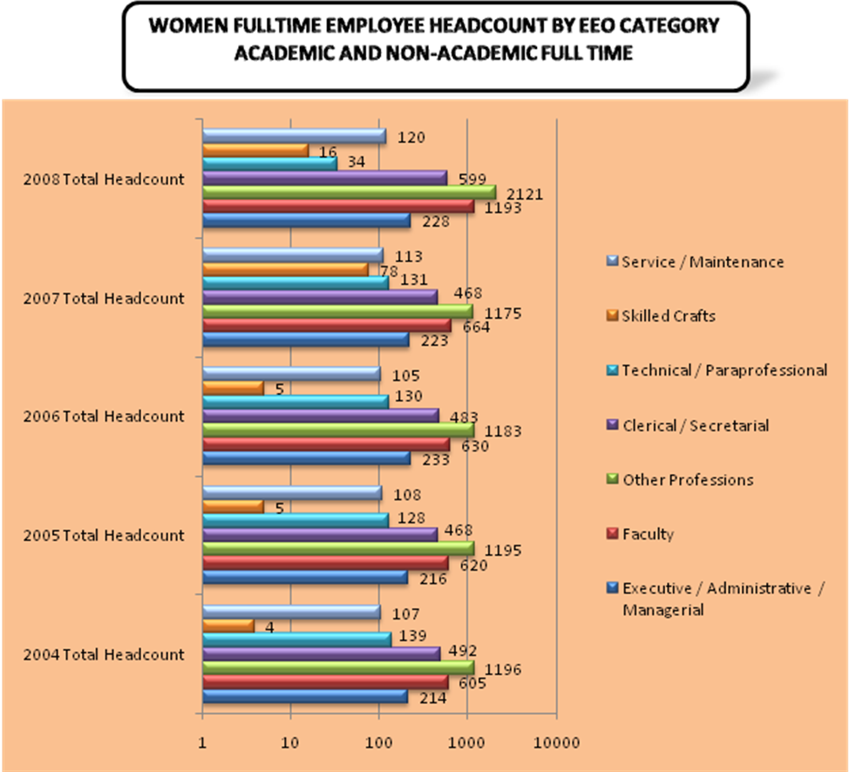

VIII. Comparison by Occupational Category

Here, we provide an additional series of charts that set forth the percentage of employees in each of the following defined occupational categories: Faculty, Executive/Administrative, Managerial, Other Professionals, Technical and Paraprofessionals, Clerical and Secretarial, Skilled Crafts, and Service/Maintenance. The charts for the Michigan Public Universities present three areas for comparison: (1) the Wayne percentage, (2) the average for all Michigan Public Universities, and (3) the average for the Michigan Public Universities, excluding those institutions in the Upper Peninsula. The reason for this exclusion in the third area is to account for the difference in population demographics for these distinct regions of the state. The charts for the national peer institutions present a comparison of Wayne against the average for all peer institutions.

Michigan Public Universities

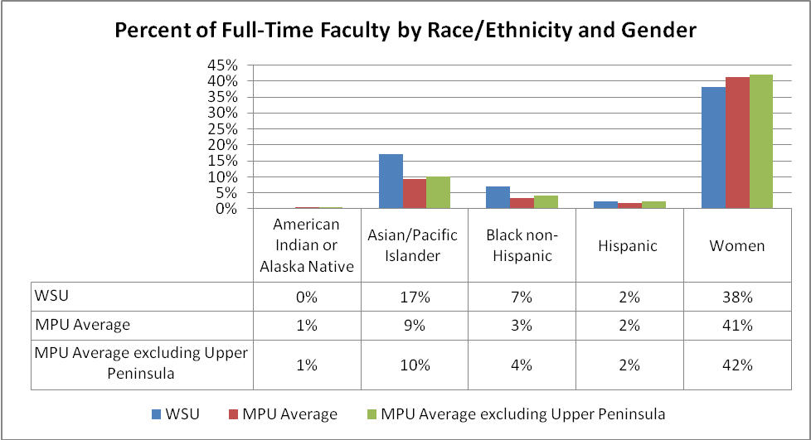

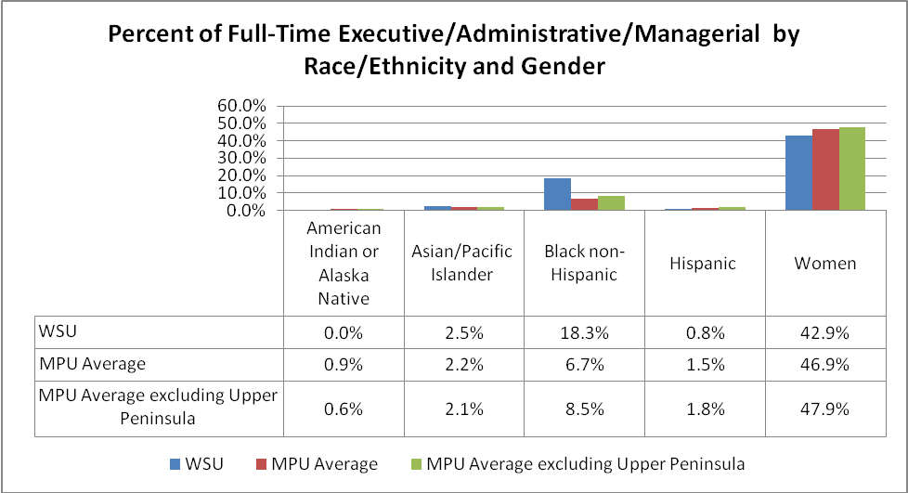

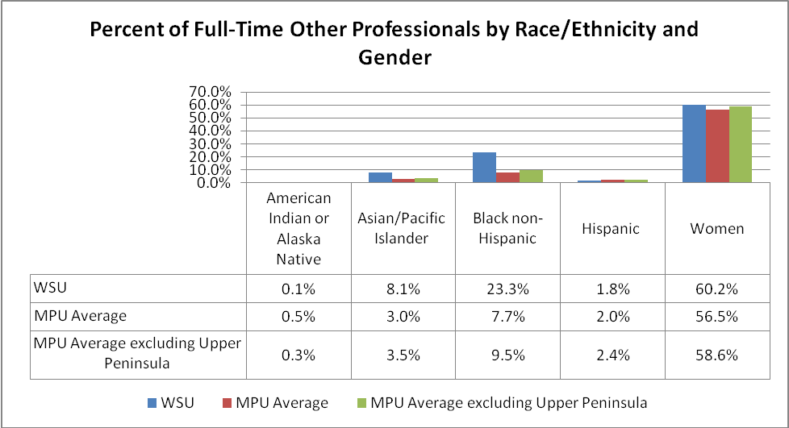

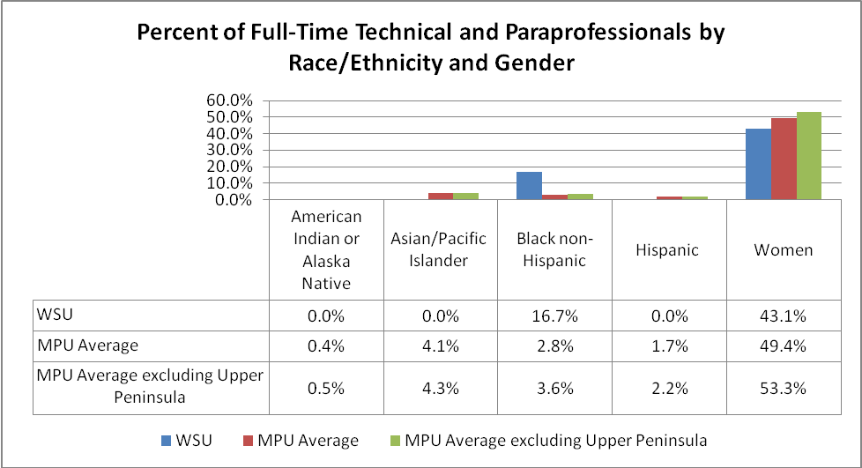

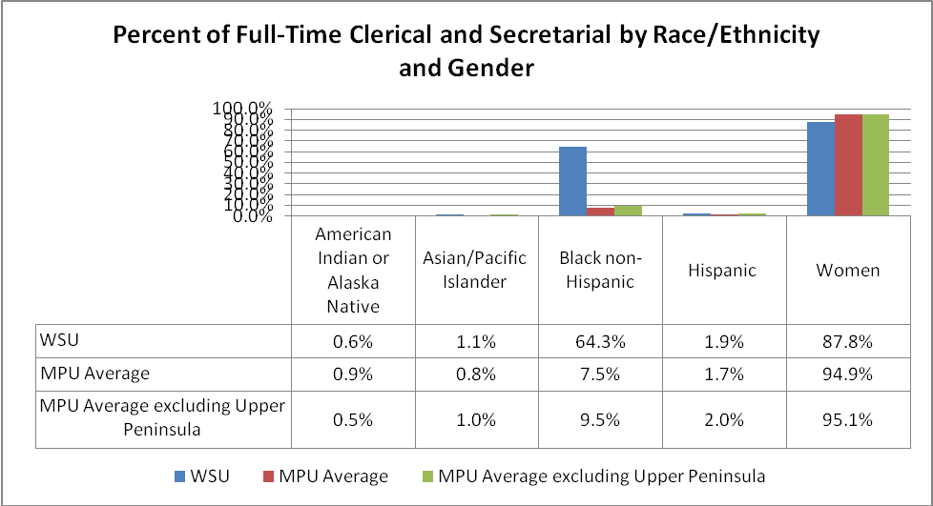

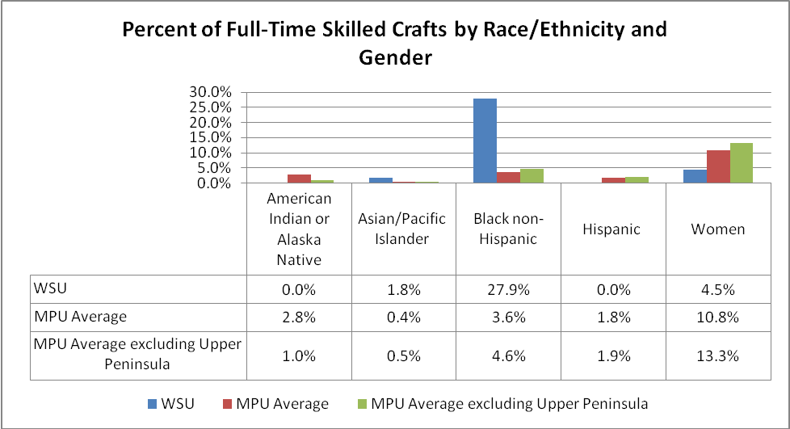

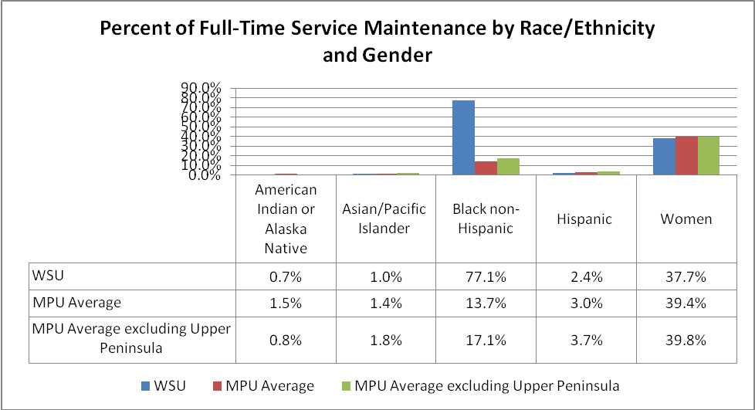

15 Peer Institutions

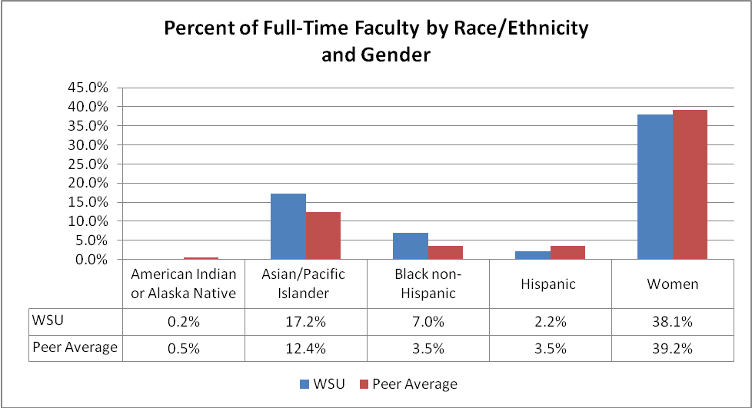

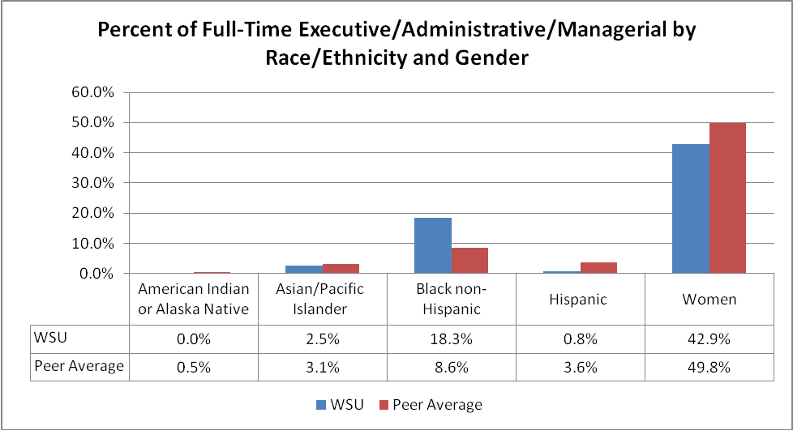

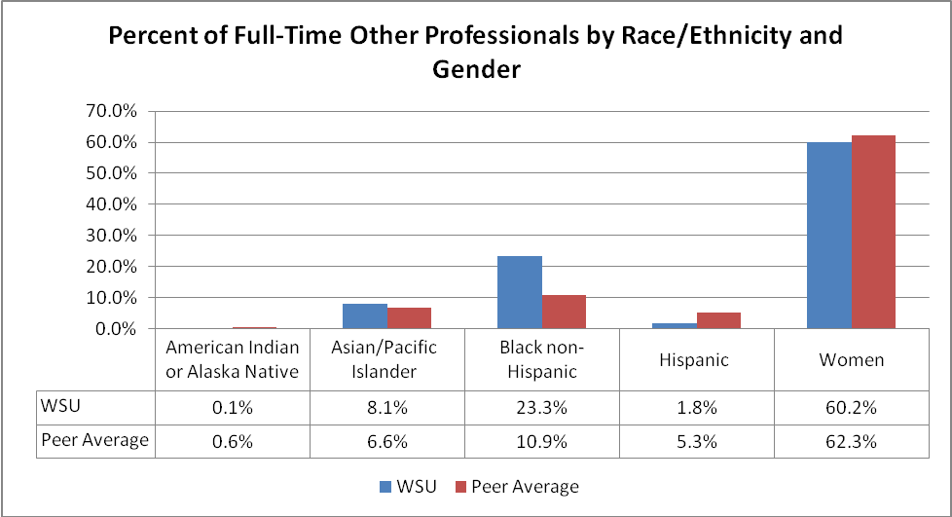

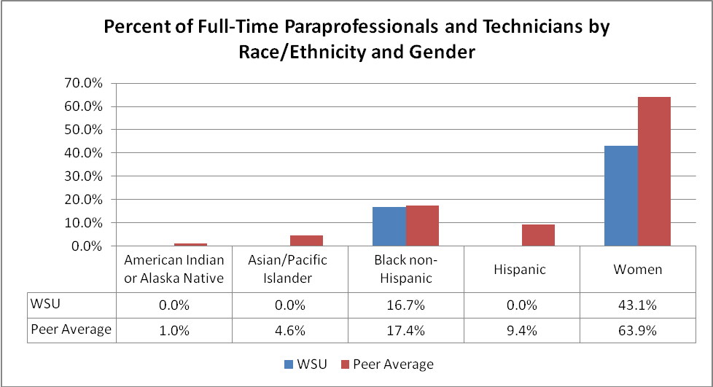

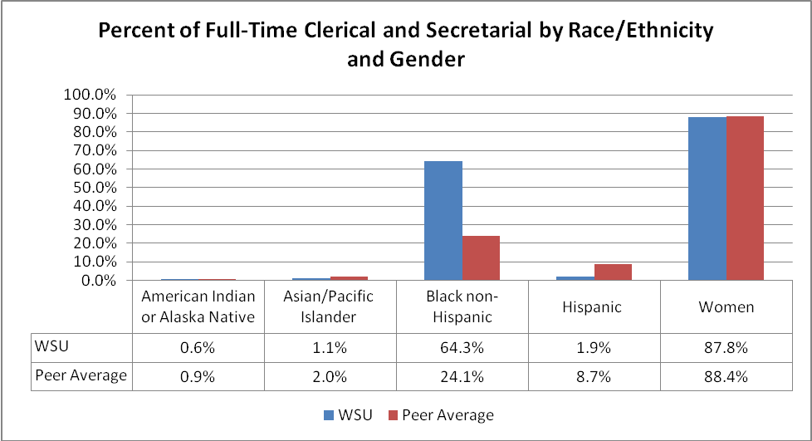

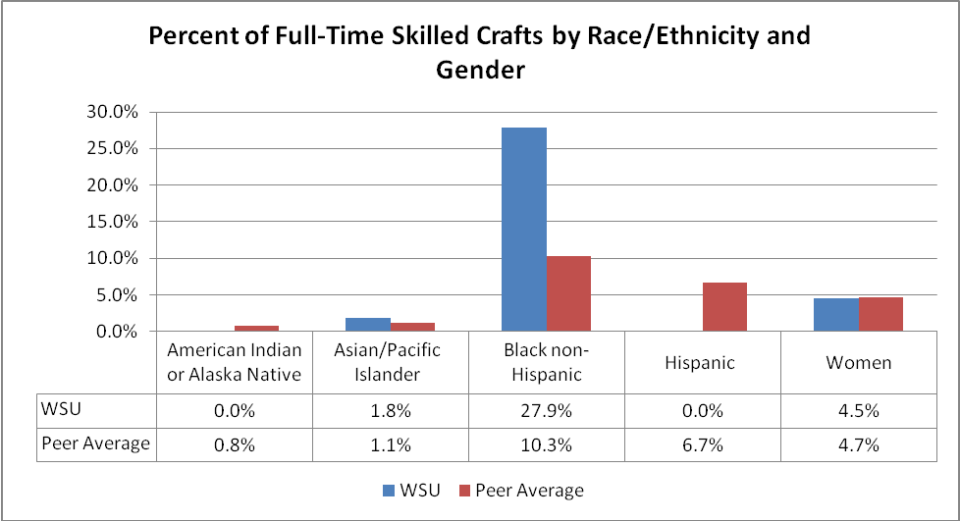

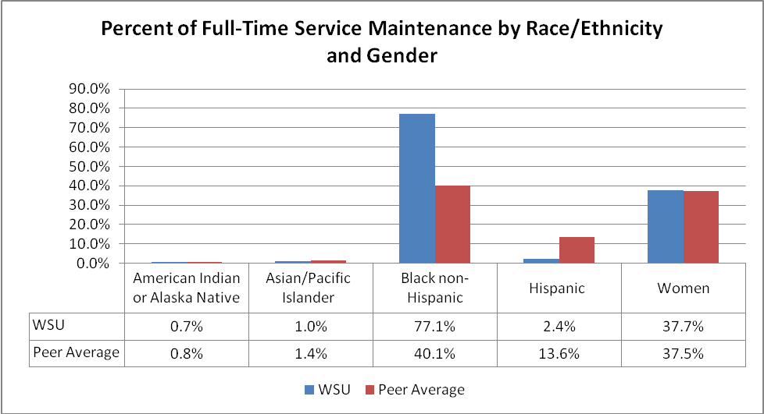



OFFICE OF EQUAL OPPORTUNITY
656 W. Kirby, Suite 4324 F/AB
Detroit, MI 48202
www.oeo.wayne.edu

This “regional availability” is based on the 2000 Michigan Department of Career Development’s Labor Market Report, the most recent data available. Southeast Michigan is defined as a four-county regional statistical area (Macomb, Oakland, Washtenaw and Wayne Counties). “Minority” and “Women” are distinct classifications. “Women” includes both minority and non-minority women.
The number of faculty includes those department chairs whose primary responsibility is “Instructional” as defined by federal law (See EEO Categories at Appendix 1 of this report).
This total includes those department chairs whose primary responsibility is Instructional as defined by the federal definition (See EEO Categories at Appendix 1 of this report). Table 4 reflects net changes, and so does not correspond precisely to the preceding text.
The methodology for the analysis was to compare Wayne in accordance with employment data submitted by IPED for 2009. IPEDS is a common university reporting data set. While this comparison may be imperfect, in that there may be variance in the ways individual institutions may arrive at the numbers they report in IPEDS, this method provides the best available data to provide a solid picture of where Wayne stands in relation to our colleagues.

